WELLENS1EK'S CQCHLEATA x DIPPES GELBE VICTORIA - ANOTHER CASE OF RECESSIVE
EPISTASIS AND DOMINANCE

Loennig, W. E. Institute of Genetics, Bonn, Federal Republic of Germany

The neutron-induced cochleata mutant of Wellensiek affects stipule mor-
phology, causing a conversion to spoon-shaped structures. The plants also
are thinner and a bit shorter than their IL. Furthermore the marked flower
anomaly associated with this mutant sharply decreases the number of seeds per
plant. In the F1 of coch x 'Dippes Gelbe Viktoria¹, the negative influence
of the recessive cochleata gene is eliminated by the normal allele of Dippes
Gelbe Viktoria and the dominant alleles for extraordinary plant height and
seed production present in the genome of the cochleata mutant in a hypostatic
state result in heterosis in F1 (Fig. 1). The cross was repeated in 1979 and
corroborated the earlier results.
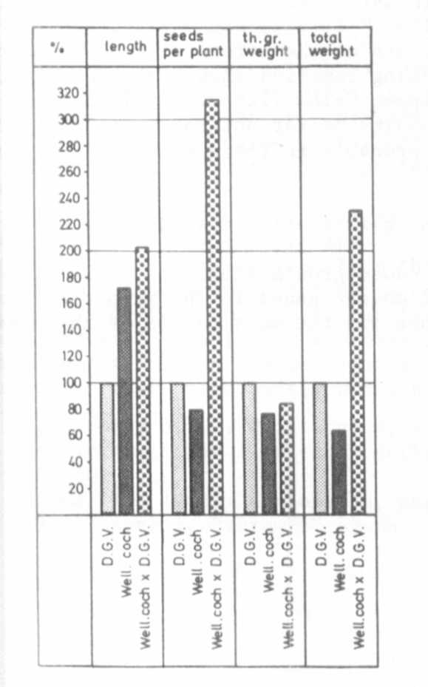
Further evidence: (1) the IL
of this cochleata mutant, Wellen-
siek' s 'Dominant' (unknown to the
author when he began studying
the first hybrids described above)
as well as the F1 Dominant x DGV
compare in length and seed produc-
tion with the hybrid cochleata
x DGV. (2) Some non-segregating
F3 families of cochleata x DGV
show length and seed production
comparable with Dominant. (3) In
relation to DGV, flowering and
ripening was delayed in the hybrids.
The difference between heterosis
in this case and that induced
by the fasciated mutants seems
to be simple: One IL, Wellensiek's
Dominant, already possesses the
dominant genes whose action is
partly suppressed by the coch
gene of the mutant. In the fas-
ciated mutants the respective
genes have mutated to the dominant
state. But in both cases the
full expression of the dominant
genes is hindered by deleterious
recessives and no heterozygosity
per se seems to be involved.

Fig. 1. Mean length, seeds per plant,
thousand seed weight, and mean
total dry weight of plants of
DGV, Wellensiek's coch, and
their F1.

