Hovinen, S. and R. Karjalainen
IMPROVEMENT OF PROTEIN PRODUCTIVITY UNDER MARGINAL CONDITIONS IN FINLAND
Hankkija Plant Breeding Institute, Helsinki, Finland

The latitude and climatic conditions of Finland are nearly marginal for
growing peas for fodder and cooking. There is therefore considerable varia-
tion in seed yield, protein content, and protein yield in different locations
and different years. Analyses of phenotypic variability of protein content
on 18 genotypes in several years and two locations showed a range of 19.9%-
29.8%. A highly significant variation was observed between cultivars and
advanced lines. Within certain cultivars the variation was very wide,
reaching 20.5%-29.8% in one cultivar. This shows that peas are very sensitive
to extreme climatic conditions.
The correlation between protein content and seed yield was negative in
four years, r=-0.179 to -0.410, p <0.05=0.396, and positive in one year,
r=0.313. The correlation between protein content and seed weight was negative
in all cases, r=-0.118 to -0.536, p <0.05=0.396. Within this material we
observed that protein content was positively correlated with growing time
in every year, r=0.138 to 0.573, p <0.05=0.396. The above figures agree
well with results recently published in Sweden (1).
Our results indicated that there would be certain difficulties in trying
to improve simultaneously both protein content and seed yield with early
maturity.
In trials the protein yield per ha varied from 0-1700 kg, and a great
part of the total yield per area is often lost because the crop fails to
mature. This emphasizes the fact that crop dependability is of crucial
importance in breeding programs in Finland. So, in trying to improve protein
productivity, the protein content is of less importance compared to seed
yield and yield stability, as recently stressed by Snoad (2) in Britain.
This means that in northern growing conditions earliness and good lodging
resistance guaranteed better protein yields (Fig. 1).

1. Bingefors, S., G. Quittenbaum, and J. Tapia Rogas. 1979. Protein-
haltsvariationer i arter. Sveriges Utsadesforenings Tidskrift 89:
189-208.
2. Snoad, B. 1980. The origin, performance and breeding of leafless peas.
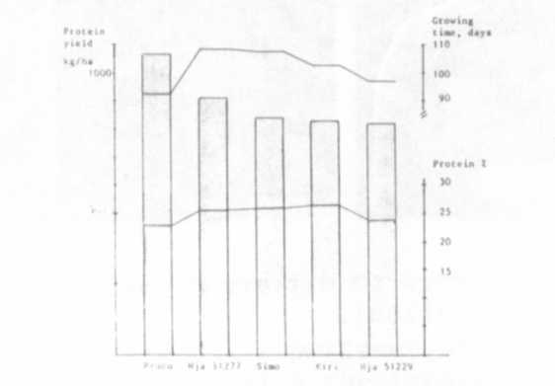
Fig. 1. Protein yield, protein content, and growing time of five
cultivars grown in Finland. Proco is very early, Hja 51277
semi-1eafless variety with good lodging resistance.
Adas Quarterly Review 37:69-86.

