THE EFFECT OF THE LIGHT/DARK RATIO ON MORPHOGENESIS FOLLOWING THE APPLICATION
OF AUXIN TO ROOTS OF PEA SEEDLINGS

Ingensiep, H. W. and H. J. Jacobsen
Institute of Genetics, Bonn, Federal Republic of Germany

It is well known that exogeneous factors (light, temperature, etc.) inter-
acting with endogeneous factors, i.e. phytohormones, may influence the expression
of morphological characters in a particular plant genotype. Hormone-dependent
regulation of plant growth can be studied by applying morphogenetic substances
to the plant. We investigated the effect of the light/dark ratio on morpho-
genesis after auxin was applied to the roots of etiolated pea seedlings. In
this paper we wish to show the relevance of our results, using our established
culture system (1), to gene controlled morphogenesis.
Auxin-induced morphogenesis of intact pea seedlings was strongly influenced
by the light/dark ratio after the pulse (Table 1). A short pulse of the
synthetic auxin 2,4-D (15 min) followed by exposure to light for ten hours
induced abnormal root growth whereas shoot development was only slightly inhibited
(Fig. 1). When the application-time was extended, and exposure to light re-
duced, the elongation of basal stem tissue in the shoot was stimulated, but
natural morphogenesis of apical parts was inhibited (Fig. 2). When the auxin
was applied for ten hours in the dark followed by an eight-hour dark period
before further cultivation for two weeks, natural development of the shoot
was strongly inhibited (Fig. 3). Numerous abnormal lateral roots were initiated
together with the formation of callus-like structures. The shoots of these
seedlings were able to initiate axillary buds, which in some cases developed
into shoots before final inhibition (Fig. 4). This phenomenon seems to depend
on breaking the apical dominance after 2,4-D was applied to the roots, probably
by inhibiting the natural auxin transport from the apex. Abnormal growth such
as adventitious roots or callus-like structures were also observed when the
seedlings were treated with 2,4-D (10⁻⁴M) for 24 hours in the dark and then
cultivated under light (1).
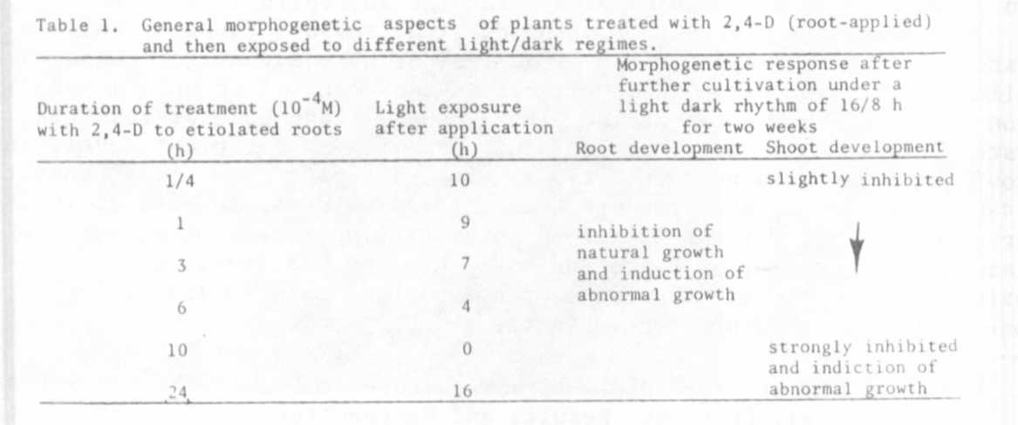
I
These examples illustrate the importance of having standardized conditions, |
especially light conditions, following the treatment of intact seedlings with
auxin. We believe that these results clearly demonstrate how exogeneous factors
such as exposure to light in the early stages of seeding development may play
an important role in the expression of morphological mutants, at least if
phytohormones are involved in the morphogenetic pathway.

1. Ingensiep, H. W. , et al. Morphogenetic response, translocation, and
metabolism of root-applied auxin in pea seedlings. PNL 13: 21. 1981.

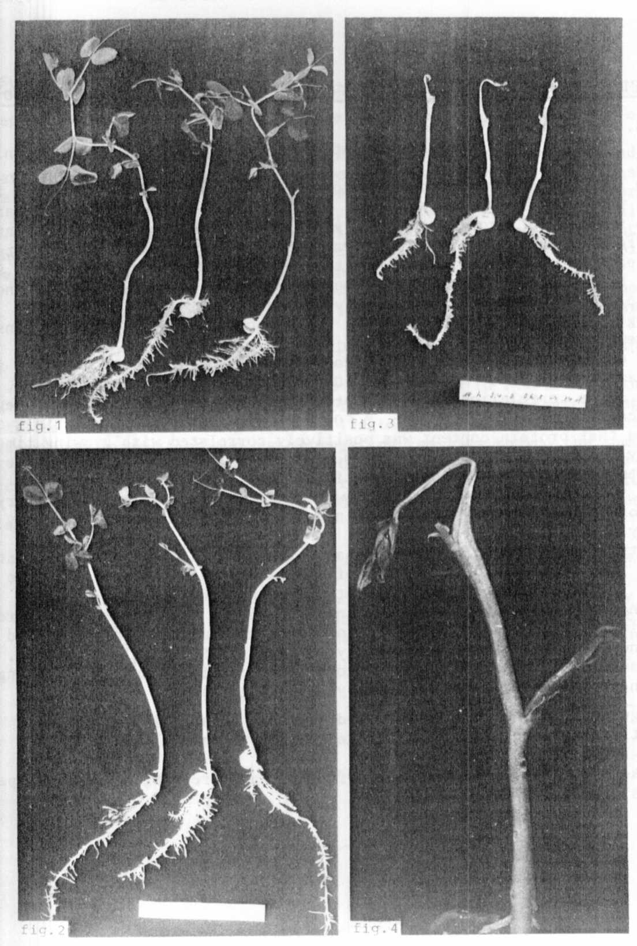
Figs. 1-4. Morphogenetic responses to different auxin-light treatments
(see text for explanation).

