MORPHOGENETIC RESPONSE, TRANSLOCATION, AND METABOLISM OF ROOT-APPLIED AUXIN
IN PEA SEEDLINGS

Ingensiep, H. W., M. Merit, and II. L. Jacobsen
Institute of Genetics, University of Bonn, Federal Republic of Germany

Gene-dependent expression of phenotypic characters in plants seems to
be mediated by the various phytohormones. Since we have only a crude under-
standing of phytohormone action, model systems have been developed for evalua-
ting their activity in addition to their effects on morphology. For short-
term effects, cereal coleoptile served as a model tissue, while the study of
long-term biochemical effects was made possible mainly by using soybean
hypocotyl or pea epicotyl. At higher concentrations there seems to be no
culture system permitting comprehensive studies of the effects of different
auxins at the morphological, physiological, and biochemical level. In previous
studies we tried to investigate auxin action using in vitro systems (1), but
for a number of reasons we judged these systems to be unsuitable. So we
developed a system using intact pea seedlings and studied the different effects
of root-applied auxins (2,4-D, NAA, IAA). In our in vivo system we found
different morphogenetic responses detectable within one week, providing us
with sufficient amounts of tissue for investigation of auxin-protein inter-
action. It has been suggested that different modes of auxin action in pea
are connected with differences in translocation and metabolism of the res-
pective auxin (2). The present paper reports the effects of exogenously
applied auxins with respect to their uptake, transport, and metabolism in
intact pea seedlings. Concurrently, studies were carried out to detect changes
in protein level and to prove the existence of specific auxin-binding proteins
(3). Furthermore, the system may allow us to correlate possible different
auxin-sensitivities of pea mutants during germination with their genetic
background, thus obtaining some information, on the physiological level,
about the particular mutational event.
One-week-old etiolated pea seedlings grown on moist vermiculite were
carefully washed and placed on plastic grids in glass vessels. This arrange-
ment allows controlled uptake of the auxins by roots of intact seedlings (10
ml/seedling of 10~⁴M water solution of unlabeled auxin with 3 x 10⁵ dpm/ml
labeled 2,4-D and NAA, and about 1 x 10⁵ dpm/ml labeled IAA). After 24 h
-pulse of auxin in the dark, treated seedlings were placed on moist vermiculite
under a light/dark cycle of 16/8 h (2500 lux) for one week. Uptake of the
auxins was recorded by measuring loss of radioactivity (i.e. dpm or decompo-
sitions per minute) in the medium. The distribution of the auxins in the
seedling was determined after differential extraction from organs or segments
and by autoradiography of the dried seedlings with X-ray film. Ethanol
soluble extracts were analyzed by paper chromatography and on cellulose thin
layer aluminium sheets using different solvent systems.
Morphogenetic response: 2,4-D (10⁻⁴M) inhibited natural differentiation
of pea seedlings treated with a 24 h -pulse by inducing abnormal growth in
root and shoot within one week (Figs. 1-4). NAA and IAA did not inhibit
natural differentiation of the seedlings under the same conditions (10⁻⁴M)
and the seedlings are comparable to the untreated control although a slight
stimulation of normal root formation was observed. This raises the question:
What are the physiological reasons for these different morphogenetic responses?

RESEARCH REPORTS

1.Effect of root-applied 2,4-D on
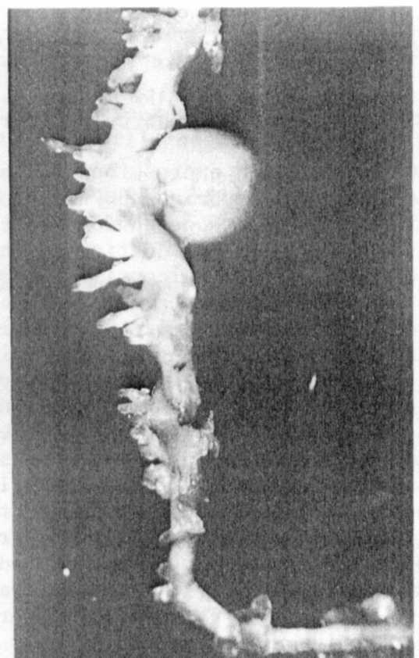
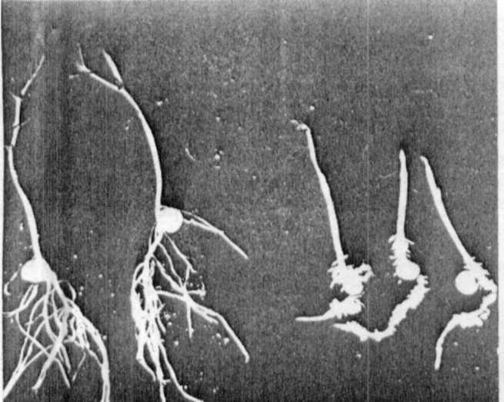
pea seedlings :Inhibition of natu-
ral differentiation within one week
(untreated seedlings on the left).

2.Induction of abnormal adventitious
roots and lateral roots after 2,4-D
treatment(on the right).

3.Induction of abnormal lateral root formation and callus-like
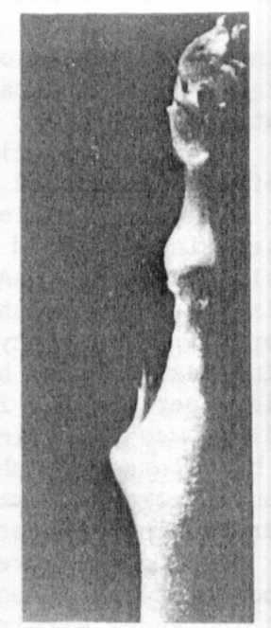
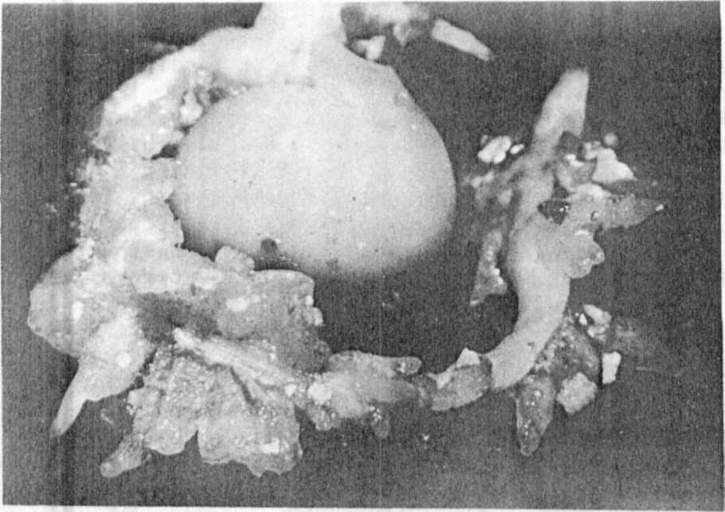
structures after 2,4-D-treatment(left).
4.Effect of root-applied 2,4-D:radial expansion of stem tissue.

PNL Volume 13 1981
RESEARCH REPORTS
3

The physiological results obtained in this system are summarized in
Table 1. In contrast to NAA and IAA, 2,4-D is characterized by a high mobility
and a low degradation in the intact plant. Uptake of 2,4-D by the roots was
about 6% after the 24 h- pulse, for NAA about 10%, and for IAA about 70% as
measured by loss of activity in the medium. In the case of 2,4-D, following
the pulse, radioactivity was accumulated in the root and during the following
culture period was transported into the shoot by the transpiration stream
as shown by differential extraction of segments and by autoradiographs. The
l_14c -activity of 2,4-D seems to be polar, having accumulated in the tip
regions of the lateral and adventitious roots, but being diffusely distributed
in stem and primary root tissue of the seedlings. There is no clear evidence
for degradation of 2,4-D. On the other hand NAA and IAA were characterized
by low mobility and high metabolic susceptibility of their molecules. After
one week most of the l-¹⁴C-activity from IAA or NAA still is fixed in the
primary root. Degradation or amino acid conjugation were detectable already
after the 24 h -pulse. The amount of free IAA is highly reduced by oxidation
and amino acid conjugation, while NAA seems to be mainly immobilized by con-
jugation. These results confirm earlier investigations (2, 4) and indicate
that the herbicidal effects of 2,4-D in pea depend on the endogeneously avail-
able amount of free unmetabolized auxin.
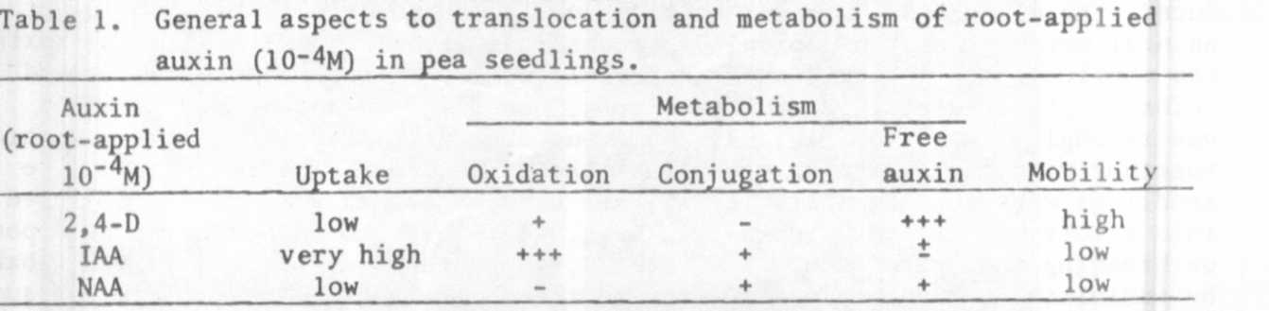
The data clearly demonstrate the advantages of the 2,4-D system used
in our investigations for studies of auxin-protein interactions in the higher
concentration range, 1) because of its pronounced morphogenetic response,
and 2) because of its less complex metabolic susceptibility.
Moreover, there are other methodological reasons favoring this culture
system: 1) The root-application of auxins has some advantages compared with
foliar-application often used. It allows easy control of uptake and calcula-
tion of accumulated auxin in the plants, and 2) last but not least this culture
system permits auxin action to be studied on the intact plant level, thereby
providing advantages over in vitro systems. Therefore, we think that the
2,4-D system is suitable for biochemical studies of auxin effects in the
herbicidal range. It was useful in investigating levels of response of cyto-
plasmatic and nuclear proteins and auxin-binding proteins. We assume that
auxin-mediating proteins could play an important role in long-term morpho-
genetic effects as demonstrated in the 2,4-D system.

1. Jacobsen, Fh et al. 1980. Tissue culture studies in Pisum sativum.
In: Plant Cell Cultures: Results and Perspectives. Elsevier, Amsterdam.
pp. 319-324.
2. Torrey, J. G. and R. Zobel. 1977. Root growth and morphogenesis. J_n:
The Physiology of the Garden Pea. Academic Press, London.
3. Jacobsen, H. J., et al. (in preparation).
4. Thimann, K. V. 1972. The natural plant hormones. I_n: Plant Physiology.
Vol. VIB. Academic Press, New York. pp. 3-365.

