INTERACTION OF ROOT-APPLIED 2,4-D AND COLCHICINE ON MORPHOGENESIS

Ingensiep, H. W.
Institute of Genetics, University of Bonn, Federal Republic of Germany

Microtubules (MT) have been shown to play an important role in cell
division and cell shape (1). It has long been known that endogenously applied
colchicine affects plant morphogenesis in a manner similar to that of some
phytohormones (2), but the extent to which phytohormones and colchicine
interact to influence MT-disorganization is not yet clear (1, 2, 3). This
prompted me to perform some experiments using the 2,4-D culture system for
etiolated pea seedlings (4).
It is well known that colchicine in low concentrations acts on the
microtubule system, in particular on the MT of the mitotic spindle (10⁻⁶ M).
In higher concentrations colchicine is known to induce peculiar swellings
in root tips named "C-tumors" (2), giving rise to the idea that because of
these morphogenetic effects it acts like a phytohormone. Less known are
the macroscopic effects on shoot development as we found in our culture
system.

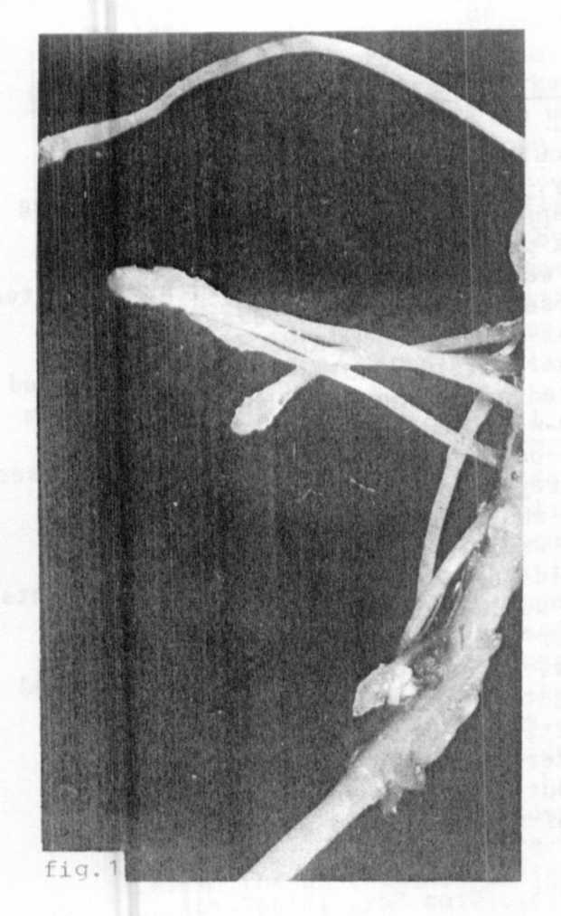
One-week-old etiolated pea seedlings
Fig. 1. "C-tumors" induced by
colchicine.
were used for studying auxin-colchicine
interactions. The seedlings were
treated with colchicine (5 x 10⁻³ M
and colchicine/2,4-D (5 x lO⁻³ M/10⁻⁴ M;
24 h root-applied) and further cultivated
on moist vermiculite for one week
(light/dark: 16/8 h; 2500 lux). Under
these conditions colchicine induced
C-tumors in root tissue of the seedlings
(Fig. 1). In the shoots, basal and
apical parts were strongly swollen
and their length reduced; the develop-
ment of the green leaves was inhibited
(Fig. 2). This effect shows some
similarities to the morphology of
fasciated mutants and may be a hint
for the understanding the basic
mechanism leading to fasciation.
If colchicine under these conditions
acts mainly as MT-disorganizer, abnormal
formation of spindle or cortical micro-
tubules during cell division or growth
may play an important role during
the induction of the observed growth
aberrations in our plants.
On the other hand it is known that
auxins induce similar depolarized
growth in plants. The questions raised
are: What are the differences between
auxin-induced and colchicine-induced
morphogenetic aberrations leading
to the death of the plants and what
kinds of interaction exist?

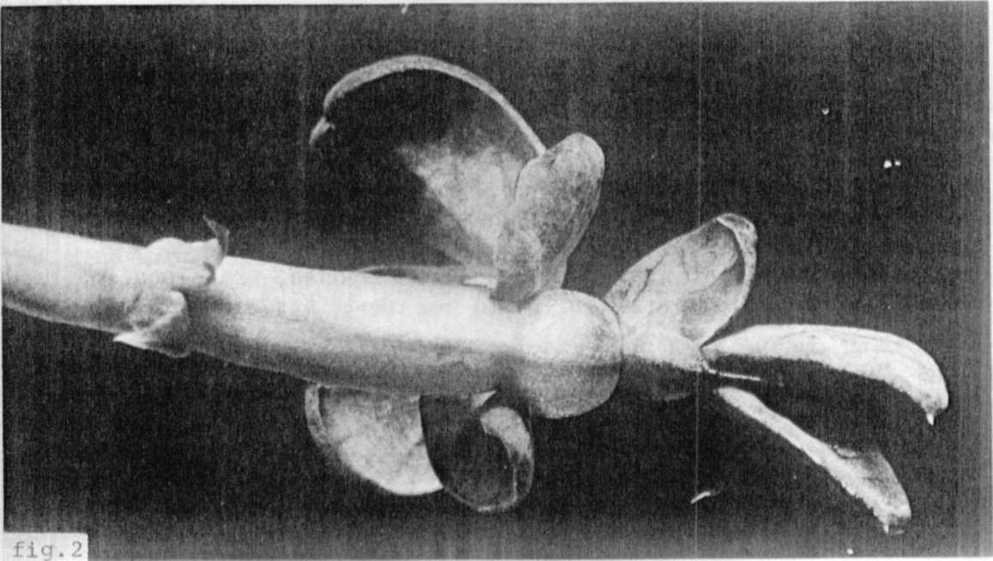
Our investigations revealed that the application of both 2,4-D and
Fig. 2. Effect of colchicine on shoot morphogenesis. Note swollen stem
and inhibited leaf development.
colchicine to the roots leads to strongly inhibited root and shoot development.
We observed tissue swelling of the primary and lateral roots leading to rup-
tures, which often are observed for 2,4-D alone in this concentration range
(4). Some swelling occurred in the root tip region, but to a lesser degree
than in seedlings treated with colchicine alone (Fig. 3). Shoot morphogenesis
was similar to that of seedlings treated with colchicine alone, but the
inhibition appeared to be stronger. Typical 2,4-D effects such as induction
of lateral or adventitious roots and formation of callus-like structures were
not observed under these conditions. This demonstrates that the drastic
morphogenic effects of 2,4-D (4) were repressed by the joint treatment with
colchicine. A repression of auxin-induced growth by colchicine and other
MT-disorganizers has already been demonstrated with wheat coleoptile segments
(3). It is assumed that polymerization of MT-subunits is required for normal
growth to occur. The effect of both compounds on polarity of single cells
is known. In the case of colchicine it was clearly demonstrated that cells
of untreated controls stretch mainly in longitudinal axial directions, while
cells of colchicine treated roots expand transversely with a maximum in the
cortical tissue above the root tip (2). This observation, led Levan to con-
clude that a similar increase in cell size results in C-tumors just as in
auxin-induced enlargement. With respect to the biochemical action of colchi-
cine on the MT-organization, the present investigations confirm the hypothesis
that expression of normal and abnormal morphogenesis in plants depends on
the basic mechanism of MT-formation within the cell, which probably is
mediated somehow by intercellular regulators like auxins.
1. Dustin, P. Microtubules. Springer, Berlin. 1978.
2. Levan, A. The macroscopic colchicine effect - a hormonic action?
Hereditas 28:1244. 1942.
3. Lawson, R. V. and R. L. Weintraub. Interactions of microtuble disorganizers,
plant hormones and red light in wheat coleoptile segment growth. Plant
Physiol. 55:1062-1066. 1975.
4. Ingensiep, H. W., et al. Morphogenetic response, translocation, and
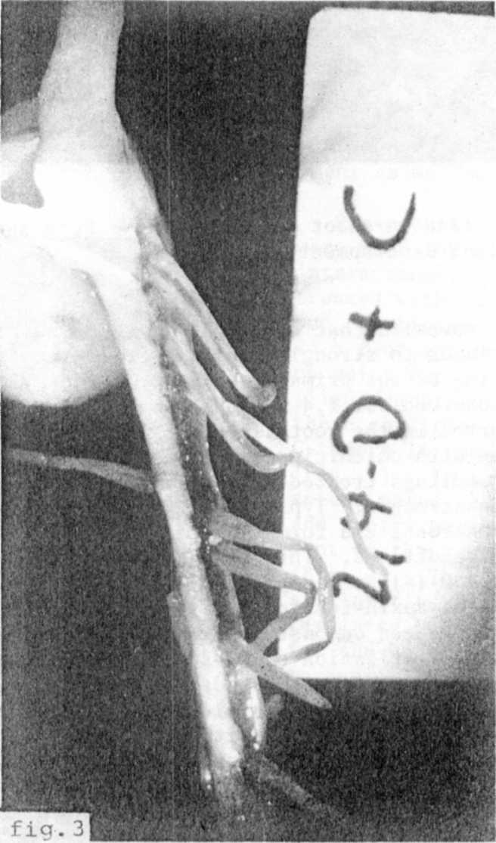
metabolism of root-applied auxin in pea seedlings. PNL 13:21. 1981.
Fig. 3. Combined effect of colchicine and
2,4-D on root development.

