IMMUNITY TO PEA SEEDBORNE MOSAIC VIRUS: A REASSESSMENT

Hampton, R. 0.
and G. A. Marx
USDA, SEA-AR, Oregon State University, Corvallis, OR USA
NYS Agricultural Experiment Station, Geneva, NY USA

Immunity to pea seedborne mosaic virus (PSbMV) was reported to be con-
ferred by a single recessive gene, designated sbm (2). However, infected
susceptible plants show an array of symptom expression (4, 5), and plants
initially identified as PSbMV-immune have sometimes proved to be susceptible
just before plant maturity (Hampton, unpublished results). Some breeders
attempting to develop disease-resistant pea cultivars have therefore begun
to question whether PSbMV-immunity is indeed conferred by a single gene.
These circumstances prompted us to re-examine the genetic control of immunity,
Details of this study will be published separately, but here we wish to confirm
previous analyses (1, 2) and to discuss how the results might be applied in
breeding programs.
Four different USDA Plant Introduction (P.I.) accessions, three of which
were recently reported to be immune to PSbMV (3), were used as parents in
reciprocal crosses with a common susceptible line. The susceptible parent,
WL-1255A ^{1/}, was also homozygous recessive for wlo, the wax gene reported by
Gritton and Hagedorn (1) to be linked with sbm. Susceptible marker parent
WL-1183 reported by these workers, like WL-1255, also carried the edible-pod
gene, p_, which is linked with wlo on chromosome 6. One of our resistant
parents, P.I. 193586, had been included in the investigation by Hagedorn and
Gritton (2).
Our results clearly confirm those previously reported (1, 2), showing
that resistance is conferred by a single gene pair, linked with wlo on chromo-
some 6 (Table 1). Our segregation ratios were determined after the plants
were repeatedly inoculated with PSbMV and then rigorously examined for presence
of disease symptoms. Moreover, all progenies remaining symptomless for 60
to 90 days after PSbMV-inoculations were assayed repeatedly on Chenopodium
amaranticolor.
In view of the technical difficulties of screening for PSbMV-immunity
by conventional methods and of the demonstrated potential for mistaking tolerance
for immunity, it would seem desirable to consider the use of marker genes
closely linked to sbm as preliminary indicators of susceptible or immune
plants, in lieu of PSbMV-inoculation. Ideally, the marker gene used to identify
resistant plants would be visible in the seedling stage and be at least horti-
culturally neutral, if not beneficial. Although the waxless (wlo) plants can
be easily scored early in seedling development, they may be considered horti-
culturally undesirable because the waxless surfaces of the leaflets predispose
the plant to damage by post-emergence applications of herbicides now commonly
in use. Still, this problem ultimately may prove less serious than it pre-
sently seems. Newer herbicides such as trifluralin are applied as a pre-emergent
treatment and it is not yet known whether pea plants with wax genes are ad-
versely affected by herbicides applied in this manner. Nor is it known whether
wlo or other wax mutants are horticulturally undesirable in their own right,
i.e. in the absence of pesticides. Moreover, should the afila gene gain com-
mercial acceptance, cultivars with wlo may not be injured by herbicides since
wlo affects only the upper surface of the leaflets and since the leaflets in
af plants are converted to tendrils. Thus, it may be unwise to dismiss wlo
as deleterious without further evaluation.

1/ - Furnished by Dr. Blixt
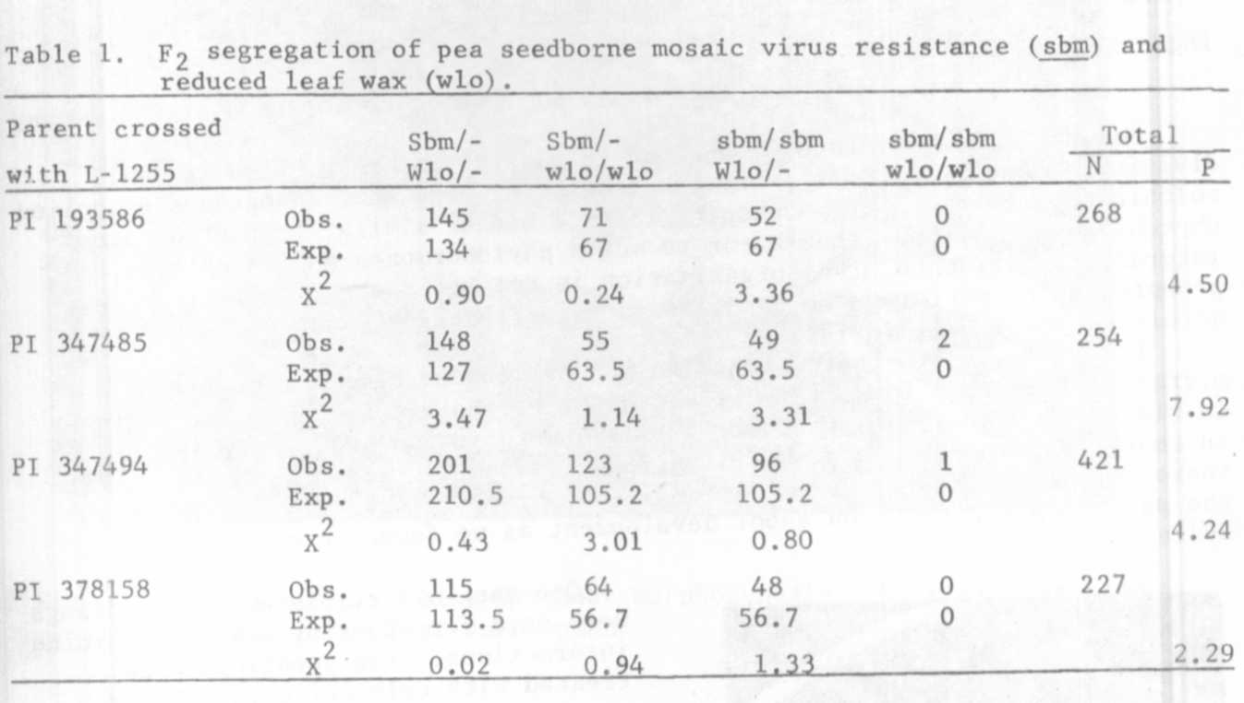
Even if wlo should prove to be horticulturally undesirable, it still
might serve effectively, though indirectly, in developing a group of breeding
lines with resistance to PSbMV. In this approach a line carrying sbm and
wlo in the coupling phase would serve as a parent in crosses with a range
of susceptible breeding lines. Selection would then be practiced, as suggested
before, on the basis of the presence or absence of wax, i.e. discarding all
normal wax segregants and retaining waxless plants which also have horticul-
tural merit on other grounds. After further selfing and selection, a selected
number of wlo breeding lines would be tested by conventional means to confirm
the presence of sbm; crossover plants (Sbm-wlo) would be discarded. This
diverse group of breeding lines could then be used in a second round of crosses
with a line(s) carrying resistance in the repulsion phase, i.e. sbm Wlo.
Selections in this second round of crosses would again be practiced on the
basis of the presence or absence of wax as well as on horticultural merit,
but in this case the normal wax plants would be retained and the wlo segregants
would be discarded because all the progeny would be homozygous for sbm.
The second closely linked gene, p, (for edible poddedness), has the dis-
advantage of being an adult plant character. Gene p could nonetheless be used
in combination with sbm either alone or together with wlo, especially if the
objective were to develop edible-podded cultivars.
It must be emphasized again that breeders who take advantage of the
linkage wlo-p-sbm, either along the lines outlined above or in some other
way, should take the necessary precaution of testing their material for
immunity at crucial steps along the way.

1. Gritton, E. T. and D. J. Hagedorn. 1975. Crop Sci. 15:447-448.
2. Hagedorn, D. J. and E. T. Gritton. 1973. Phytopathology 63:1130-1133.
3. Hampton, R. 0. and S. W. Braverman. 1979. Plant Dis. Reptr. 63:95-99.
4. Hampton, R. o. 1980. PNL 12:27-28.
5. Hampton, R., G. Mink, L. Bos, T. Inouye, M. Musil and D. Hagedorn.
1981. Neth. J. PI. Path. 87 (in press).

