1 RESEARCH REPORTS
PNL Volume 13
1981

THE GENOTYPIC CONSTITUTION OF SOME LINEARLY FASCIATED RECOMBINANTS DERIVED
FROM THE STRONGLY FASCIATED MUTANT 489C

Gottschalk, W.
Institute of Genetics, University of Bonn, Federal Republic of Germany

Mutant 489C of the variety 'Dippes Gelbe Viktoria' (DGV) shows a pro-
nounced stem fasciation in the upper part of the stem combined with a strong
shortening of the uppermost internodes. It is homozygous for about 15 mutant
genes, most of them being hypostatic. Therefore, their action cannot be
discerned in the mutant itself but only in specific recombinant types selected
after having crossed 489C with non-fasciated genotypes. The mutant contains
at least three, possibly four, genes causing different kinds of stem fascia-
tion, the gene for strong fasciation being epistatic over the other genes
of this group. Moreover, five different mutant genes for plant height and
internode length are present in 489C1/. In 1980, they caused the following
lengths of the main stem:
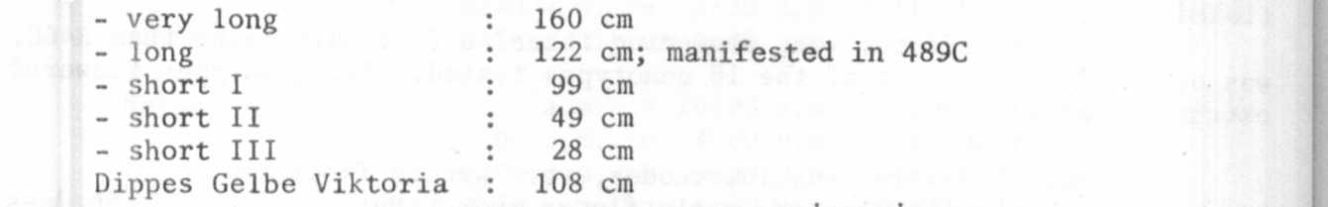
The gene for long internodes was found to be epistatic over the other four
genes of this system. Some fasciated recombinant types were crossed with
non-fasciated genotypes in order to clarify their genotypic constitution
particularly with regard to the presence or absence of hypostatic genes.
Theoretically, a variety of recombinants should be expected from such hybridi-
zations differing from each other with regard to the total number of mutant
genes derived from the parental mutant 489C. Hypostatic genes for a slightly
reduced chlorophyll content and for extremely late flowering and ripening
are not considered in these investigations. The following results were ob-
tained :
Recombinant R 98B - from the cross of mutants 489C x 176 (narrow leaves, gene
dim-1) . The plants show the following characters: Short I (from 489C); lineal
stem fasciation, uppermost internodes not shortened (from 489C); stem in the
top region often bifurcated (from 489C); later than the mother variety (from
489C); small seeds (either gene sg from 489C or the pleiotropic gene dim-1
from 176A). In F2 of the cross DGV x R 98B, only two classes of phenotypes
were observed: Normal plants, equal to the mother variety, R 98B. Thus,
recombinant R 98B has a very simple genotypic constitution. Not present in
its genome are: The epistatic genes for strong fasciation and for long inter-
nodes of 489C, and the hypostatic genes very long, short II, short III of
489C.
Recombinant R 161 - from 489C x 1201A (dichotomous stem bifurcation, gene
bif-1). Characters: Short I (from 489C); linear stem fasciation (from 489C);
later than DGV (From 489C); stem bifurcation (probably from 1201A). According
to the F2 segregations of the cross R 161 x DGV, the following genes of 489C
are not present in the genome of R161: The epistatic genes for strong fasciation

^{1/}— Definite symbols are not yet given to the genes of mutant 489C because it is
not yet clear whether some of them are identical with Pisum genes already
designated.

and for long internodes; the hypostatic genes very long, short II, short III;
and gene sg for reduced seed size.
Recombinant R 661 - from 489C x 26 (extremely shortened internodes; plant
height only about 15 cm). Characters: Plant height equal to 489C; very weak
linear fasciation (from 489C); normal seed size (from 26); normal flowering
time (from 26). According to the F₂ of the cross R 661 x DGV, the following
genes of 489C are not present in the genome of R 661: The epistatic gene
for strong fasciation; the hypostatic genes very long, short I, short II;
the gene for lateness.
Recombinant R 667 - from 489C x 169 (chlorina). Characters: Plant height
equal to 489C; very weak linear fasciation (from 489C); reduced seed size
(gene sg_ of 489C); normal flowering time (from 169). According to the F2
of the cross R 667 x DGV, the following genes of 489C are not present in the
genome of R 667: The epistatic gene for strong fasciation; the gene for
lateness; whereas the hypostatic genes very long, short I, short II, and
probably also short III as well as the gene for stem bifurcation are present.
Thus, R 667 has a much more complicated genotypic constitution than the other
recombinants mentioned so far.
Recombinant R 177 - from 489C x 1201A (dichotomous stem bifurcation; gene
bif-1). Characters: Reduced grain size (gene sg of 489C); stem in the upper
part of the shoot bifurcated (gene bif-1 of 1201A); possibly a gene for weak
stem fasciation (from 489C). According to the F₂ of the cross R 177 x DGV,
the recombinant contains exclusively gene sg and perhaps one of the fasciata
genes of 489C whereas all the other genes of the mutant are not present.
R 177 is the simplest recombinant type selected in all the crosses in which
mutant 489C has been used as one of the partners.

