PNL Volume 12 1980
1 RESEARCH REPORTS

ELECTRQPHORETICAL INVESTIGATIONS ON SEED ALBUMINS OP Pisum sativum:
IDENTIFICATION OF SEVERAL ENZYMES

Wolff, G. Institute of Genetics, University of Bonn, West Germany

Seed albumins, the water soluble fraction of pea seeds, are composed
predominantly of enzymes. There is comparatively little enzyme activity
in dormant seed because, in this status, metabolism is reduced. Nevertheless,
enzymes must be available as soon as germination begins to enhance respiration
and to initiate glycolysis. This is why several enzymes should be detectable
already in dry seeds.
Total seed protein was extracted from dry seeds by a 0.2 M salt solution.
A globulin-free albumin solution was obtained after dialysing this extract
against running tap water. Separation of albumins was carried out by flat-gel
electrophoresis. Five identical assays were separated on the same gel.
Each time 50 ul of the albumin solution (1 mg/ml) was placed on the gel's
surface and each time one of the 5 assays was stained with Coomassie Blue.
As Fig. 1 (first column) shows, 33 bands can be detected in the pherogram.
The two distinct bands at position R_{p} 0.28 and Rp 0.35 are characteristic
for the Pisum-albumin pattern. A group of distinct slow running bands is
also evident (upper third of pherogram) as well as a number of fast running
bands which are not so pronounced (lower part).
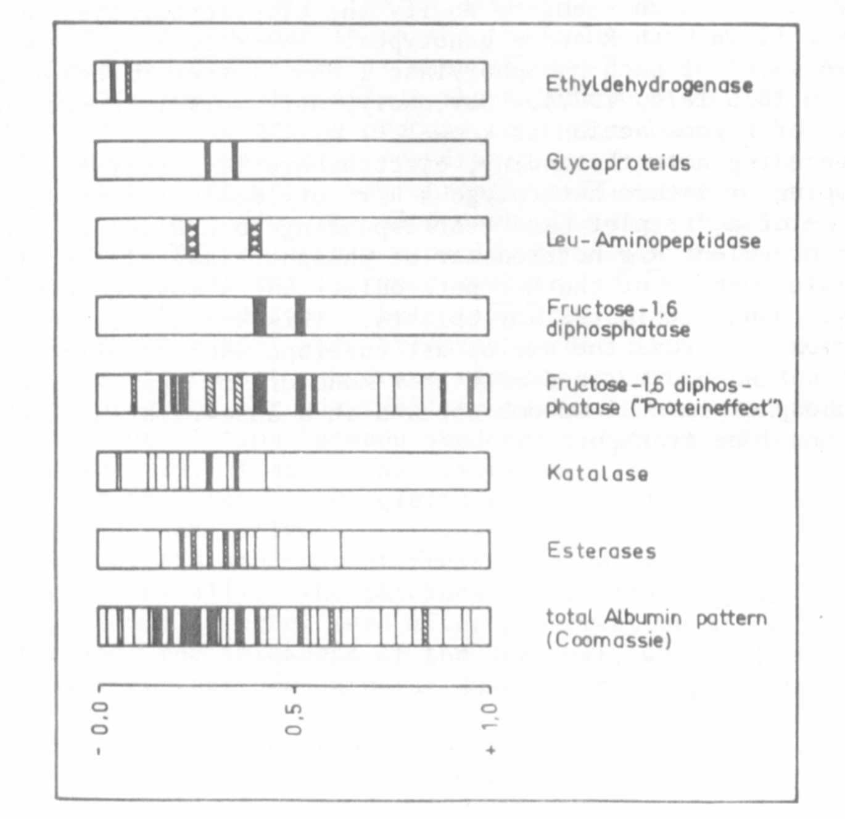
Fig. 1. Gel-electrophoretic distribution pattern of seed albumins of
Pisum sativum and of several enzymes.

In contrast to the findings of other investigators, amylase and acid
PNL Volume 12 1980 RESEARCH REPORTS 3
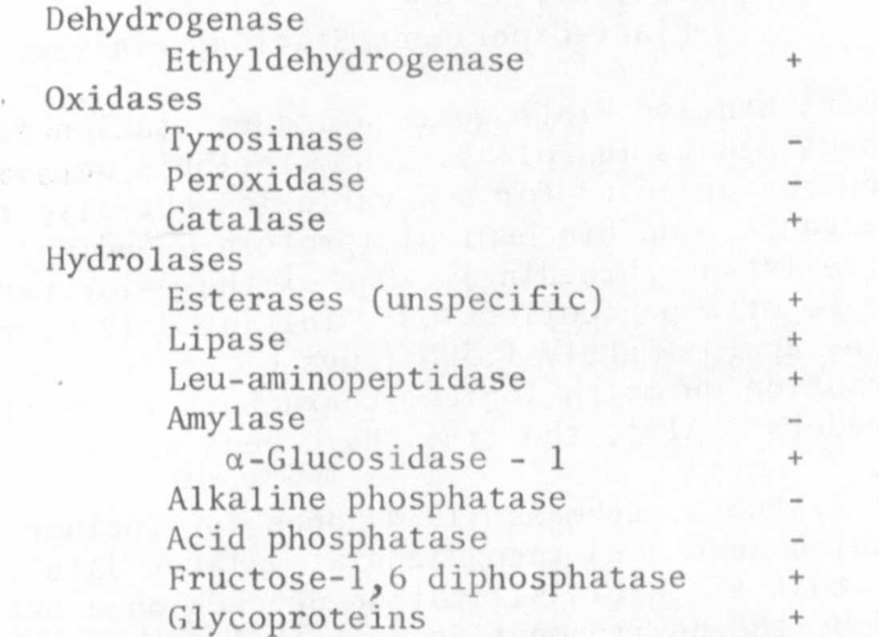
By applying specific methods, single enzymes can be detected within
the albumin pattern. So far, the following enzymes were examined:
phosphatase could not be determined under our conditions. Fig. 1 presents
the distribution of some of the above-mentioned enzymes on the gel. The
enzymes show a multiple banding pattern. The dark blue bands with Rp 0.28
and R_{p} 0.35 are the position of several substances (esterases, catalase,
and glycoproteins), thus being a collection of proteins with similar or
identical electrophoretic properties.
The determination of fructose-1,6 diphosphatase was complicated by the
"protein effect". The "protein effect" was described by Searcy et al. (1965)
in connection with starch-iodine reaction in human serum protein. Zimniak-
Przybylska and Przybylska (1976) found the same effect during their investi-
gations on amylase, and Jacobsen (1980) during investigations with rlbonuclease,
Thus it seems reasonable that the "protein effect" is not exclusively re-
stricted to starch-iodine reaction, as was proposed by Zimniak-Przybylska
and Przybylska, but that it is connected with the method of "negative staining"
which is the common feature of all three methods (determination of amylase,
ribonuclease, and fructose-1,6 diphosphatase).

Jacobsen, H. J. 1980. Plant Cell Physiol, (in press)
Searcy, R. L. 1965. Clin. Chem. Acta 12:631
Zimniak-Przybylska, Z. and J. Przybylska. 1976. Genetica Polonica 17:133

