PNL Volume 12 1980
1 RESEARCH REPORTS

LOW-TEMPERATURE SEED GERMINATION TESTS

Wehner, T. C. and North Carolina State University, Raleigh, NC, USA
E. T. Gritton University of Wisconsin, Madison, WI, USA

Improvement of the germination ability of peas in cold soil would permit
earlier planting of the crop in the spring, and would allow more uniform stand
establishment under adverse soil conditions. Other researchers have found
genetic differences in emergence speed of pea seedlings from cold soil (Torfason
and Nonnecke, Can. J. Pl. Sci. 39:119-124, 1959). Our objectives were to find
a rapid test to use in screening lines for low-temperature germination ability,
and to determine if selected lines differed genetically for this trait.
Four cultivars were used: 'Alaska' and 'Alsweet', both early-season
cultivars, and 'New Season' and 'New Line Early Perfection' (NLEP), both
mid-season cultivars. In the first tests, only these four cultivars were
used. In a later test, two families (consisting of two parents, their Fi,
reciprocal F1, and F₂) were tested. The two families tested were Alaska
x New Season and NLEP x Alsweet. All seeds used for the cold tests were
produced in the field along one wire trellis in the same growing season. Petri
plates (100 x 15 mm) were filled halfway with sterile silica sand, moisture
was added, and 15 seeds were placed in the sand. The plates were checked
every 12 hours for sprouted seeds. The average number of days for germination
of each plate of 15 seeds was calculated and the data were analyzed as a
completely randomized experimental design. Two replications were employed
in the first tests and six in the tests involving parents, F1's, and F₂.
Three conclusions can be drawn from the data in Table 1. First, there
are differences among cultivars for low-temperature germination ability. Second,
the differences among cultivars become greater as the temperature is dropped
from 20 to 8°C. This is indicated by the greater ranges (number of days between
fastest and slowest germinating cultivars) at the lower temperatures. Third,
there is no correlation between low-temperature germination ability and maturity,
as the fastest and slowest germinators at 8°C are both mid-season cultivars.
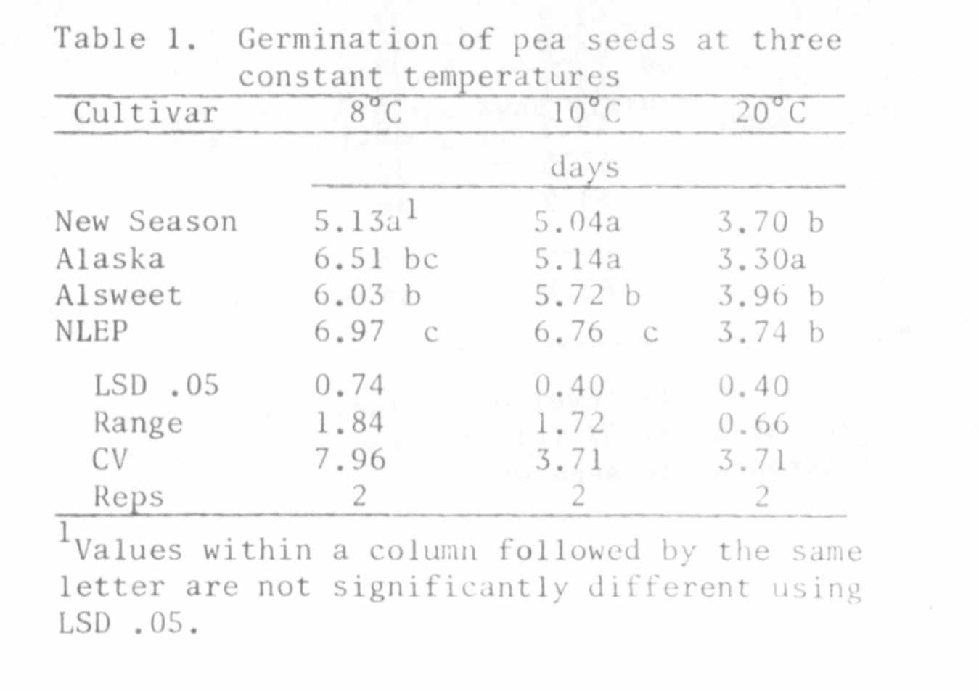

RESEARCH REPORTS 3
PNL Volume 12 1980

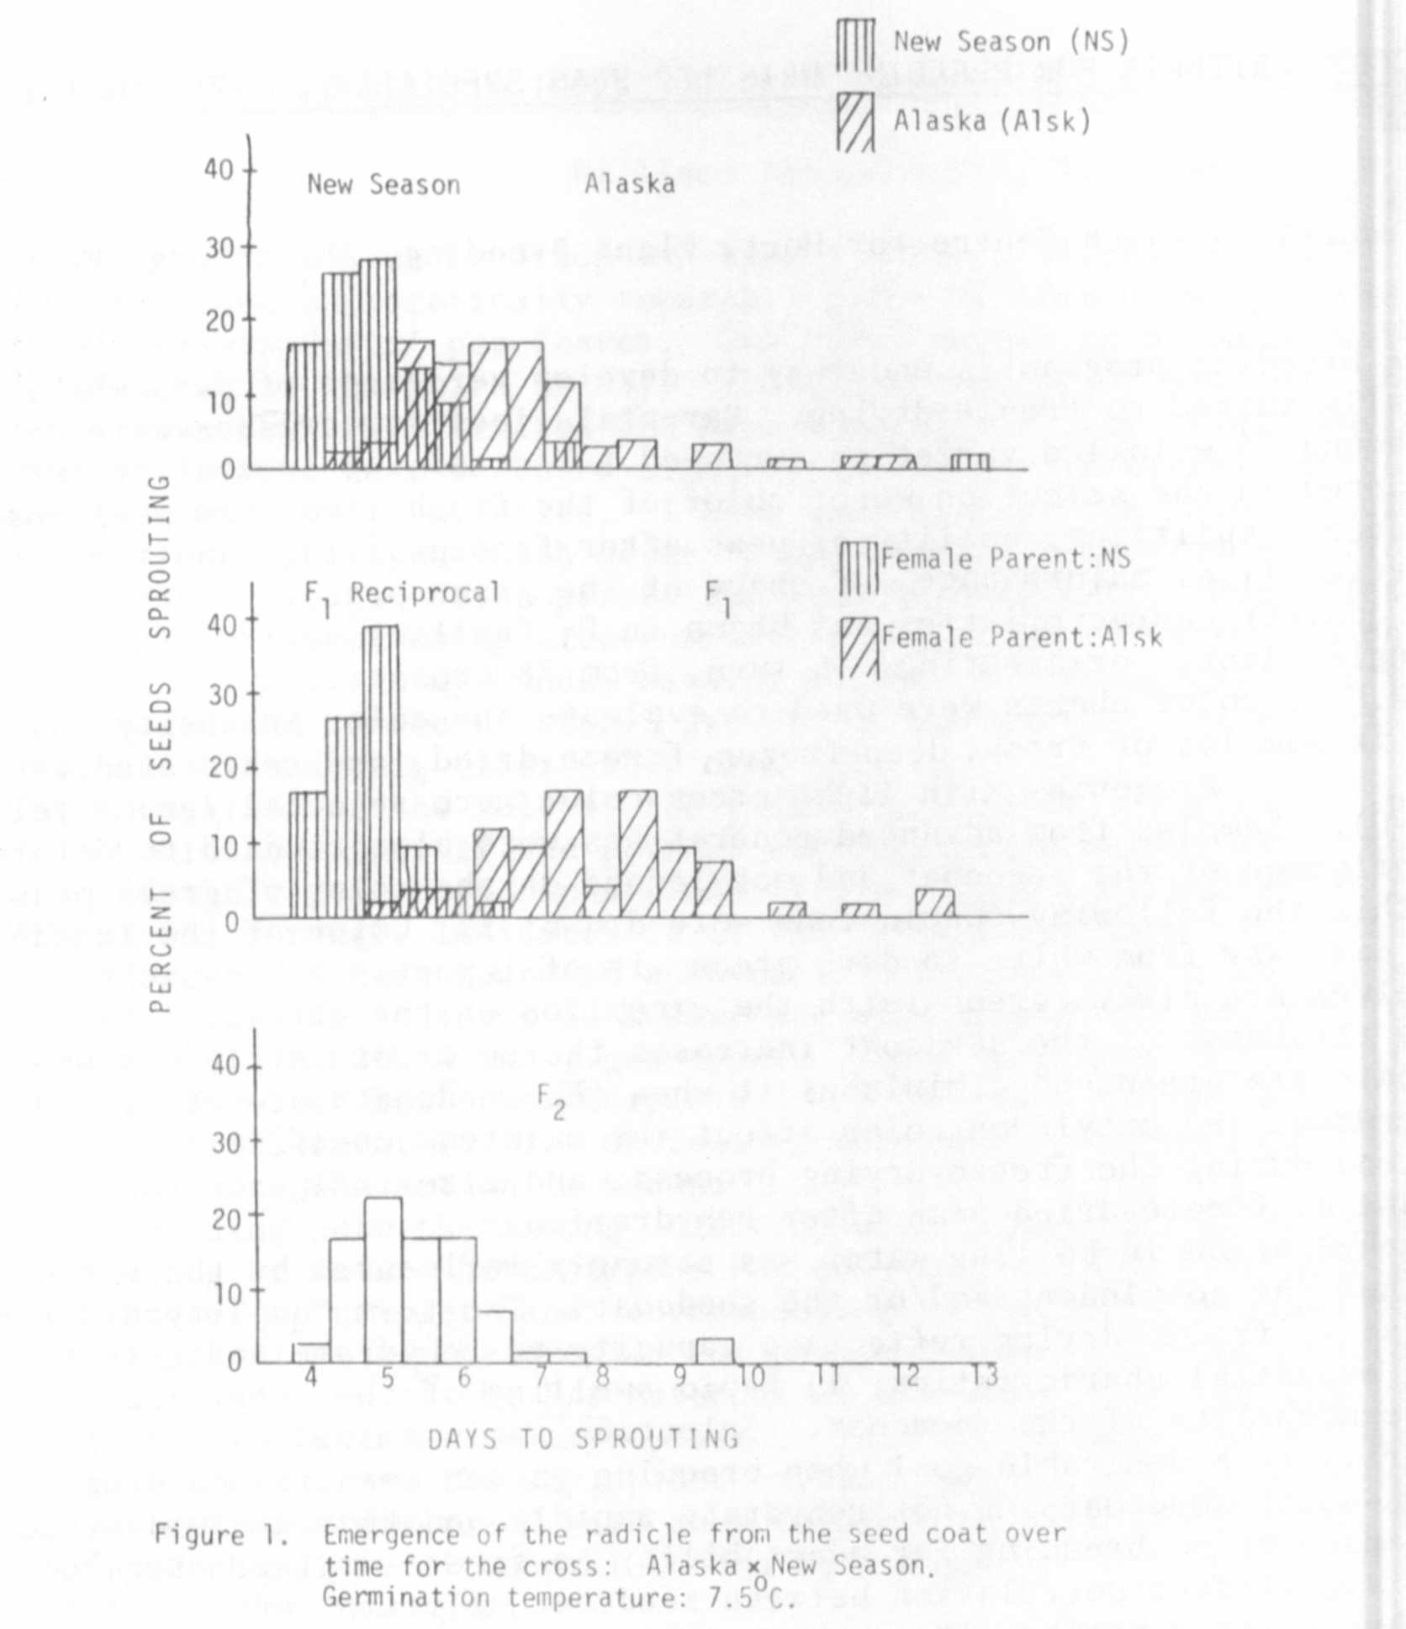
Distribution of seeds for low-temperature seed germination ability was
similar in the two families tested, so only the Alaska x New Season cross is
presented (Fig. 1). There is a strong maternal effect for this trait since
the Fi tends to be similar to the female parent in mean and range of the distri
bution. The distribution of the Fj ^{ls} skewed toward the fast-germinating
parent indicating dominance for low-temperature seed germination ability.
Low-temperature germination tests run at 8°C or below should be useful
in screening lines of peas for use in a breeding program to improve cold
tolerance. Maternal effects may complicate the procedure, but the test Is
rapid and genetic variability for the trait exists.

