DOSAGE EFFECTS AT THE R LOCUS ON THE PROPERTIES OF THE STARCH FRACTIONS

Boyer, C. D., P. A. Damewood, and G. L. Matters
Rutgers University, New Brunswick, N.J, USA

Previous work in maize has shown that starch from endosperms homozygous
for amylose-extender (ae) have an altered arnylopectin in addition to
increased amylose (Boyer and Preiss, Biochem. & Biophys. Res. Communications
80:169. 1978, and references therein). The starch from cotyledons of
peas homozygous for rugosus (r) also contain increased amylose (Hilbert
and McMasters, J. Biol. Chem. 162:229, 1946). In view of the similar
effects of ae and r on the amylose contents of the starch, similar effects
might also be expected in the arnylopectin fractions of the starch. There-
fore, the properties of the starch fractions of mature cotyledons with 0,
1, and 2 doses of the r allele have been reinvestigated. Starch granules
were isolated as previously described for maize starch granules (Boyer et
al., Cereal Chem. 83:327, 1976). Fractionation of dispersed starch was
accomplished by gel filtration and butanol complexing followed by gel filtra-
tion. Two dosage series were investigated: commercial varieties 'Alaska'
and 'Progress #9' (and crosses) and experimental lines provided by
G. A. Marx. No reciprocal differences were observed so only the properties
of a single heterozygote sample will be reported. In addition, no signifi-
cant differences in the two dosage series were observed so only one will
be reported at this time.
Properties of the starches and starch fractions from an r dosage
series are shown in Table 1. Although increasing dosage of the r allele
increased amylose content of the starch when measured by two methods, Blue
Value (iodine absorbance at 615nm) or fraction into size classes, the pro-
perties of the amylose fraction appeared unaffected by genotype. Equally
important, however, is the decrease in the arnylopectin content with increased
r dose. In addition, the increasing absorbance maxima and A₆₆₀/A₅₄₀ ratio
of the iodine spectra of these fractions with r dosage suggest an increasing
linearity of the molecules. It is important to note that these methods
fully separate the arnylopectin fron the low molecular weight amylose.
Therefore, the arnylopectin fractions of the starches examined are qualita-
tively different.

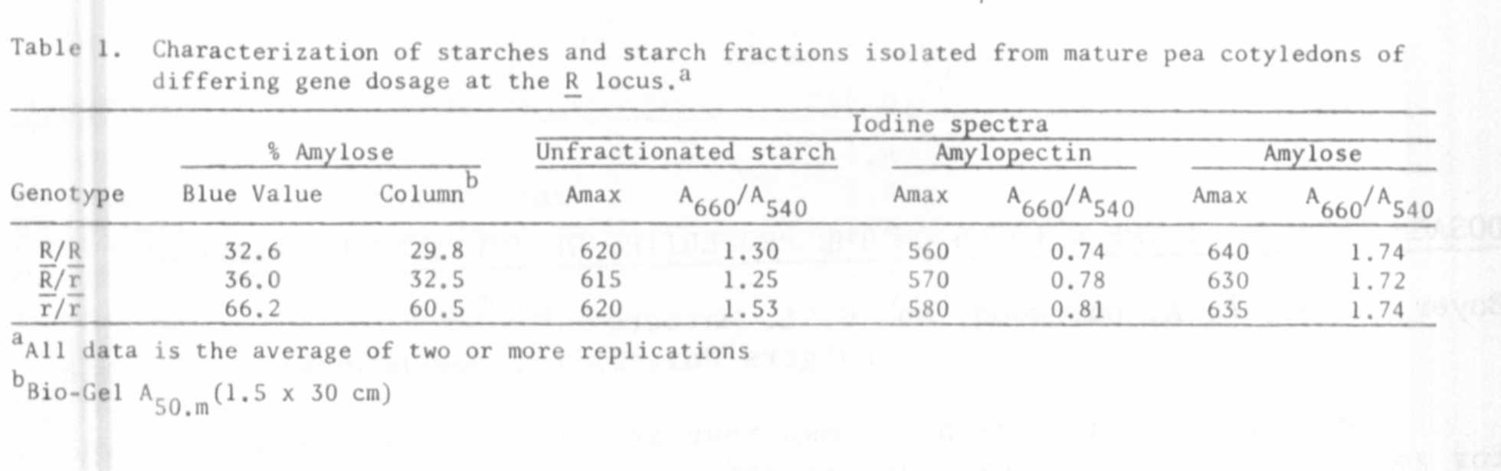

Any model of molecular action of the gene product of the r locus must
also account for the above observed qualitative changes in the arnylopectin
fraction of the starch. Although it is clear that soluble phosphorylase
activities are different in R/R and r/r seeds (Williams, PNL 11:36), it is
less clear how this difference can account for the observed differences in
the amylopectins. We are presently examining the effects of the R locus
on other starch metabolizing enzymes, namely starch synthase and branching
enzyme.

^{1/}
^{1/} This work was performed under New Jersey AL:S Project 12442.

