INHERITANCE OF PROTEIN CONTENT IN PEA
II. HERITABILITY OF PROTEIN CONTENT IN RANGER X STRAL AND PALOMA X STRAL CROSSES

Swiecicki, W.K., Z. Kaczmarek, Plant Experiment Station, Wiatrowo, Poland
and M. Surma Institute of Plant Genetics, Poznan, Poland

On the basis of breeding data obtained in the past, three varieties were
chosen for studies, viz. 'Ranger¹, 'Stral' and 'Paloma'. The breeding data
showed some strains with a higher protein content (WTD 4011 and WTD 4015),
originating from crosses where one of the parents was the variety Ranger or
Stral. Paloma lias a low protein content, but is among the highest yielding
varieties in Poland. Crosses were made between varieties Ranger x StrSl and
Paloma x Stral. The F1, F2, BC1, BC2, and parents were tested in each cross.
Protein content was analyzed in single seeds by the Kjehldal method.
To assess the degree of genetic control over the protein content in the
seeds, heritability coefficients were estimated in a narrow and a broad sense.
The heritability coefficient estimate in the broad sense was calculated by
a commonly used formula, i.e. by estimating the variance of the F2 and that
of the parents. The value of this coefficient for the cross Ranger x Stral
was 79.8% and that for Paloma x Stral 78.0%.
From the point of view of breeding it is far more interesting to know
the heritability coefficient estimate in the narrow sense, expressed by the
additive to phenotypic variance ratio (Mather and Jinks, 1971). It is possible
to estimate this coefficient when gene action in a given cross is additive-
dominance (Kaczmarek, Surma, and Swiecicki, in press). The adequacy of the
additive-dominance model of gene action was tested using the significance
of differences between the observed and expected means for the analyzed genera-
tions (Chi square statistics). The results are presented in Table 1.
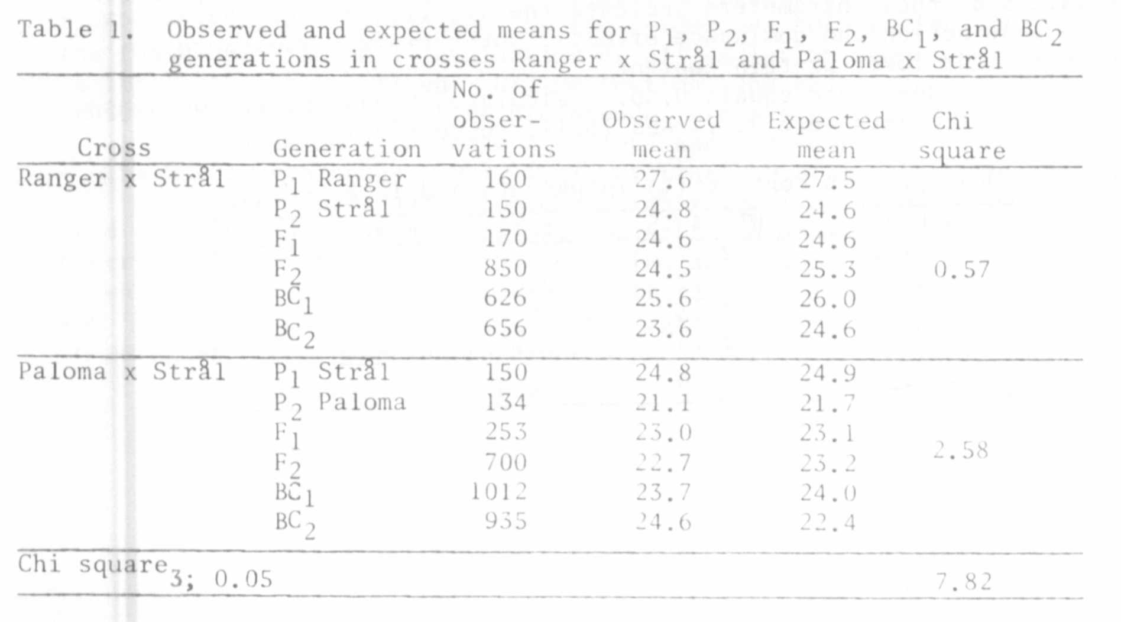

RESEARCH REPORTS 2
PNL Volume 12 1980

Since in both crosses the calculated Chi square values were lower than
the critical values of Chi squareg 05 there is no foundation to reject the
hypothesis of the additive-dominance model of gene action.
Table 2 presents estimates of additive ([d]) and dominant ([fi]) gene
action and of the mean (m), including standard errors as well as the herit-
ability coefficients in the narrow sense (A_{ns}). The effects of additive
gene action are similar in the two crosses. Marker differences, however, are
noted for the effects of dominance.
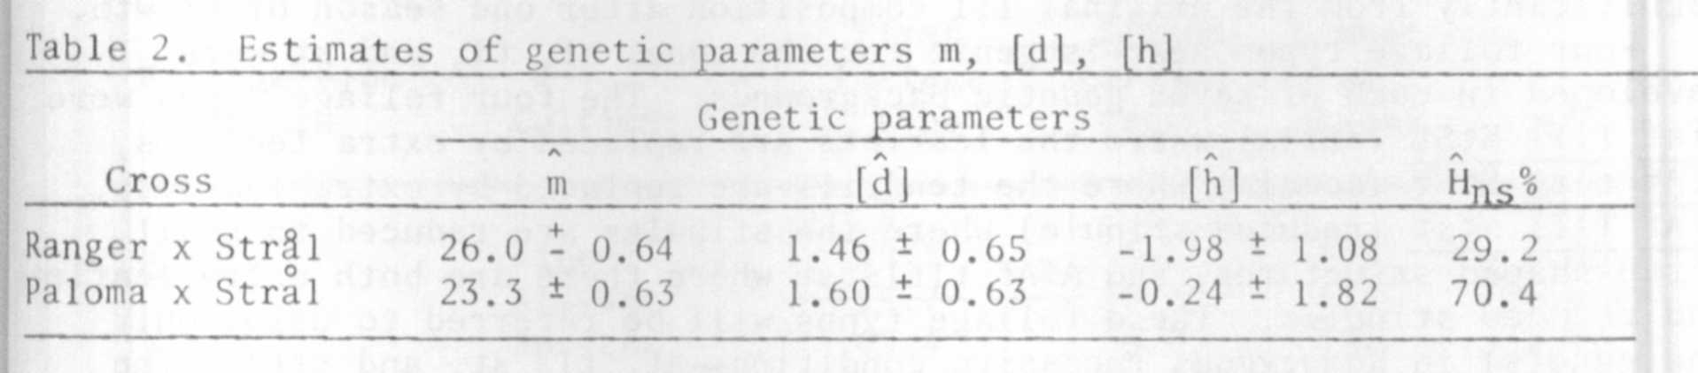

Though dominance was well indicated in the lower protein content in both
crosses, the cross Ranger x Stral, i.e. between high and medium protein
varieties, showed a much greater effect of dominance than the cross Paloma
x Stral. This is reflected in the narrow sense heritability coefficients.
The results suggest that in breeding for high protein content the desired
results may be better and easier to obtain when varieties with medium protein
content are crossed.

