INDUCTION OF CHROMOSOME DUPLICATIONS IN PEAS

Saccardo, F. and N. La Gioia Center of Nuclear Studies, Rome, Italy
and L. M. Monti University of Naples, Portici, Italy

There is general agreement among geneticists that chromosome duplica-
tions may provide an important source of new genetic material. For this
reason, the production of duplications is considered as a plant breeding
technique. Hagberg (Hereditas 48:243-246, 1962) used translocation lines
to induce duplications in barley. In our experiments we obtained pea lines
with duplicated chromosome segments by using lines with dicentric chromo-
somes .
After pollen irradiation of the fodder pea 'Parvus', some variegated
mutants were obtained in M1 which in M2 segregated different phenotypes.
Only after cytological characterization of the variegated mutants was this
abnormal segregation explained on the basis of the behavior of some unstable
chromosomes which were present in this material. Variegated phenotype is
characterized by leaves with irregular margins and with small light-green
spots and variable thickness of the veins; lighter areas are due to lack of
palisade tissue and of chloroplasts.
Cytological analysis of such variegated mutants has shown a mixochimeric
structure due to the presence of dicentric chromosomes which can go through
"breakage-fusion-bridge" cycles. Dicentric chromosomes found in pea mutants
were demonstrated to be persistent and transmissible also through male
gametes. At meiosis the dicentric chromosomes gave rise to associations
with their homologues. From the disjunction of such associations normal
gametes, aneuploid gametes, or gamates with dicentrics can be formed; by
breakage of dicentric chromosomes in anaphase I and II deleted or duplicated
chromosomes can also be produced.
On the basis of such findings and considerations, the progenies des-
cending from four M^ variegated mutants (2n=12+l dic.+l telo.) isolated
after X-irradiation of pollen of the canning variety 'Sprinter', were
examined with particular care. Three different phenotypes were found in
M₇ corresponding to three different genomes: normal phenotype with 14 chromo-
somes, variegated phenotype with dicentric chromosomes, and abnormal types
which were found to be aneuploids (partial trisomies).
The progenies of the normal plants were carried into succeeding genera-
tions, with the same selection procedure as the mutant plants. In M6
two lines descending from such material showed good yield and better processed
quality than the mother line. Two longer chromosomes were found at the
mitotic metaphase in both lines. No translocations were found in the meiotic
analysis of F1 plants obtained after crossing the two lines with the mother
variety. The pollen and the pod fertility in F1 was normal (Table 1),
so it was concluded that the longer chromosomes had some duplicated segments.
The two lines with chromosome duplication will be analyzed for different
parameters, mainly disease resistance and chemical characters of the seeds,
in order to check any possible effect of these chromosome rearrangements
in the Sprinter background and also, by crossing, in other genetic backgrounds.

RESEARCH REPORTS 2
PNL Volume 12 1980

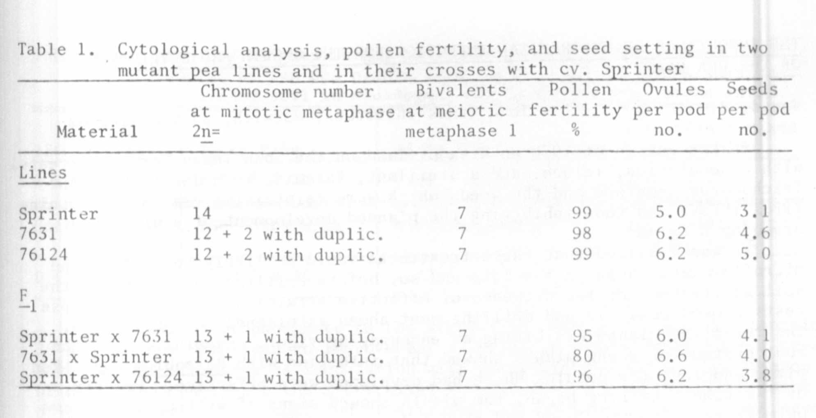

1C

