RESEARCH REPORTS 1
PNL Volume 12 1980

THE MAP DISTANCE BETWEEN THE e AND wlo LOCI

Murfet, I.C. Botany Department, University of Tasmania, Hobart, Australia

The presence of locus e_ on chromosome 6 was first indicated by
linkage between e and p (2). Subsequently, testcross data involving genes
e, p and pl revealed the gene order to be e-p-pl (4) The observed
crossover value of 28% between e_ and p placed the e locus at the upper
extremity of chromosome 6 above the existing uppermost marker, wlo. The
joint segregation data in Table 1 indicate a distance of 26 units between
e and wlo. The map of chromosome 6 as drawn by Blixt (1) is therefore
extended by that amount. The data in Table 1 were obtained by crossing
line 60 (lf E Sn hr Wlo) to segregates with the genotype lf e Sn hr wlo in
the F₃ of cross 256 (L31 x L58).
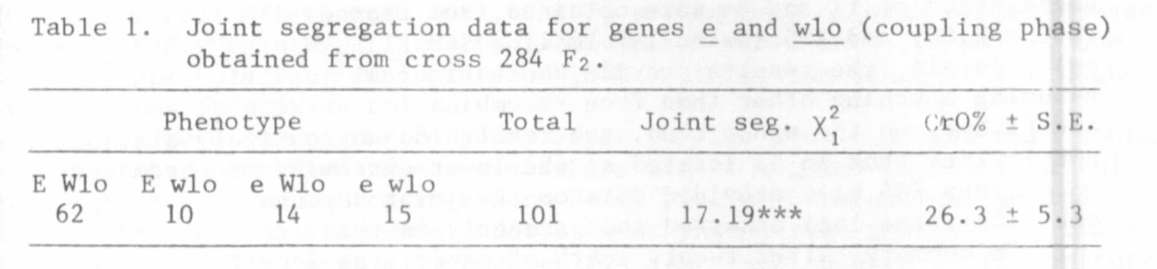

Although the position of the e locus is now established, the locus
itself has certain disadvantages as a marker. Firstly, the E/e segrega-
tion is only apparent with certain combinations of the major flowering
genes, e.g. it is obscured by the epistatic action of the genes Lf and Lf(2,5). These higher alleles in the l_f series are in fact very common.
Secondly, the variable penetrance of Sn(with respect to flowering node)
means that with certain polygenic backgrounds genotype lf e Sn hr can
flower at a low node and may therefore be confused with lf E- Sn hr (2).
Thirdly, a single dose of E is sometimes insufficient to overcome the
latening action of Sn and segregates of genotype lf Ee Sn hr may flower at
a high node and thus be confused with the penetrant lf e Sn hr plants (5).
The last two situations can often be resolved by growing F3. Such was the
case in Cross 284 where, fortunately, the penetrance of Sn was very close
to one but about 25% of Ee heterozygotes escaped from the early class.
These escapes were readily identified in F₃. Finally, as with the other
flowering genes, observation of an E/e segregation is facilitated by the
use of controlled environment conditions. However, special conditions are
not necessarily obligatory (3).

1. Blixt, S. 1972. Agri Hort. Genet. 30:46-47.
2. Murfet, I.C. 1971. Heredity 27:93-110.
3. Murfet, I.C. 1975. PNL 7:41-2.
4. Murfet, I.C. 1977. PNL 9:38.
5. Murfet, I.C. 1978. PNL 10:48-52.

