Comparative agronomic and technological trials, performed in different
Italian districts, confirmed the improved nature of the two mutant lines,
mainly for some qualities of the processed product, such as taste and color.
The certification procedure has already been started to release the two lines
as new varieties.
Comparison of the results between the two treatments seems to indicate
that pollen treatment probably induces a higher rate of the so-called point
mutations than seed treatments. This is substantiated 1) by the lower rate
of chlorophyll mutations, which are mainly attributed to chromosomal mutations,
and 2) by the higher number of high yielding lines selected from M5, on.
The higher rate of point mutations induced by pollen treatments in comparison
with seed treatments is probably due to the sieve action of the haplontic
selection at the moment of the M1 zygote formation.

ISOLATION OF THE STORAGE PROTEINS OF PEA SEEDS

MUller, H. P. Institute of Genetics, University of Bonn, West Germany

Legume cotyledons accumulate during their development both albumins
and globulins. The latter constitute a protein reserve deposition which
serves the nutritional requirements of the developing embryo during germination.
The incorporation of proteins into the cotyledon is governed by a genetically
regulated protein-synthesizing system, the mechanism of which is unknown.
The globulins are proteins with particular physical properties exhibiting
heterogeneity with regard to their subunit composition. Since most of the
cotyledon proteins are coded for by nuclear DNA of the embryo, the storage
proteins constitute an especially valuable system for analyzing the control
mechanism of the genome as well as the physiological influence of the seed-
bearing plant.
For understanding the controlling mechanism responsible for the synthesis
of specific proteins in the cotyledons we first must have an idea of the
different protein species found within the seeds. Then it is important to
isolate, purify, and finally to biochemically characterize those proteins
in detail.
Using SDS-gel-electrophoresis for analyzing the purified globulin frac-
tion of pea seeds, one obtains a genotype-specific polypeptide pattern.
Analyzing seeds of mutants of the same variety presents considerable
difficulties witli regard to quantitative extraction of proteins. The:extrac-
tion methods commonly used for Phaseolus and Vicia are not well suited for
extracting Pisum seed proteins. Therefore, it was necessary to develop an
extraction method especially adapted for pea seed proteins: the proteins
were first extracted at the isoelectric point (IEP) at low salt concentration
(acid extraction), then under alkaline conditions. This procedure allowed
100% recovery. Sucrose gradient analysis of the two extracts resulted in
two dilution profiles as demonstrated in Fig. 1.
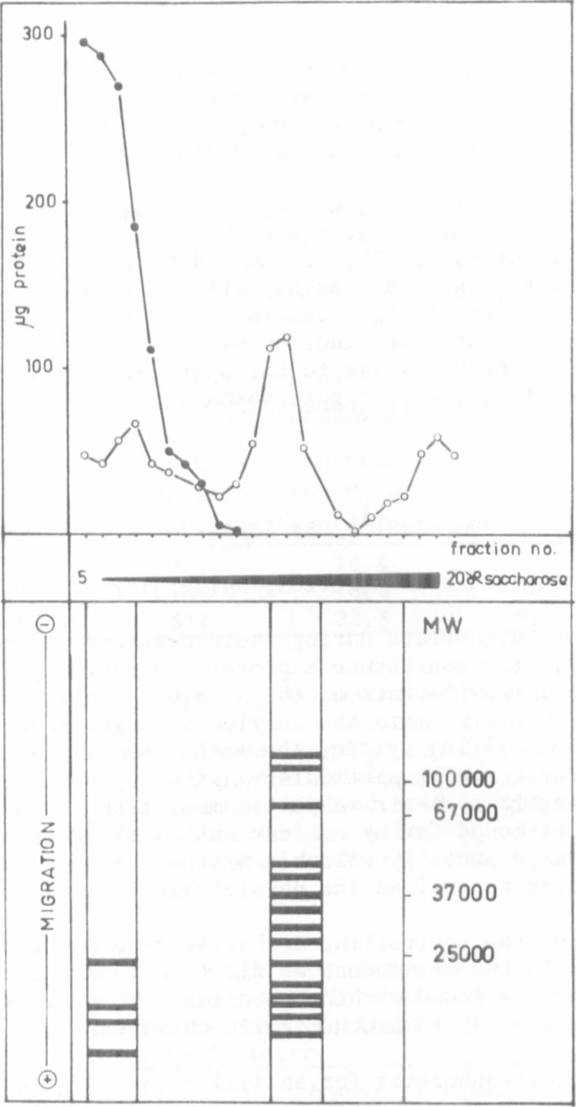
Fig. 1. Isolation and characterization of the seed globulin fraction.
(Above: elution profiles of fractions 1 and 2; below: electro-
phoretic polypeptide patterns of fractions 1 and 2).
In this way two clearly separated fractions were obtained. Analysis
by means of SDS-gel-electrophoresis showed each fraction to have a distinct
sublimit pattern (Fig. 1, lower part). The scale on the far left denotes
the movement of proteins in the gel, that on the far right that of the marker
proteins. The left-hand drawn fraction consists of four, the right-hand
fraction of 15 clearly distinguishable subunits. The polypeptide composition
of these fractions differ from each other. The complexity of the polypeptide
composition of both fractions is astonishing. Further investigations, including
a broader range of genotypes, are necessary for evaluating more accurately
the nature of this diversity.

