PNL Volume 12 1980
1 RESEARCH REPORTS

PEA MUTATIONS OF PRACTICAL VALUE

Monti, L. M., University of Naples, Portici, Italy
F. Saccardo, and P. Vitale Center of Nuclear Studies, Rome, Italy

By comparing mutagenic treatments on seed and on pollen of the canning
variety 'Sprinter', and by classifying all the mutations found in M2 for
chlorophyll and morphological mutations (Table 1), a higher frequency of
the latter types was found after pollen treatments (82.5%) than after seed
treatments (less than 36.5%).

Table 1. Frequency of mutations induced in variety Sprinter after treatment
of uollen and of seed with mutagenic agents.
Irradiation  on | Mutagenic  agent | Mi plant  analyzed  (no.) | Mutations  per Mj plant  (%) | Relative frequency  of mutations  Chlorophyll Morphological  (%) (%)
Pollen | X-rays | 271 | 14.8 | 17.5 | 82.5
Seed | X-rays | 1107 | 16.0 | 80.3 | 19.7
 | DS | 372 | 22.3 | 63.8 | 36.2

The progenies of the morphological mutants isolated in M2 after seed
and pollen treatments were analyzed in succeeding generations, the same
selection procedure being followed from M2 on. In M3, only mutations which
could have a practical interest were considered, e.g. mutations for height,
flowering time, fertility, pod length, and seed weight and size. From M4
on, only lines with agronomic merit were selected. In M8 only two lines,
both derived from pollen-irradiated material, were superior to the control
varieties in yield (Table 2).
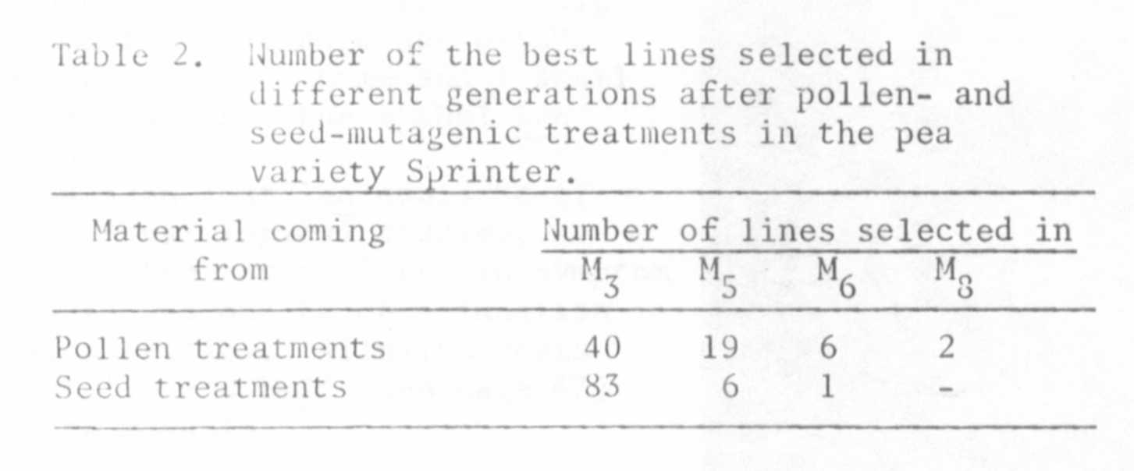

Comparative agronomic and technological trials, performed in different
Italian districts, confirmed the improved nature of the two mutant lines,
mainly for some qualities of the processed product, such as taste and color.
The certification procedure has already been started to release the two lines
as new varieties.
Comparison of the results between the two treatments seems to indicate
that pollen treatment probably induces a higher rate of the so-called point
mutations than seed treatments. This is substantiated 1) by the lower rate
of chlorophyll mutations, which are mainly attributed to chromosomal mutations,
and 2) by the higher number of high yielding lines selected from M5, on.
The higher rate of point mutations induced by pollen treatments in comparison
with seed treatments is probably due to the sieve action of the haplontic
selection at the moment of the M1 zygote formation.

ISOLATION OF THE STORAGE PROTEINS OF PEA SEEDS

MUller, H. P. Institute of Genetics, University of Bonn, West Germany

Legume cotyledons accumulate during their development both albumins
and globulins. The latter constitute a protein reserve deposition which
serves the nutritional requirements of the developing embryo during germination.
The incorporation of proteins into the cotyledon is governed by a genetically
regulated protein-synthesizing system, the mechanism of which is unknown.
The globulins are proteins with particular physical properties exhibiting
heterogeneity with regard to their subunit composition. Since most of the
cotyledon proteins are coded for by nuclear DNA of the embryo, the storage
proteins constitute an especially valuable system for analyzing the control
mechanism of the genome as well as the physiological influence of the seed-
bearing plant.
For understanding the controlling mechanism responsible for the synthesis
of specific proteins in the cotyledons we first must have an idea of the
different protein species found within the seeds. Then it is important to
isolate, purify, and finally to biochemically characterize those proteins
in detail.
Using SDS-gel-electrophoresis for analyzing the purified globulin frac-
tion of pea seeds, one obtains a genotype-specific polypeptide pattern.
Analyzing seeds of mutants of the same variety presents considerable
difficulties witli regard to quantitative extraction of proteins. The:extrac-
tion methods commonly used for Phaseolus and Vicia are not well suited for
extracting Pisum seed proteins. Therefore, it was necessary to develop an
extraction method especially adapted for pea seed proteins: the proteins
were first extracted at the isoelectric point (IEP) at low salt concentration
(acid extraction), then under alkaline conditions. This procedure allowed
100% recovery. Sucrose gradient analysis of the two extracts resulted in
two dilution profiles as demonstrated in Fig. 1.

