1 RESEARCH REPORTS PNL Volume 12 1980

A MUTANT CAUSING NECROSIS OF THE LEAFLET MARGINS

Marx, G. A. New York State Agricultural Experiment Station, Geneva, NY USA

An EMS-induced mutant, marked by necrotic spots on the leaflet margins,
is still another of a series of mutants obtained through the kind cooperation
of L. G. Cruger. The spots generally appear on leaves borne at the 4th
to 7th node of the seedling when the plant is in the 6th to 10th node stage
of development. Thus, the disorder progresses acropetally as the seedling
develops but there is a lag between the appearance of new leaves and the
onset of the symptoms. Initially the spots are small and brown; later they
enlarge, coalesce, and turn yellowish brown, then nearly white. The condition
strongly resembles some disorders caused by mineral deficiency (Fig. 1).
Although affected plants are weaker and less productive than normal, the
disorder is not lethal.
The time and node that the symptoms appear is variable and appears con-
ditional upon specific environmental conditions. This conclusion is drawn
from having grown the original mutant on at least ten different occasions
in the greenhouse and field since 1977. Field conditions are generally
more conducive to strong symptom expression than greenhouse conditions,
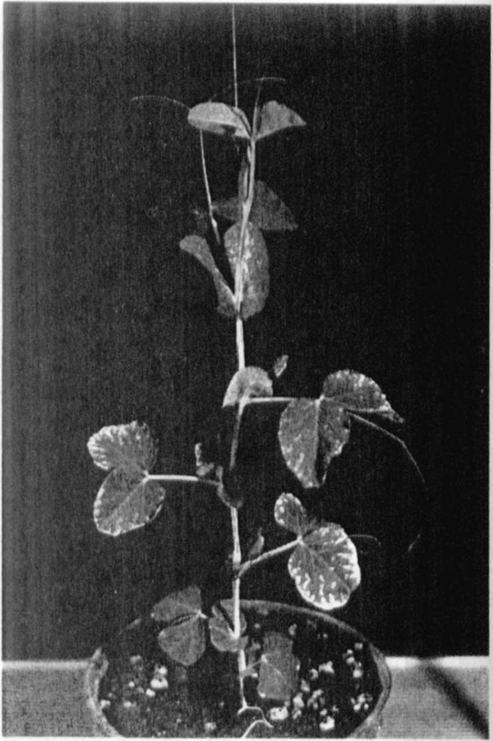
but it is not known what environmental
component or combination of components
may be responsible for the differences.
The mutant behaves as a recessive
but the segregation ratios may be
disturbed by a deficiency of recessives
(Table 1 a). However, some populations
may yield good 3:1 ratios (Table 1 b).
The populations in which fewer than
expected mutant segregants were recovered
were grown in the greenhouse. Attempts
to determine the linkage relations have
not yet succeeded. The original designa-
tion by Cruger, "leaf edge necrosis",
seems appropriate as a name and I shall
provisionally suggest the symbol len
for this mutant.
It would seem that len could be of
interest in physiological studies,
especially if the variability in symptom
expression turned out to be a function
of mineral nutrition. Allelism tests
showed that len and bulf (see page 47)
are separate mutants.
Fig. 1. Seedling showing necrotic
leaflet margins caused by
the mutant len.

RESEARCH REPORTS 3
PNL Volume 12 1980

