1 RESEARCH REPORTS
PNL Volume 12
1980

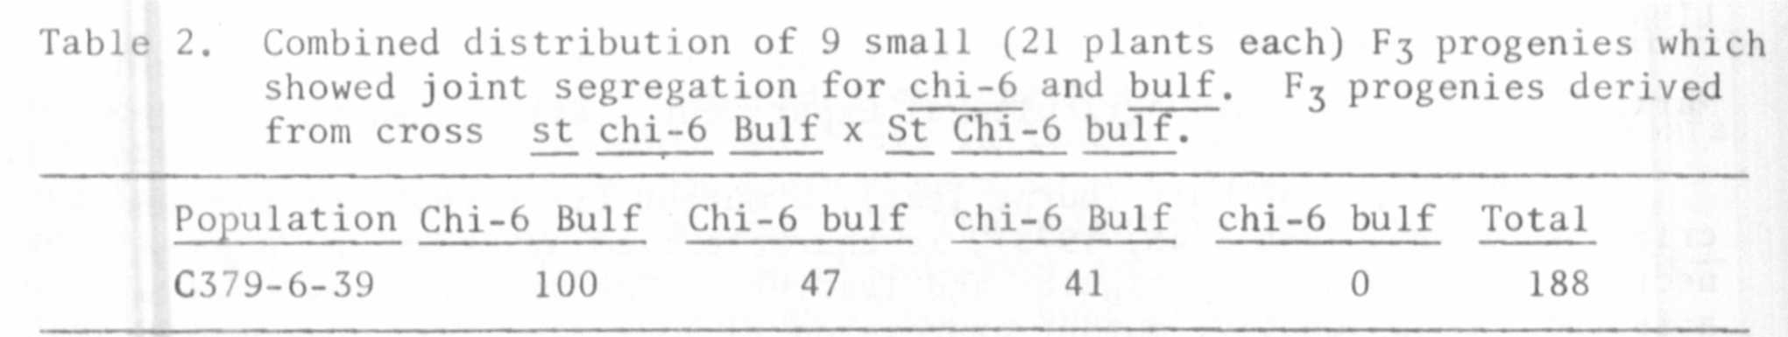
New crosses have been initiated to get corroborating evidence and
improved estimates of linkage not only between bulf and chi-6 and s_t, but
also between bulf and other markers on chromosome 3.
The estimate of percent recombination between sjt and chi-6 was 37-5,
which is consistent with estimates presented earlier (PNL 5:26) and with
other evidence obtained in 1979 but not reported.

LINKAGE: RELATIONS OF A MUTANT CONFERRING MECHANICAL STERILITY

Marx, G. A. New York State Agricultural Experiment Station, Geneva, NY USA

After treating one of his lines with EMS, L. G. Cruger recovered a
mutant which affects floral morphology and reproductive behavior. Subse-
quently he made seeds of the mutant available to me.
Mutant behavior is, in a number of respects, similar to that of crpt
(crumpled petal), a mutant isolated and described by Sharma and Aravindan
(PNL 3:50-51, 1971). Flowers are characterized by exserted pistils and
crumpled petals and stamens. This abnormal floral morphology leads to
mechanical sterility because the anthers are denied close proximity with
the stigma. Still, based on the description of crpt, the two mutants appear
to have some important dissimilarities. Unlike crpt, the plants are not
waxless, fertility of selfed plants apparently is normal, and flowers are
not typically "ball-shaped".
Plants homozygous for this recessive gene may show a range of mutant
expression. Sterility appears to be enhanced under field conditions, whereas
greenhouse conditions seem to promote more normal floral morphology and
greater fertility (occasionally completely normal). Typically in the green-
house the flowers are near normal in size, the corolla is more or less
tubular when fully open, and the banner is not reflexed backward. The keel
may be rather sharply curled and the filaments of the stamens compressed
and twisted at the apex of the keel. Depending on the specific conditions,
the pistil may or may not extrude from the keel.

RESEARCH REPORTS 3
PNL Volume 12 1980

Even in the field, where conditions are generally favorable for mutant
expression, and where sterile plants can easily be distinguished from normal
sibs in segregating populations, sterile plants occasionally produce a few
seeds. Progeny tests revealed that such seed was a product of selfing.
In general, the flowers borne at the higher reproductive nodes have a greater
tendency to produce selfed seed. In this and some other respects, mutant
behavior resembles the mutant re (infecunda) reported by Nilsson (Hereditas
17:71-99, 1932; see also Lamprecht, Agr Hort. Genet. 18:181-204, 1960).
Thus, given the uncertainty of identity among crpt, re, and the Cruger mutant,
a name and symbol for the latter will not be suggested pending the outcome
of allelism tests. The designation "mes" is only a working symbol for
convenience.
In crosses between the Cruger mutant and normal fertile lines, the
F1's were fertile and the F2 ratios were in accord with monogenic control.
There was no indication of the deficiency of recessives as was noted by
Nilsson and by Lamprecht for re. Moreover, there is rather clear evidence
of linkage with af on chromosome 1 (Table 1). Lamprecht (1960) found re
to be loosely linked (ca. 35-40% CrO) with A on chromosome 1, but the
contingency chi-square for linkage between A and the Cruger mutant did not
reach statistical significance in one small population of 212 plants (Table 1
