RESEARCH REPORTS 1
PNL Volume 12 1980

LINKAGE RELATIONS OF bulf

Marx, G. A. NYS Agricultural Experiment Station, Geneva, NY USA

The phenotype of bulf (burnt leaf), a mutant first isolated and des-
cribed by Sharma (PNL 5:46, 1973), is characterized by brownish, papery,
necrotic margins of the stipules and leaflets. The tendrils may also be
affected. Occasionally, mutant expression is so slight that some mutant
segregants can be taken as normal unless carefully scrutinized. Usually,
however, homozygous recessive segregants can be readily discerned, even in
the early seedling stage, and, although the adult plants may be weaker than
normal, they produce adequate amounts of seed. Hence, bulf is a valuable
seedling marker.
We originally obtained the type line for bulf, WL 5872, from Dr. Blixt
for the purpose of testing it for allelism with a somewhat similar mutant
with which we have been working (see page 52). Then we began a search for
the linkage relations of bulf. In the combined F₂ populations in which bulf
showed no linkage with the markers tested, the following segregation ratio
was observed: Bulf 263 : bulf 105 (X²[3:1]=2.45^{ns}), indicating monogenic
control with good penetrance. Evidence for linkage was detected in one
small F₂ population involving chromosome 3 markers (Table 1). This was
a three-point cross but two genes, st and chi-6, were in coupling whereas
bulf was in repulsion. The cross yielded no chi-6-bulf recombinants and
only 3 st-bulf recombinants in a total of 155 plants. F3 progenies consis-
ting of 21 seeds each from 22 different chi-6/chi-6 Bulf- F₂ plants produced
3 F3 progenies segregating for bulf. Recombination between chi-6 and bulf
based on these results is estimated as 7-4%. Among 25 st/st Bulf/- I
plants progeny tested, 11 F3 progenies segregated for bulf. The estimated
recombination between st and bulf was 28-8% based on F3 data and 26±7% based
on F2 data.
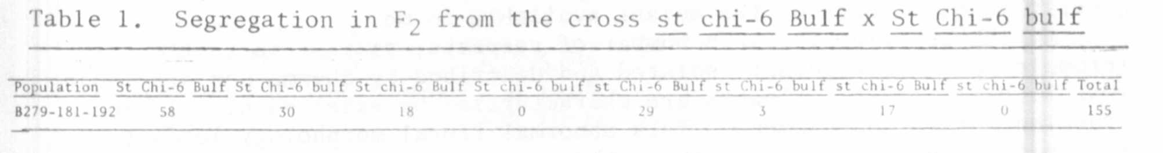
Nine of the F3z progeny test families segregated for both chi -6 and
bulf, giving the combined joint segregation shown in Table 2. Again, as in
the F2, no chi-6 bulf recombinants were recovered in a total of 188 plants.
Taken together, the data are consistent in showing a moderately strong linkage
between bulf and chi-6 and a less strong but fairly clear linkage with st.

3 RESEARCH REPORTS
PNL Volume 12
1980

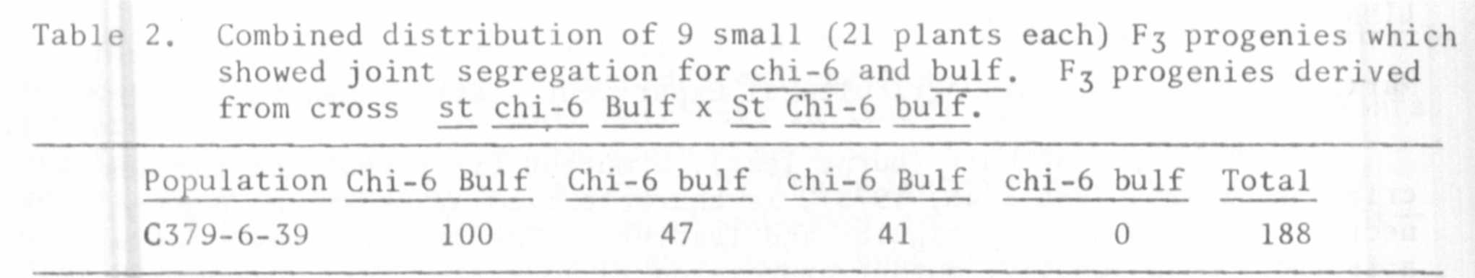
New crosses have been initiated to get corroborating evidence and
improved estimates of linkage not only between bulf and chi-6 and s_t, but
also between bulf and other markers on chromosome 3.
The estimate of percent recombination between sjt and chi-6 was 37-5,
which is consistent with estimates presented earlier (PNL 5:26) and with
other evidence obtained in 1979 but not reported.

LINKAGE: RELATIONS OF A MUTANT CONFERRING MECHANICAL STERILITY

Marx, G. A. New York State Agricultural Experiment Station, Geneva, NY USA

After treating one of his lines with EMS, L. G. Cruger recovered a
mutant which affects floral morphology and reproductive behavior. Subse-
quently he made seeds of the mutant available to me.
Mutant behavior is, in a number of respects, similar to that of crpt
(crumpled petal), a mutant isolated and described by Sharma and Aravindan
(PNL 3:50-51, 1971). Flowers are characterized by exserted pistils and
crumpled petals and stamens. This abnormal floral morphology leads to
mechanical sterility because the anthers are denied close proximity with
the stigma. Still, based on the description of crpt, the two mutants appear
to have some important dissimilarities. Unlike crpt, the plants are not
waxless, fertility of selfed plants apparently is normal, and flowers are
not typically "ball-shaped".
Plants homozygous for this recessive gene may show a range of mutant
expression. Sterility appears to be enhanced under field conditions, whereas
greenhouse conditions seem to promote more normal floral morphology and
greater fertility (occasionally completely normal). Typically in the green-
house the flowers are near normal in size, the corolla is more or less
tubular when fully open, and the banner is not reflexed backward. The keel
may be rather sharply curled and the filaments of the stamens compressed
and twisted at the apex of the keel. Depending on the specific conditions,
the pistil may or may not extrude from the keel.

