FASCIATION AND HETEROSIS IN PEA

Lonnig, W. E.
Institute of Genetics, Bonn, Federal Republic of Germany

Under the climatic conditions of Central Europe, our fasciated mutant
489 C always causes a strong heterotic effect in stem length, seeds per plant,
and other characters when crossed with the initial line (IL) 'Dippes gelbe
Viktoria', other lines, or different mutants (Fig. 1). Mutants 251 A, 123,
and other fasciated forms genetically comparable with mutant 489 C cause a
similar, but in some cases clearly weaker, heterotic effect (2).
As perhaps more than 15 genes are mutated in
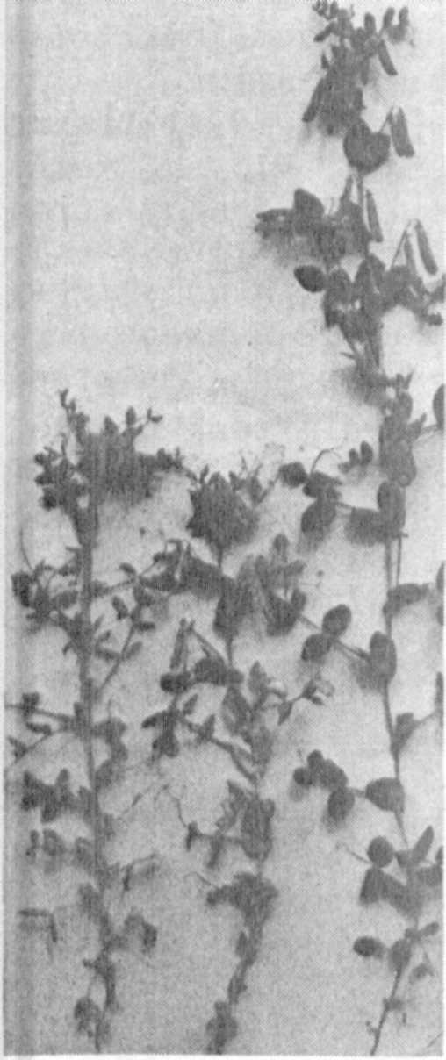
489 C, it is not possible to say prima facie whether
Fig. 1.
one or more of the genes causing fasciation or other
unrelated mutant genes contribute to the heterotic
effects. Nor is it clear whether the phenomenon
is caused by a) heterozygosity per se, b) dominant
factors "hidden" or impeded by detrimental recessive
genes in the same mutant [most of the 15 genes have
mutated to the recessive state, as, for instance,
the genes for fasciation, but a few of them are
dominant in relation to the IL, as lateness in
flowering and ripening, sensitivity to day length
(4), and, perhaps, the genes for increased stem
length], c) gene interactions, or d) a combination
of the above.
In seeking answers to these questions, we used
the following mutants and recombinants for our
studies (all forms are derived from Dippes gelbe
Viktoria): a) strongly fasciated mutants 489 C,
33 A, b) linearly fasciated mutant 251 A, c) linearly
fasciated recombinants R 859 (derived from 123 x
46 C), R 661 (derived from 489 C x 26), and R 667
(derived from 489 C x 169), d) weakly fasciated
recombinants, stem bifurcated, R 161 (derived from
489 C x 1201 A) and R 177 (derived from 489 C x
1202 A), e) other mutants 176 A—narrow leaves,
flowers, and pods, 1201 A—stem bifurcated, 1001 —
489C
x
1201A
thousand-grain weight increased.

489C 1201A
The results of these crosses are shown in Fig. 2
and can be summarized as follows: a) 33 A, R 161,
R 661, and R 859 do not cause heterosis; the small
deviations are well in the range of the IL. This
means that the genetic causes for strong, linear, and weak fasciation are
not necessarily correlated with the heterotic effects, b) R 177 x IL, etc.,
do not show heterosis in length although the character "seeds per plant" seems
to show significant heterosis. For final analysis the crosses should be
repeated with more extensive material. If verified, there would be no strict
correlation between heterosis in length and yield, c) linearly fasciated
R 667 seems to cause a strong heterotic effect, comparable to that of 489 C
x IL, etc. However, 667 x IL is not very representative as we had only nine
plants in F1. According to the results, under a) the genetic cause for fas-
ciation may not be the direct cause of this heterosis either.
Segregation: Wherever a marked heterosis effect was evident in F1, all the
segregations studied so far in F2 showed a majority (sometimes more than three-
quarters) of plants as long as the F1 hybrids. However, a simple 3:1 segre-
gation is excluded by several hypostatic genes segregating for shorter plants
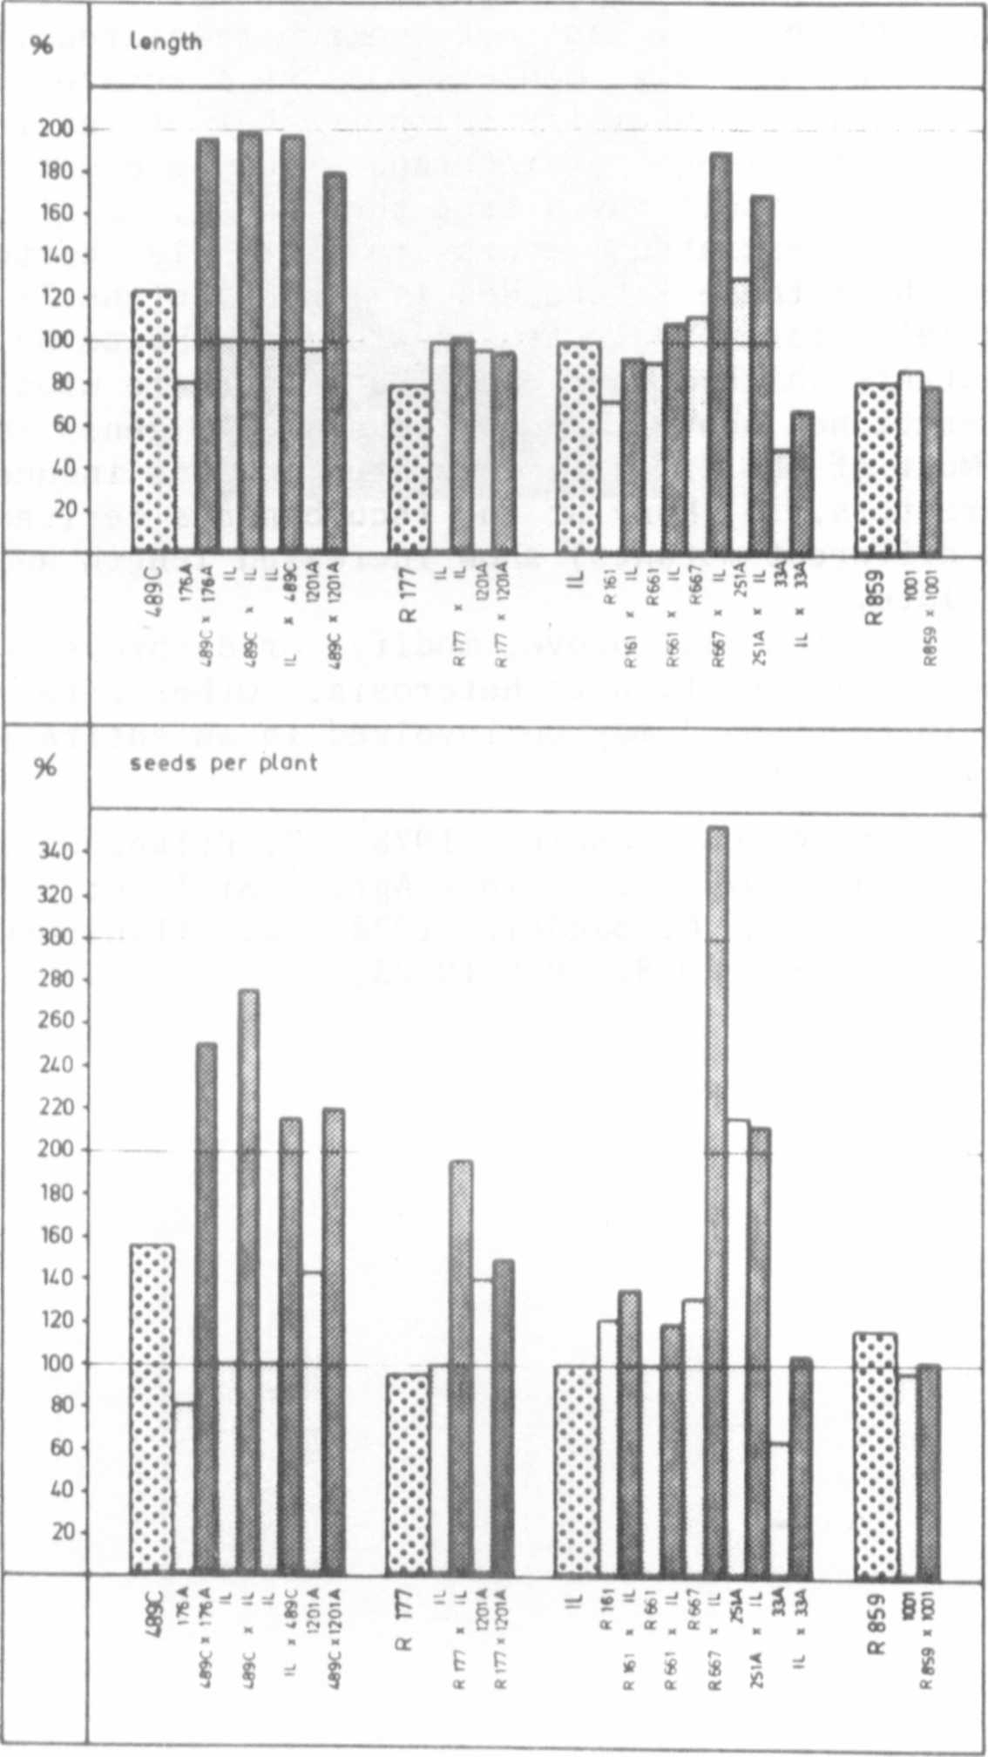
Fig. 2. F1's of the crosses
of different length.
The following facts seem to support the working hypothesis for special
importance of the genes for increased stem length and, perhaps, lateness:
1) Where there was no detectable heterosis in length in the F1, no long plants
were found in F2; unusual length doesn't seem to be a simple hypostatic
factor. None of these F1's was late. 2) The height of the hybrids was, of
course, a function of internode number and—even more important in this case—
internode length. Keeble and Pellew (1910) found both characters to show
dominant inheritance in crosses between non-fasciated lines. The situation
is, however, sometimes very complex. 3) The fasciated mutants causing hetero-
sis show an increase, especially in the number of internodes (Milutinovic,
1972), but the total length of internodes may be counteracted by recessive
genes. Fasciation itself may affect the length. Since the uppermost inter-
nodes of strongly fasciated mutants are extremely shortened, one could imagine
that the length of these internodes is longer in the F1 as a result of the
action of alleles for normal stem growth contributed by the IL. Strongly
fasciated mutants which do not cause heterosis are usually smaller than the
IL and, as mentioned above, may not possess the genes for special length and
lateness. Most of the linearly fasciated mutants induce weaker heterosis
in many characters. 4) Many of the recombinants derived from crosses of 489
C x IL (and different mutants) show increased length and yield (3, 4). Most
of them are late.
Further research will prove, modify, or disprove some of the above-
mentioned points in relation to heterosis. Other determinants (heterozygosity
and/or gene interactions) may be involved in an entirely satisfying explanation
of this case of heterosis.

1. Bandel, G. and W. Gottschalk. 1978. Z. Pflanzenzuchtg. 81:60-76.
2. Gottschalk, W. 1977. J. Nuclear Agric. Biol. 6:27-33.
3. Gottschalk, W. and G. Bandel. 1978. Z. Pflanzenzuchtg. 80:117-128.
4. Hussein, H. A. S. 1978. PNL 10:23.

