1 RESEARCH REPORTS PNL Volume 12 1980

CORRELATION COEFFICIENTS AMONG SUGAR, PROTEIN, AND YIELDS IN NINE LINES OF PEA

Krarup, A. Universidad Austral de Chile, Valdivia, Chile

Total sugars and protein, as well as yields at the green and dry pea
stages, were determined for 5 varieties ('Cobri', 'Wando', 'Triofin', 'Cob-
rette', and 'Vitalis') and 4 F9 lines. Total sugars were determined by
McCready's et al. method (1) (expressed as glucose) and protein by micro-
Kjeldahl (x factor 6.25), both on a dry matter basis.
The correlation matrix for sugars, protein, and yields showed, as ex-
pected, a high significant correlation between green and dry pea yields
(r = 0.91**).
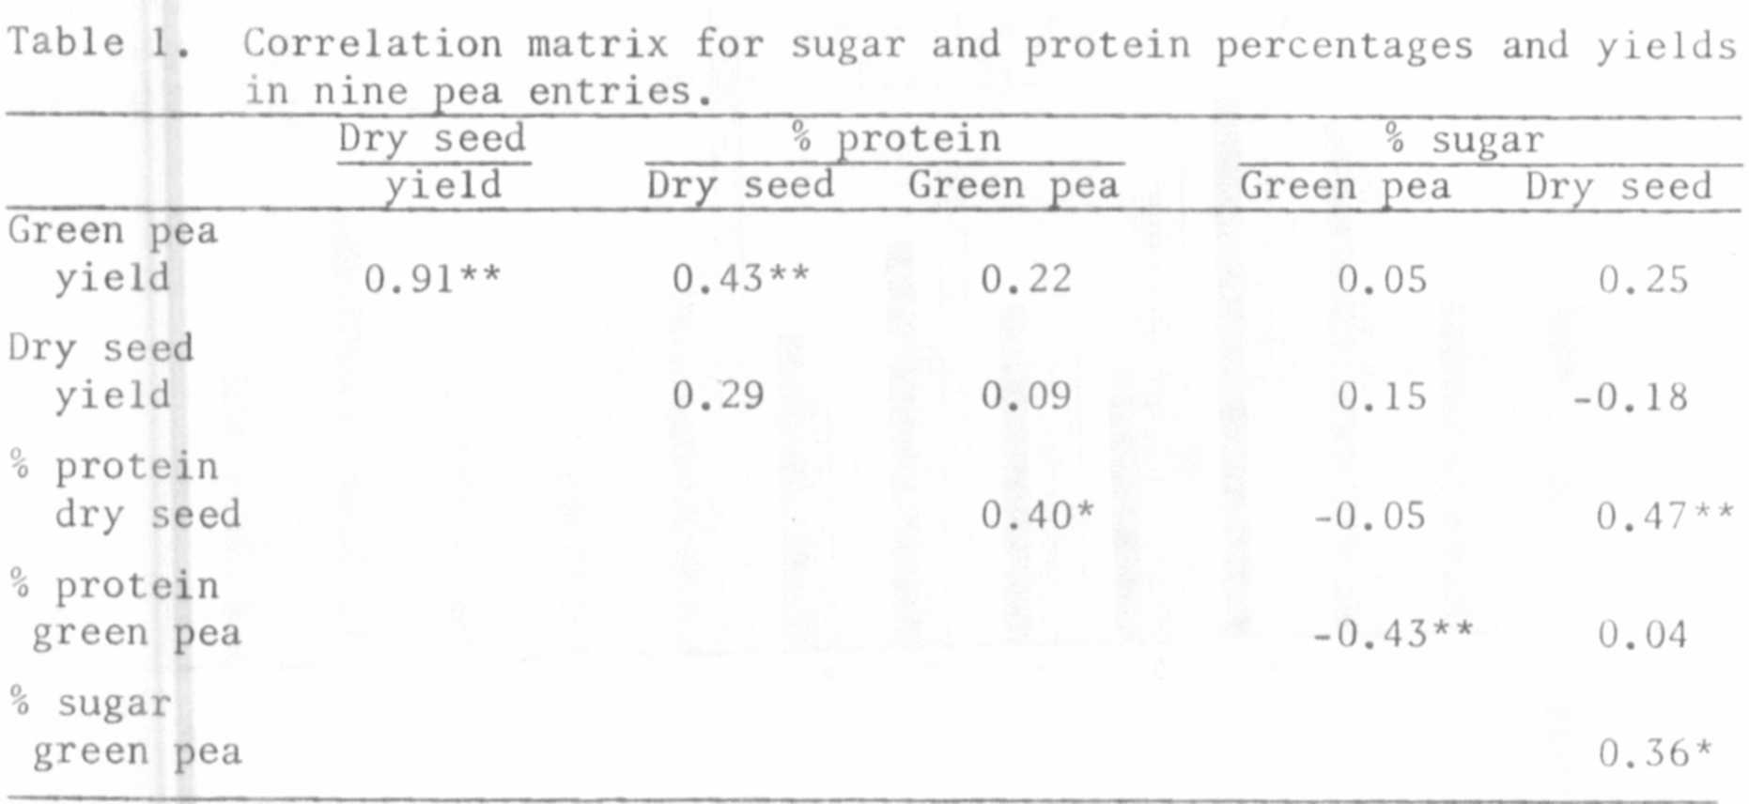
Green pea yield showed correlation with % protein of dry seeds
(r=0.43**); in a previous work (2) a similar tendency was established but
it did not reach significance (r=0.43).
Dry seed yield showed no correlation with protein and sugar percentages,
the sign being positive with protein and negative with sugar, which was also
the case in the previous work mentioned.
Protein content of dry seeds was significantly correlated with sugar
content of the same kind of seeds (r=0.47**) and also, as expected, with
protein content of green pea. Nevertheless, in the case of % protein versus
% sugar in green peas, a significantly negative correlation was obtained.
(r=-0.43**). There seems to be an inversion of the association of % protein
versus % sugar when comparing them at the green and dry seed stages. Further
investigation is needed to clarify this situation.

1. McCready, R. M., J. Guggolz, V. Silviera, and H. S. Owens. 1950.
Analyt. Chem. 22:1156-1158.

2. Krarup A. and N. Aguila. 1978. Agro Sur 6(2):97-99.

