GENOTYPE-ENVIRONMENT INTERACTION IN PEA

Kaul, M.L.H., Institute of Genetics, University of Bonn, West Germany
V. Goel, and B. K. Yadav Kurukshetra University, India

Sixty plants each of 13 pea varieties were grown along with the control
variety 'Bonneville' in a completely randomized block under the semi-arid
climate of Kurukshetra and under the temperate climate of Kashmir (India).
These genotypes were grouped in increasing order of their shoot height as
related to Bonneville from the data obtained at Kurukshetra; the order 1-13
was GC-477, IP-3, GC-463, 'Lincoln', 'Conquette', 'Early December', Pusa-
vipasha, GC-195, 'Wando', Kashmir-local, Boasch-selection, 'Early Giant',
and 'Banarsi-sweet'. Data for seed number and grain yield per plant of these
genotypes were also related to Bonneville for both the locations, viz.
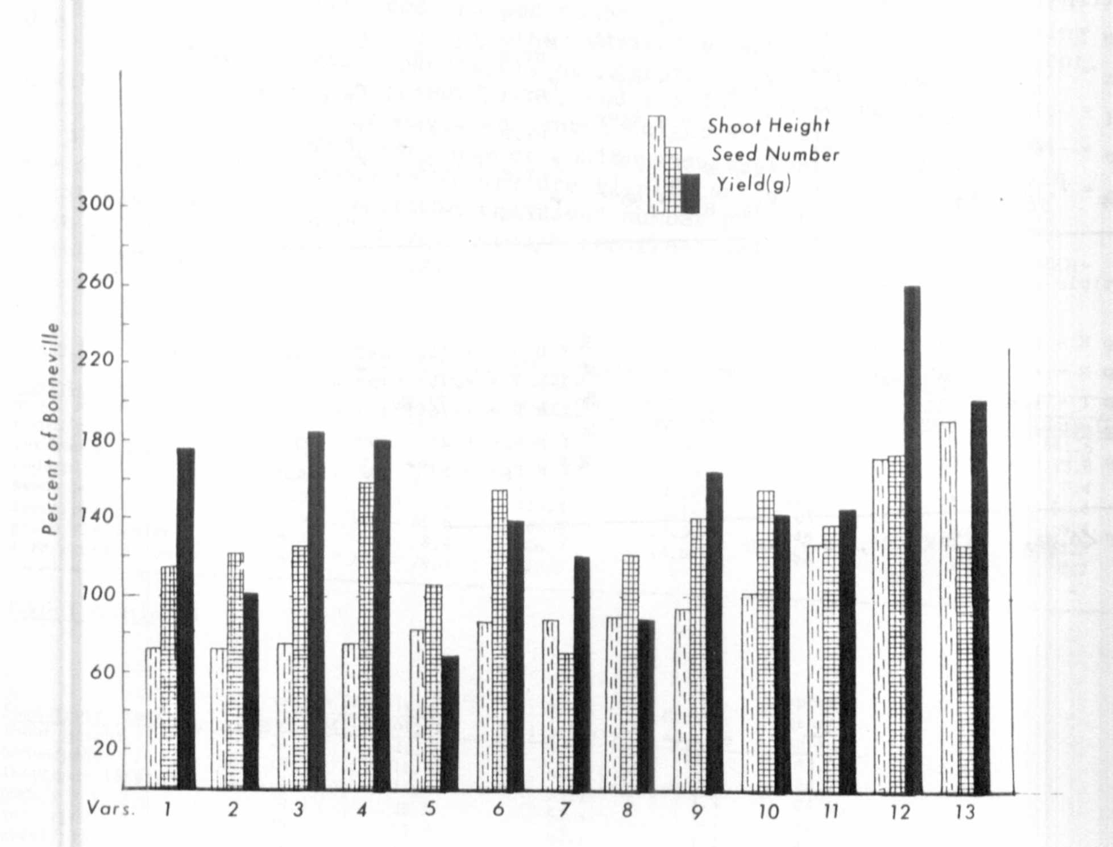
Kurukshetra (Fig. 1) and Kashmir (Fig. 2).
Fig. 1. Plant performance of varieties 1-13 (GC-477, IP-3, GC-468,
Lincoln, Conquette, Early-December, Pusa-vipasha, GC-195, Wando,
Kashmir-local, Boasch-selection, Early-Giant, and Banarsi-sweet)
at Kurukshetra.

PNL Volume 12
1980
RESEARCH REPORTS 39

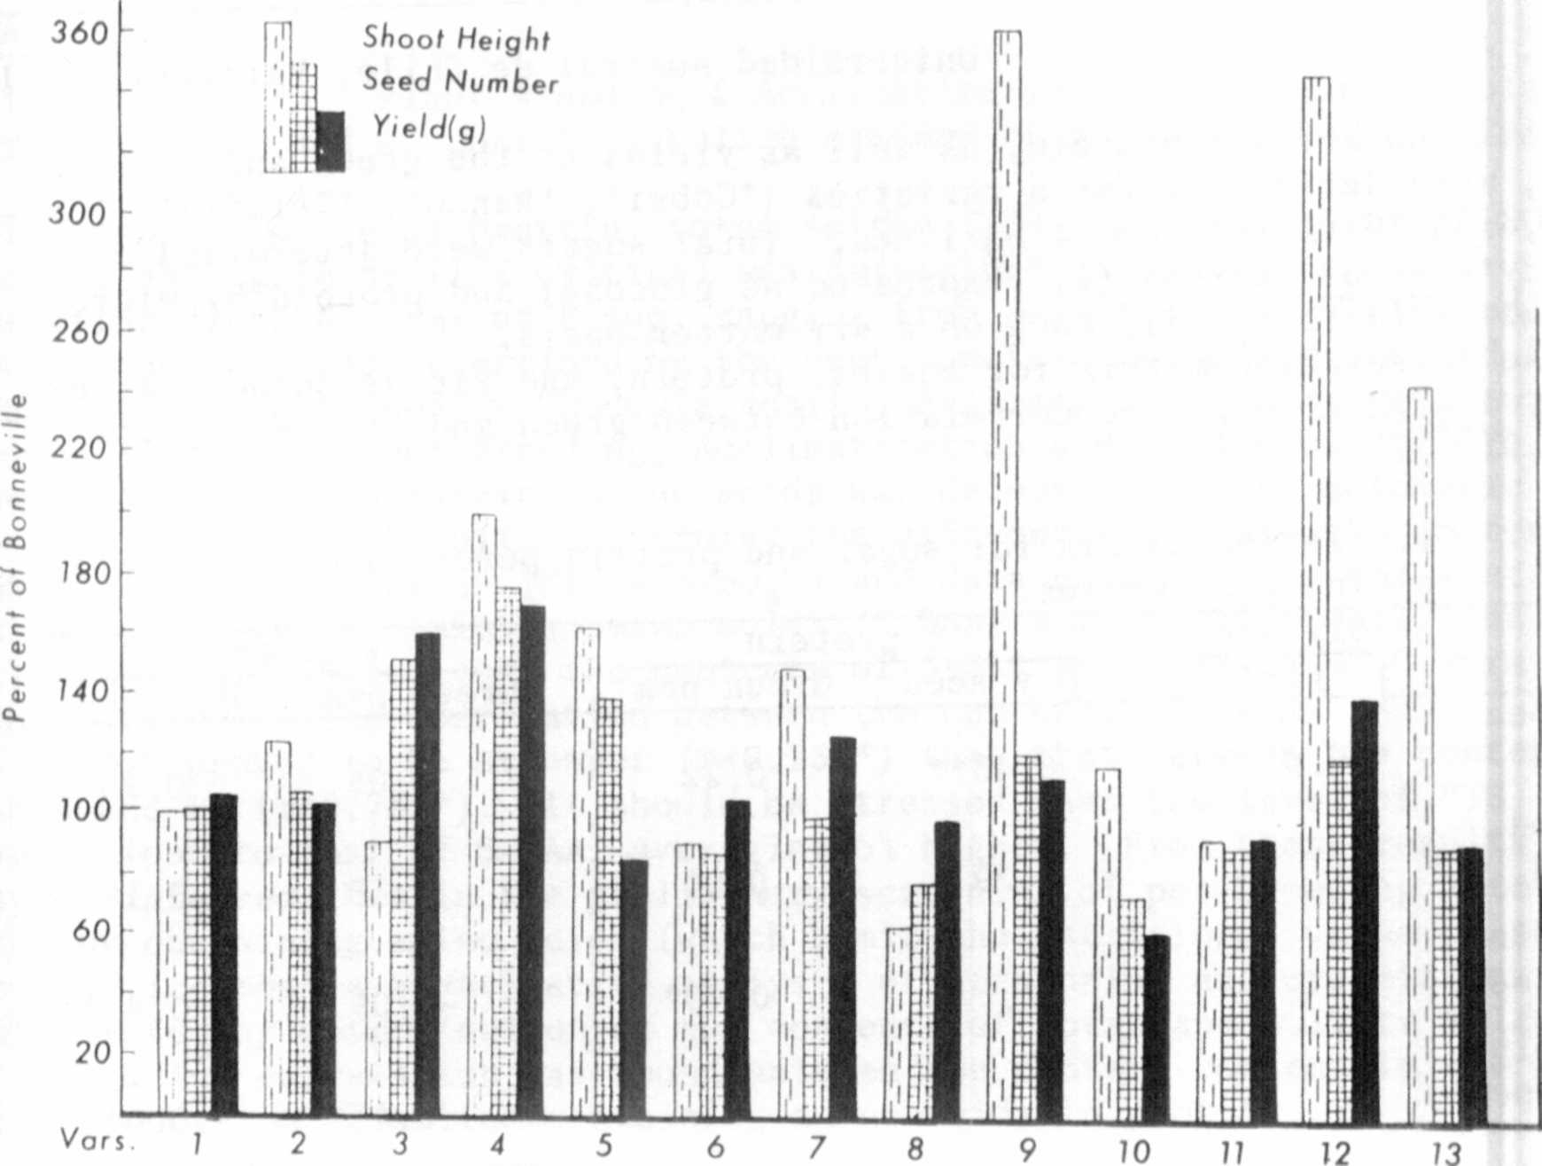
Fig. 2. Plant performance of varieties 1-13 (GC-477, IP-3, GC-468,
Lincoln, Conquette, Early-December, Pusa-vipasha, GC-195, Wando,
Kashmir-loca1, Boasch-selection, Early-Giant, and Banarsi-sweet)
at Kashmir.
Only Early Giant and Banarsi-sweet were very tall at Kurukshetra, but
at Kashmir Lincoln, Wando, Conquette, and Pusa-vipasha were also very tall.
Seed number of Lincoln, Early December, Wando, Kashmir-local, Boash-selection,
Early Giant, and Banarsi-sweet was significantly increased at Kurukshetra
but at Kashmir only GC-468, Lincoln, and Conquette were higher than Bonneville,
At Kurukshetra, tnc grain yield of Conquette and GC-195 were less than
Bonneville, whuroas the othet lines were nearly the same or higher. At
Kashmir, however, only GC-468, Lincoln, and Early Giant were better yielding
tnan Bonneville, .lost lines exhibited differential behavior at the two sites
resulting from genotype-environment interaction.

