RESEARCH REPORTS .1
PNL Volume 12 1980

on wheat suggested that polyembryo formation can be caused by herbicides
used at a critical developmental stage (4). For this reason it is not clear
whether the observed variation between varieties in twin formation is based
mainly on genetical differences or on environmental conditions.
The twin method for selection of haploids has been without any success
after examining 76,342 seedlings and investigating 89 twins cytologically.
1. Ahmad, Q. N., E. J. Britten, and D. E. Byth. 1975. J. Hered. 66:327-330.
2. Beeversdorf, W. D. and E. T. Bingham. 1977. Can. J. Gen. & Cyt. 19:283.
3. Frandsen, N. 0. 1968. Z. Pflanzenzuchtg. 59:343-358.
4. Ferguson, J. D., M. M. Mcewan, and K. A. Card. 1979. Physiol. Plantarum
45:470-474.
5. Kazimierski, T. and E. M. Kazimierska. 1970. Genetica Polonica 11:62-80.
6. Tjio, J. H. and A. Levan. 1950. An. Estacion exp. Aula. Deiz. 2:21-64.

GENETIC VARIABILITY AND CORRELATIONS AMONG METRIC TRAITS OF SOME HIGli
PROTEIN PEA LINES

Kaul, M.L.H. Institute of Genetics, University of Bonn, West Germany

Most of the 19 high pea protein lines tested (PNL 10: 27-28) proved
to be low yielders. Grain yield of 16 such genotypes was also low (Fig. 1)
but most of them possessed considerable genetic variation for various yield
components, the maximum being in grain yield and the minimum in seed protein
content (Table 1). Since selection was directed towards higher seed protein
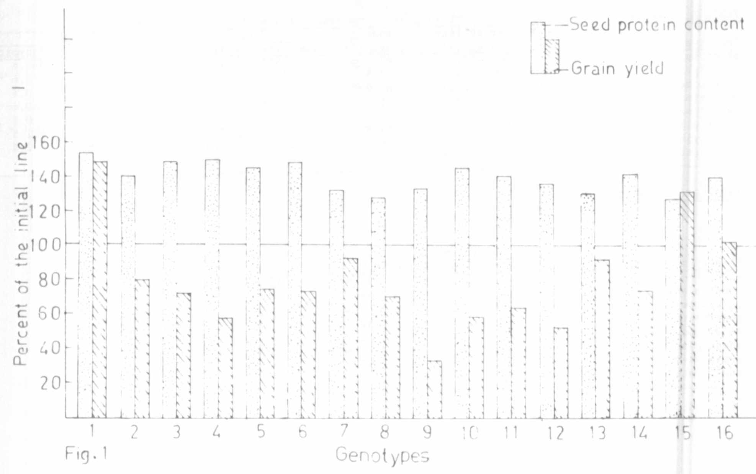
Fig. 1. Seed protein content and grain yield of 16(1-16) high protein pea genotyj

PNL Volume 12 1980
2 RESEARCH REPORTS

content, its variation was narrowed. The trait "seed number per plant"
possessed the maximum phenotypic variability, genotypic coefficient of
variation, heritability, and expected genetic advance (Table 1). Therefore,
its selection value and breeding significance is high and the enhanced
variability within the genotypes observed in this trait is due to a high
degree of additive genetic effect. As shoot height possesses a high herita-
bility and genetic advance, its control by major genes is inferred. Total
grain yield (Y) is related to the various metric traits as follows:
Y = 5.67 - 0.01 X (X = shoot height); Y = 5.39 - 0.034 X (X = nodes
per plant); Y = 5.73 - 0.262 X (X = internode length); Y = 0.95 + 0.290 X
(X = pods per plant); Y = 2.77 + 0.702 X (Y = seeds per pod); Y = 1.22 +
1.07 X (Y = seeds per plant).
These regression equations imply a strong dependence of grain yield
upon seed number per plant. This relationship is substantiated by the
phenotypic, genotypic, partial and multiple correlation values (Table 2).
Approximately 65-67% of the variance (R²) in grain yield was accounted for
by its association with seed and pod number per plant, the remaining being
due to action and interaction of other variables including the environment.
Significant positive phenotypic and genotypic correlations between
grain yield and seed number per plant, and the insignificant genotypic
correlations between grain yield and shoot height indicate that selection
of plants with increased seed number would produce plants higher in grain
yield without influencing their stature significantly. Since sufficient
genotypic variability exists in the "seed number per plant", it appears
that the trait can be improved through recurrent selection without substan-
tially affecting other traits.
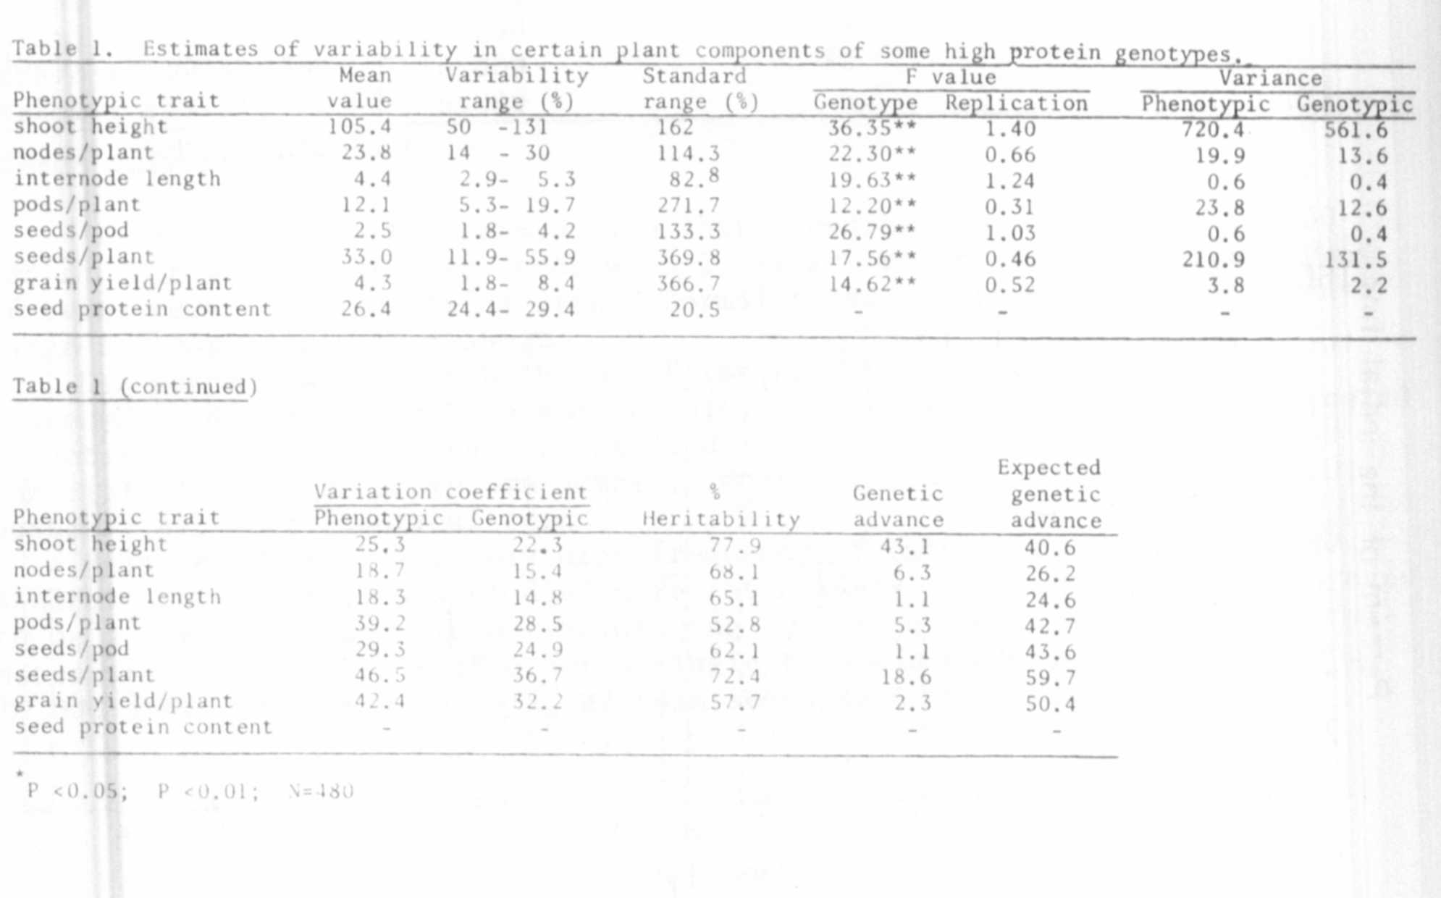

PNL Volume 12 1980
RESEARCH REPORTS

