The st gene is located on chromosome 3 so en is also a member of this
linkage group. We detected no linkage with which may indicate that en
lies on the far side of st [M side-- Ed.]. Our data with f is incomplete
but a greater number of parental types than expected was found in the segre-
gation of en and f, thus suggesting that en may lie on the same side of
st as f.

Editor's Note:
The results reported in the above paper are in accord with
unpublished results secured by I). W. Barton in 1959. Barton
obtained negative evidence for linkage with markers on chromo-
somes 1, 2, 4, 5, 6, and 7 but positive evidence for linkage with
M and st on 3. The CrO estimates between En-M and En-St were
calculated as 33 and 38, respectively. In the case of the En-M
linkage, a combined population of over 2200 plants was involved,
but the population size for the En-st linkage was only 171 plants
The estimate of linkage with b was 45% but the Chi-square was
not significant. He concluded that En probably lies between M
and St.

WITHIN-LINE HETEROGENEITY FOR GENE sbm IN THE U.S. PI SUM COLLECTION

Hampton, R. 0. US Dept. Agric. Oregon State Univ., Corvallis, OR U.S.A.

During a recent search (1) for sources of immunity to pea seedborne
mosaic virus [gene sbm (2)] among 668 untested U.S. Plant Introduction
accessions of Pisum, 16 lines homogeneous for immunity were identified. The
16 lines were released to U.S. plant breeders by special memorandum in
October, 1976. Having been selected specifically for PSbMV-immunity, these
lines represented the usual gamut of non-horticultural plant characteristics.
Numerous other lines, however, consisted of obvious mixtures of seed and
plant type, but contained a majority of immune plants, and still others con-
tained a minority of immune plants.
These results prompted the question: is the sbm allele relatively common
in the USDA collection of Pisum? If so, might a diverse source of sbm provide
breeders with a better choice of horticultural characteristics for breeding
purposes than is available in the released lines?
I therefore examined data from the above 668 lines to identify those
that were previously excluded on the basis of either seed or plant type mix-
tures, or heterogeneity for gene sbm (not pure for sbm/sbm plants). Resis-
tance was found in 160 lines in addition to the 16 previously released to

2 RESEARCH REPORTS
PNL Volume 12 1980

plant breeders. Some of these (Table 1) offered plant characteristics
generally superior to those of lines already released and consequently might
serve as good sources of resistance.
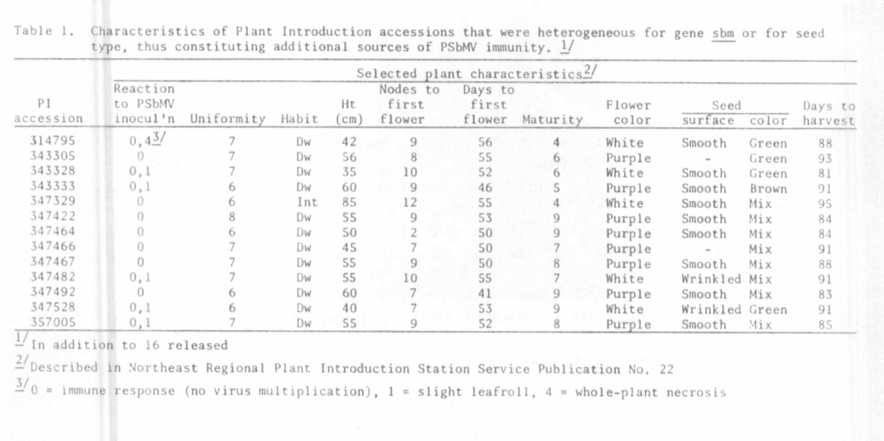

It must be stressed, however, that if accessions such as PI 314795,
347795, and 347528, which were found to contain mixtures of susceptible
and immune types, were selected as a source of sbm, then the persons attempting
to utilize this source would need to be equipped to detect and eliminate
susceptible plants from the stock prior to use. Less than stringent measures,
in this case, would permit introduction of PSbMV into a program, predisposing
susceptible materials to infection.

1. Hampton, R. 0. and S. W. Braverman. 1979. Plant Dis. Reptr. 63:95-99.
2. Hagedorn, 1). J. and E. T. Gritton. 1973. Phytopathology 63:1130-1133.

