was very low, ranging between 3.6 and 7.6% of the control over 5 replications
(lefthand part of the figure). Some of the green flowering recombinants had
an equally low seed production so yield was not improved by combining gene
gf with the other genes involved. Some other recombinant types, however,
showed a strikingly better yield than mutant 189; details can be seen from
the figure. Of particular interest is a small group of long-stemmed recombinants
exceeding mutant 189 by 400 to 800%. This holds true for certain fasciated
as well as for certain non-fasciated genotypes, the genes for stem fasciation
and long internodes deriving from mutant 489C of our collection.
These findings show that the reduced seed production of mutant 189 is
not necessarily correlated with the presence of gene gf. On the contrary,
combinations between gf and other mutant genes gave excellent yields. Thus,
gene gf shows a high degree of dependence not only on certain environmental
factors but also on the genotypic background.
Mutant 189 is without any interest for pea breeding. It is quite possible,
however, that other genes of known agronomic value might show a similar behavior.

IMPROVEMENT OF AN EARLY FLOWERING GENOTYPE THROUGH RECOMBINATION

Gottschalk, W. Institute of Genetics, University of Bonn, West Germany

The recombinant R 46C of our collection is homozygous for genes efr
(flowering 7-10 days earlier than the mother variety) and bif-1 (dichotomous
stem bifurcation). It has little agronomic value as such because seed pro-
duction was low in most of the 21 generations tested so far (Fig. 1; lefthand
part).
Recombinant R 46C was crossed with many mutants in order to combine
gene efr with other genes or gene groups of the genome. The respective
recombination types were then selected and developed into pure lines. The
seed production of 59 different early flowering recombinant strains was
evaluated and compared with that of the parental recombinant R 46C in 1979
(Fig. 1). Most genotypes were grown in 3-5 replications with 20 plants per
replication.

RESEARCH REPORTS 2
PNL Volume 12 1980

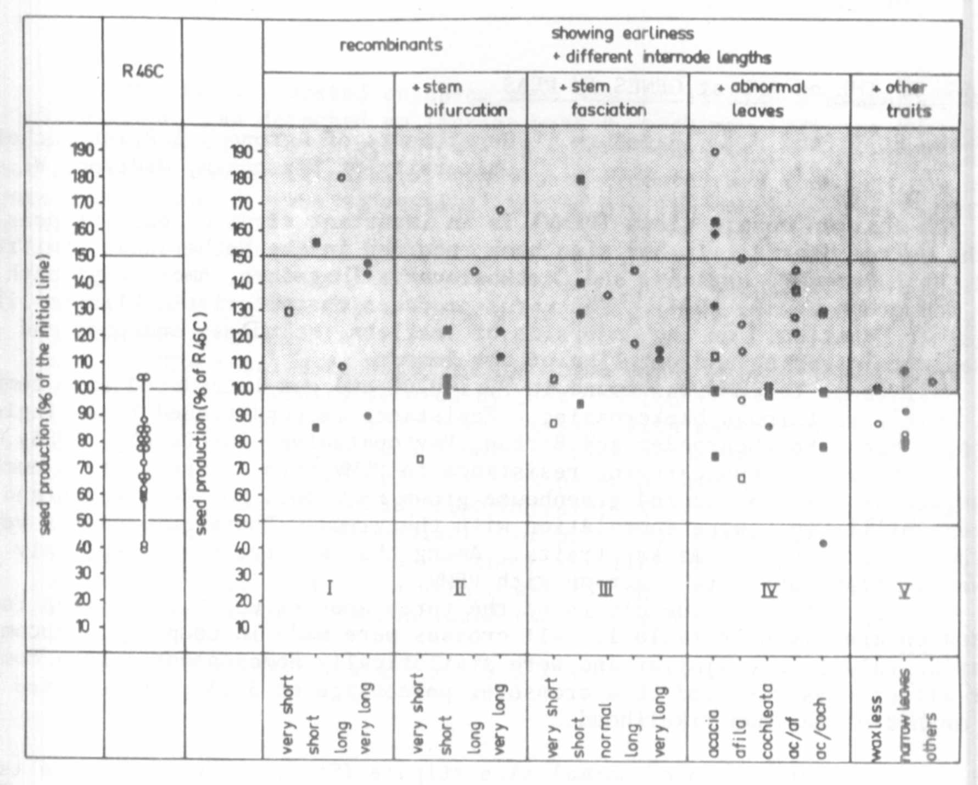

Fig. 1. Left: Seed production of the early flowering recombinant R 46C
in 21 generations. Each dot represents the mean value for
the number of seeds per plant for one generation as related
to the control values of the mother variety 'Dippes gelbe
Viktoria'.

Right: The seed production (number of seeds per plant) of 59 early
flowering recombinant lines as related to the control value
of R 46C. Each dot represents the mean value for one line
grown in 1979.

The genetically heterogeneous material can be subdivided into five
morphologically different groups according to internode length, stem fas-
ciation or bifurcation, leaf morphology, or other mutant characters. In each
group, some of the genotypes produced considerably more seed than R 46C.
This was true not only for longstemmed genotypes, but also for some recom-
binants with reduced internode length or even for some dwarfy genotypes.
The findings show that it was possible to improve the selection value
of the early flowering recombinant R 46C by combining its two mutant genes
with other mutant genes of the genome. The recombinants available represent
an interesting series for studying problems of interactions between mutant
genes.

