PNL Volume 12 1980 RESEARCH REPORTS 1

ACTION OF GENE gf AS INFLUENCED BY ENVIRONMENT AND BACKGROUND GENOTYPE

Gottschalk, W. Institute of Genetics, University of Bonn, West Germany

Gene g_f of Pisum causes reduced flowers which are greenish in color
due to the presence of some chlorophyll in the petals. Plants of the X-ray
induced mutant 189 of our collection are homozygous for gf but are otherwise
normal. They flower belatedly and show unusual sensitivity to changes in
environmental conditions. Plants of this genotype produced a seed yield
about 50% higher than that of the mother variety in 1978, but no seeds at
all in 1977. In the other 13 generations tested so far, the mean values for
seed yield per plant ranged between 1 and 79% of the control values of the
initial line.
In 1979, 22 different recombinant lines were available at our institute,
all homozygous for gf and one or several other mutant genes of our collection.
They were grown in several replications and their seed production was compared
with that of the parental mutant 189 (Fig. 1). The seed yield of mutant 189
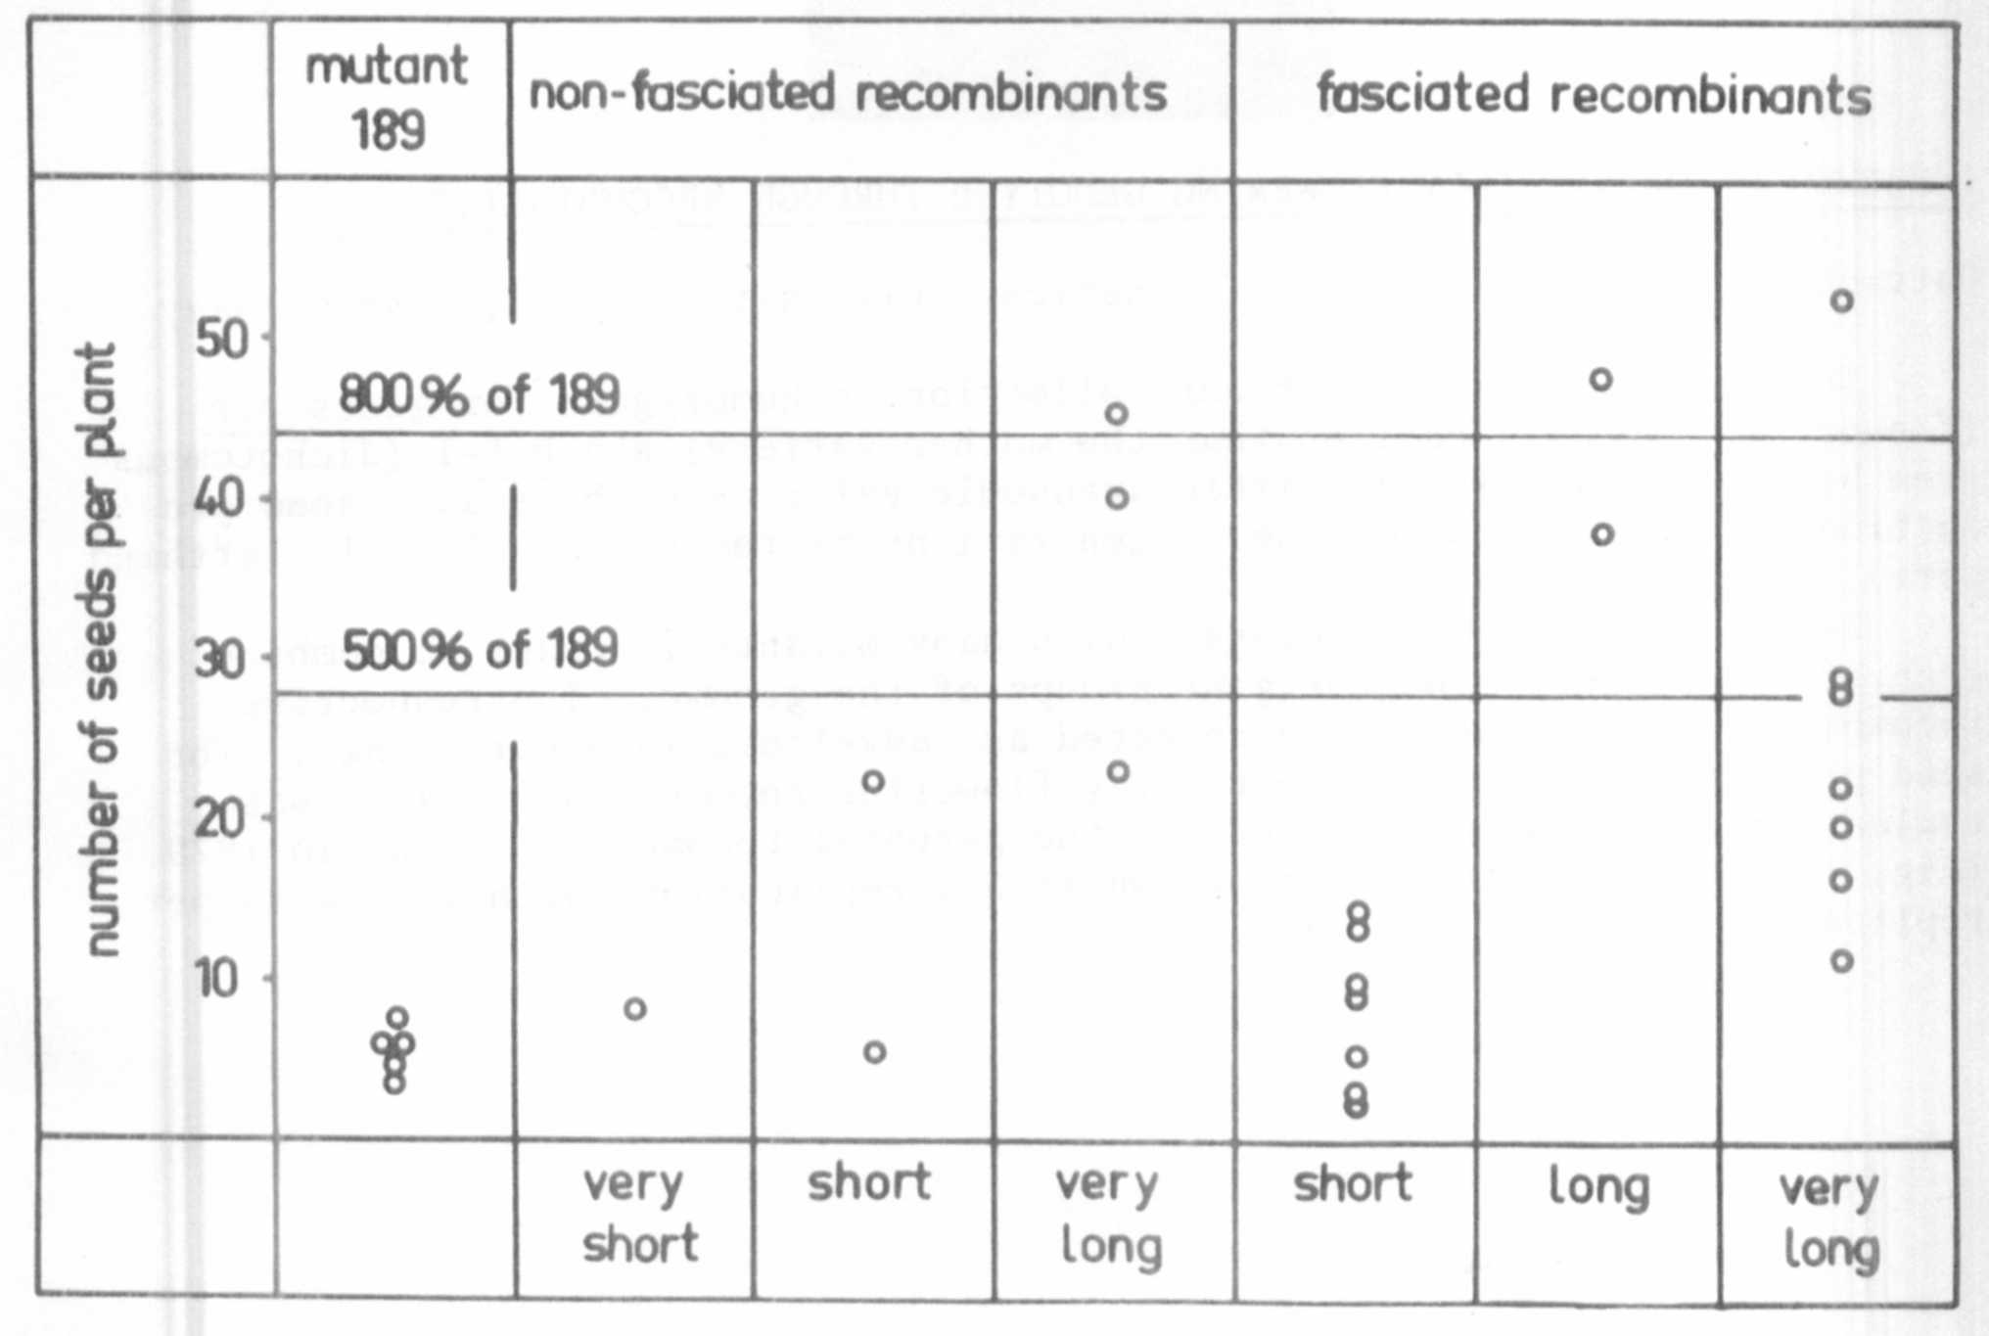
Fig. 1. Seed production of mutant 189, homozygous for gene gf,
and of 22 recombinant lines homozygous for gf and for
other specific genes. Each dot represents the mean
value for the number of seeds per plant obtained in
1979. All the values are related to the control values
of the initial line.

was very low, ranging between 3.6 and 7.6% of the control over 5 replications
(lefthand part of the figure). Some of the green flowering recombinants had
an equally low seed production so yield was not improved by combining gene
gf with the other genes involved. Some other recombinant types, however,
showed a strikingly better yield than mutant 189; details can be seen from
the figure. Of particular interest is a small group of long-stemmed recombinants
exceeding mutant 189 by 400 to 800%. This holds true for certain fasciated
as well as for certain non-fasciated genotypes, the genes for stem fasciation
and long internodes deriving from mutant 489C of our collection.
These findings show that the reduced seed production of mutant 189 is
not necessarily correlated with the presence of gene gf. On the contrary,
combinations between gf and other mutant genes gave excellent yields. Thus,
gene gf shows a high degree of dependence not only on certain environmental
factors but also on the genotypic background.
Mutant 189 is without any interest for pea breeding. It is quite possible,
however, that other genes of known agronomic value might show a similar behavior.

IMPROVEMENT OF AN EARLY FLOWERING GENOTYPE THROUGH RECOMBINATION

Gottschalk, W. Institute of Genetics, University of Bonn, West Germany

The recombinant R 46C of our collection is homozygous for genes efr
(flowering 7-10 days earlier than the mother variety) and bif-1 (dichotomous
stem bifurcation). It has little agronomic value as such because seed pro-
duction was low in most of the 21 generations tested so far (Fig. 1; lefthand
part).
Recombinant R 46C was crossed with many mutants in order to combine
gene efr with other genes or gene groups of the genome. The respective
recombination types were then selected and developed into pure lines. The
seed production of 59 different early flowering recombinant strains was
evaluated and compared with that of the parental recombinant R 46C in 1979
(Fig. 1). Most genotypes were grown in 3-5 replications with 20 plants per
replication.

