PNL Volume 12 1980 RESEARCH REPORTS 1

IMPROVEMENT OF THE SEED PRODUCTION OF THE afila MUTANT

Gottschalk, W. Institute of Genetics, University of Bonn, West Germany

The afila mutant, spontaneously arisen in Argentina and Russia, has
branched tendrils instead of leaflets, giving a high degree of standing
ability to the plants in dense stands. The af gene is being utilized in
England and other countries in breeding programs. We have used Goldenberg's
afila mutant for combining the af gene with specific mutant genes of our
collection and for testing the seed production of the respective recombinant
strains. The results (Fig. 1) obtained in 1979 are related to the control
values of the variety 'Dippes gelbe Viktoria' which has been used as initial
line for our radiation genetic experiments.
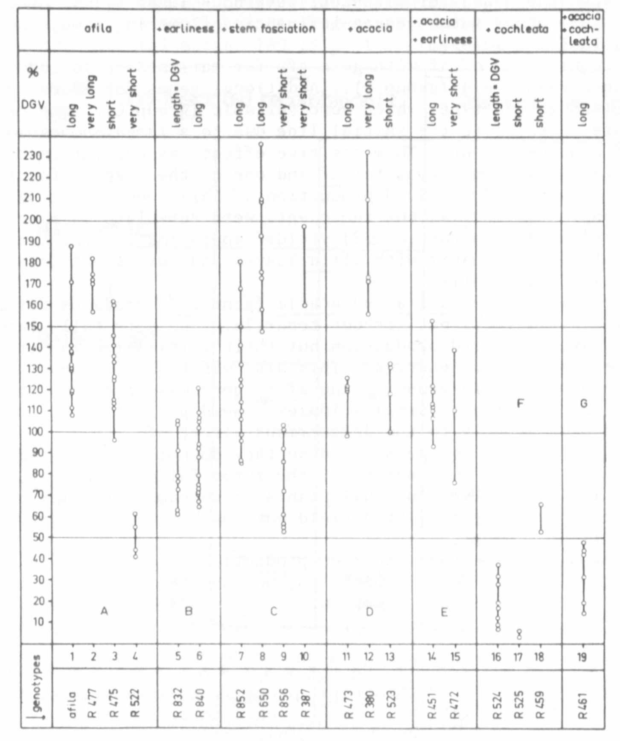
Fig. 1. Seed production of Goldenberg's afila mutant and of 18 different
recombinant types homozygous for gene af and distinct mutant genes
of our collection. Circles: Mean values for the number of seeds
per plant in several replications of several successive generations
as related to the control values of Dippes gelbe Viktoria.

The mean values for the number of seeds per plant of Goldenberg's
afila mutant varied between 108 and 188% of the control values in the repli-
cations of 8 generations. The plants were somewhat taller than those of
Dippes gelbe Viktoria. Group A of the figure contains some recombinant
types, in which gene af is combined with genes for different internode
lengths. A gene for shortened internodes reduced the plant height consider-
ably, whereas the seed production over a long period was only slightly
reduced (R 475). This was an improvement over the afila line from Goldenberg.
A stronger reduction of the stem length, however, led to a very strong
reduction of the seed yield (R 522). Recombinant R 477, on the other hand,
which contains a gene for very long internodes, showed excellent yielding
capacity, but the plants are too tall for cultivation in the field.
The groups B to G contain recombinants in which gene af is not only
combined with the genes for different internode lengths just mentioned but
also with some other mutant genes influencing flowering time, shoot struc-
ture, and leaf morphology.
The combination of af with gene efr for earliness resulted in genotypes
with reduced seed yield (group B). Additional genes for apical stem fascia-
tion resulted in genotypes which were variable (group C). Our fasciated
mutants are superior to the initial line due to a large increase in the
number of pods per plant. This positive effect was evident in the plants
of R 650 which was homozygous for af and one of the 4 genes for stem fascia-
tion of the mutant 489C. Seed production of this recombinant was clearly
better than that of afila, but the plants were very late in ripening. A
similar fasciated genotype (R 852) yielded approximately the same as afila.
Two fasciated recombinants with afila leaves and very short internodes each
yielded quite differently.
The combination of afila and acacia (gene tl^{w}) produces foliage leaves
with many tiny leaflets but without tendrils. The very tall plants of R 380
(group U) gave good seed production but their cultivation is difficult
because of the lack of tendrils. This also was true for the other recom-
binants of group 1). In group F, the afila gene was combined with the
cochleata gene causing abnormal stipules. Seed production of these genotypes
was very low due mainly to the deleterious effect of coch. These plants
represent truly "leafless peas" because they do not have any leaf-like
organs. Finally, the combination of the three foliage genes af, tl , and
coch (R 461) leads to very unusual plants which cannot readily be discerned
as peas prior to flowering. Seed yield was low but they are very interesting
for theoretical reasons.
Our findings show that the seed production of Goldenberg's afila
mutant could be improved in some cases, but not to the extent it has in
England [or elsewhere--Ed.] . Obviously, af is not able to realize its
optimal efficiency in the genotipic background of our variety Dippes gelbe
Viktoria.

Editor's Note: A new commercial processing variety named 'Novella'
combines the fasciation and afila characters. Novella is a freezer
variety developed by the Rogers Bros. Seed Company in the U.S.
The practical merit of af from a breeding standpoint is seen chiefly
in solid (commercial,) plantings where there is intense interplant
competition.

