THE SEED PROTEIN PRODUCTION OF HIGH-YIELDING PISUM GENOTYPES
Gottschalk, W. Institute of Genetics, University of Bonn, West Germany

Three groups of high-yielding mutants and recombinants of our Pisum
collection were investigated with regard to seed production, seed size,
and protein content of the seed flour. From these data, the seed protein
production per plant was computed and compared with the control value of
the variety 'Dippes gelbe Viktoria¹ which was used for our radiation-genetic
experiments (Fig. 1).
The first group contained mutants and recombinants showing apical stem
fasciation which results in a strong increase of the number of flowers and
pods per plant. Therefore, the number of seeds per plant is essentially
higher than the control value of the mother variety. The various genotypes
were tested in different years, some of them over a period of 7 to 13 genera-
tions with 4-6 replications per year. The mean number of seeds per plant
for each generation is given in the upper half of the figure. Unfortunately,
most of these genotypes contain the mutant gene sg responsible for reduced
seed size derived from the fasciated mutant 489C. Their high seed production
did not lead to an equally high production of seed proteins. On the con-
trary, the 1978 values of 5 genotypes of this group were only roughly equal
to or even lower than the control value of the initial line. The seed
production of recombinant R 668A, for instance, varied between 172 and 227%
of the control values considering 7 generations. In 1978, the protein
content of its seed flour was similar to that of the initial line, but the
seed size was essentially smaller (thousand seed weight of the mother variety
283.4 g of R 668A: 147.9 g ). This reduced the seed protein production
per plant to about 94% of Dippes gelbe Viktoria. Recombinant R 849 and
mutant 1206E, on the other hand, had a lower seed production than R 668A,
but their seed size was only insignificantly reduced. The protein production
per plant of these two genotypes was about 60% higher than that of the mother
variety.
The genotypes of the second group exhibited a dichotomous stem bifur-
cation in the upper part of the shoot (gene bif-1). Recombinant R 177 also
contained gene s_g for small seeds and therefore showed no increased protein
production in spite of its high seed production. The increased protein
production of the genetically very complicated recombinant R 20D, on the
other hand, is again the result of the combination of a very high number
of seeds per plant and nearly normal seed size. The protein content of
the seed meal was about equal to the control; the protein production per
plant, however, was 80% higher in 1978.
The three genotypes of the last group have a normal shoot structure.
Recombinant R 933 is of particular interest. It originated from the cross
of mutant 3137 (late, tall, very high seed production, but small seeds)
x 1001 (increased seed size). The seed production of this recombinant type
was found to be very high-; the seed size was nearly normal. In 1978, the
protein content of the seed flour was slightly increased. The favorable
combination of these properties led to an extraordinarily high protein
production per plant, exceeding the control value by about 140%.
Most of the genotypes with improved protein production are not suited
for field cultivation because of their tallness. The recombinants R 224
and RM 1010, however, are not inferior to their mother variety with regard
to plant height and flowering time. In 1978, their protein production was
20-30^{n}6 higher than that of the initial line. The protein quality, i.e.
amino acid composition, was not influenced by the mutant genes. These
recombinants will be tested more intensively in the future.
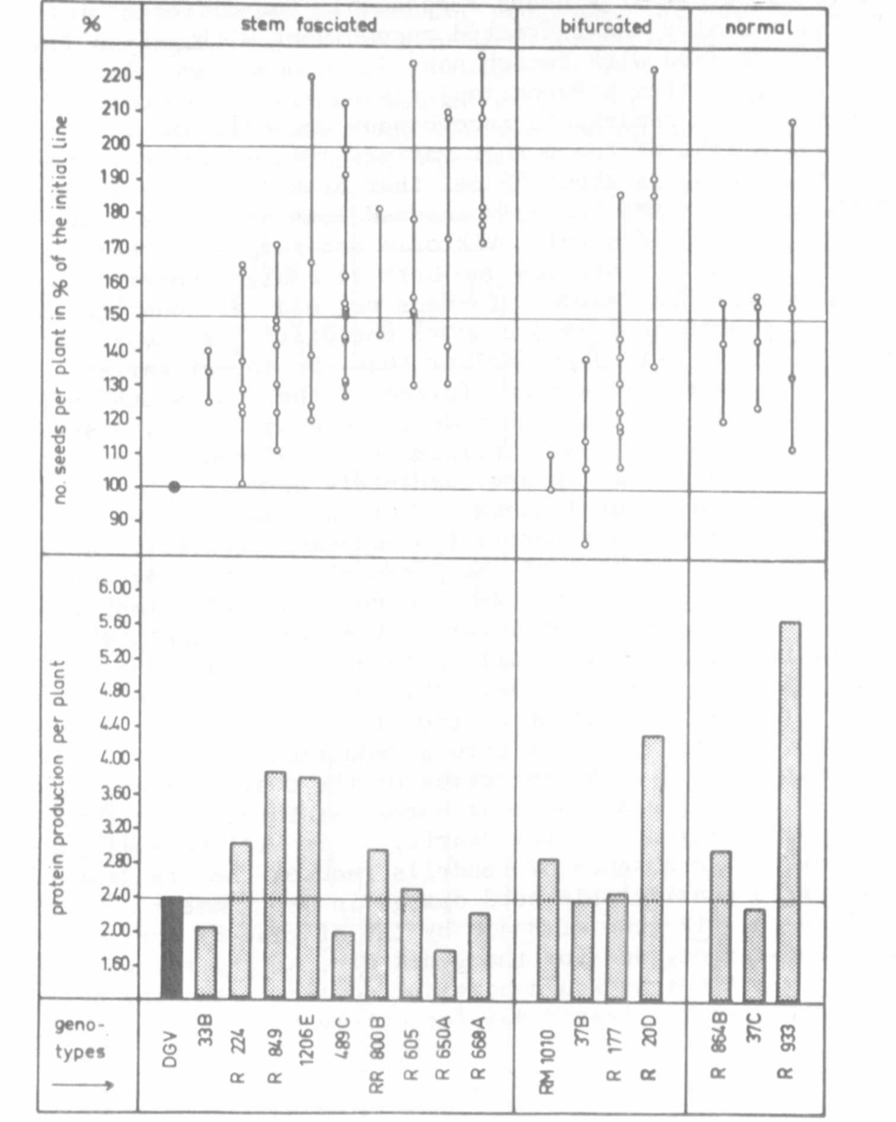
Fig. 1. Upper part: Seed production of 16 pea mutants and recombinants
as related to that of the mother variety Dippes gelbe Viktoria
in successive generations. Each dot represents the mean value
for the character number of seeds per plant for one generation.
Lower part: Mean values for the protein production per plant of
the same genotypes determined in 1978.

