THE EFFICIENCY OF SOME MICRO-MUTANTS

Gottschalk, W. Institute of Genetics, University of Bonn, West Germany

Some of our radiation-induced mutants do not show any obvious morpho-
logical deviations from the initial line. They are somewhat later ripening
and their seed production is higher (mutant 37C, recombinant R 624), Two
other mutants differ from the mother variety so insignificantly that they
cannot be classified reliably in segregating families. This is the case
for mutant 68C having an increased number of ovules per carpel and for mutant
39 having a subtly deviating leaflet shape. Thus, these genotypes represent
typical "micro-mutants". Seed and protein production in these mutants was
compared with values obtained from genotypes with stronger anomalies.
The positive effect of the increased number of ovules per carpel in
68C is counteracted by the reduced number of pods per plant resulting from
the pleiotropic action of gene ion. Its seed and protein production per
plant was nearly equivalent to that of the mother variety (Fig. 1). Mutant
39 has good yielding properties combined with normal seed size and normal
protein content of the seed meal. In two years tested, its protein produc-
tion per plant was 20-30% higher than that of the initial line. This mutant
will be tested more intensively during the next generations.
Recombinant R 624 arose from the cross of mutant 489C (stem fasciation
and many other anomalies) x 142B (tiny plants with degenerating leaves).
Its seed production was determined from replicated rows grown in three
consecutive generations. The mean number of seeds per plant was regularly
higher than the control material, but because of reduced seed size the seed
weight per plant was not improved.
Mutant 37C is of particular interest because of its good yielding
capacity. It, too, was tested over three generations and showed a very high
seed production due to a strongly increased number of pods per plant.
Unfortunately, the seed size of this genotype is reduced. Thousand seed
weight for 1978 and 1979 was as follows: 1978: 222.80 g (mother variety:
283.40 g); 1979: 234.33 g (mother variety: 302.07 g). Protein content of
the seed meal was found to be approximately equal to that of the initial
line. Because of the high seed production, 15-20% higher values for the
protein production per plant were obtained in 1978 and 1979. The protein
quality, i.e. the relative amounts of the different amino acids, was normal.
Thus, the protein production of this micro-mutant exceeded the mother variety
in spite of having a strongly reduced seed size.

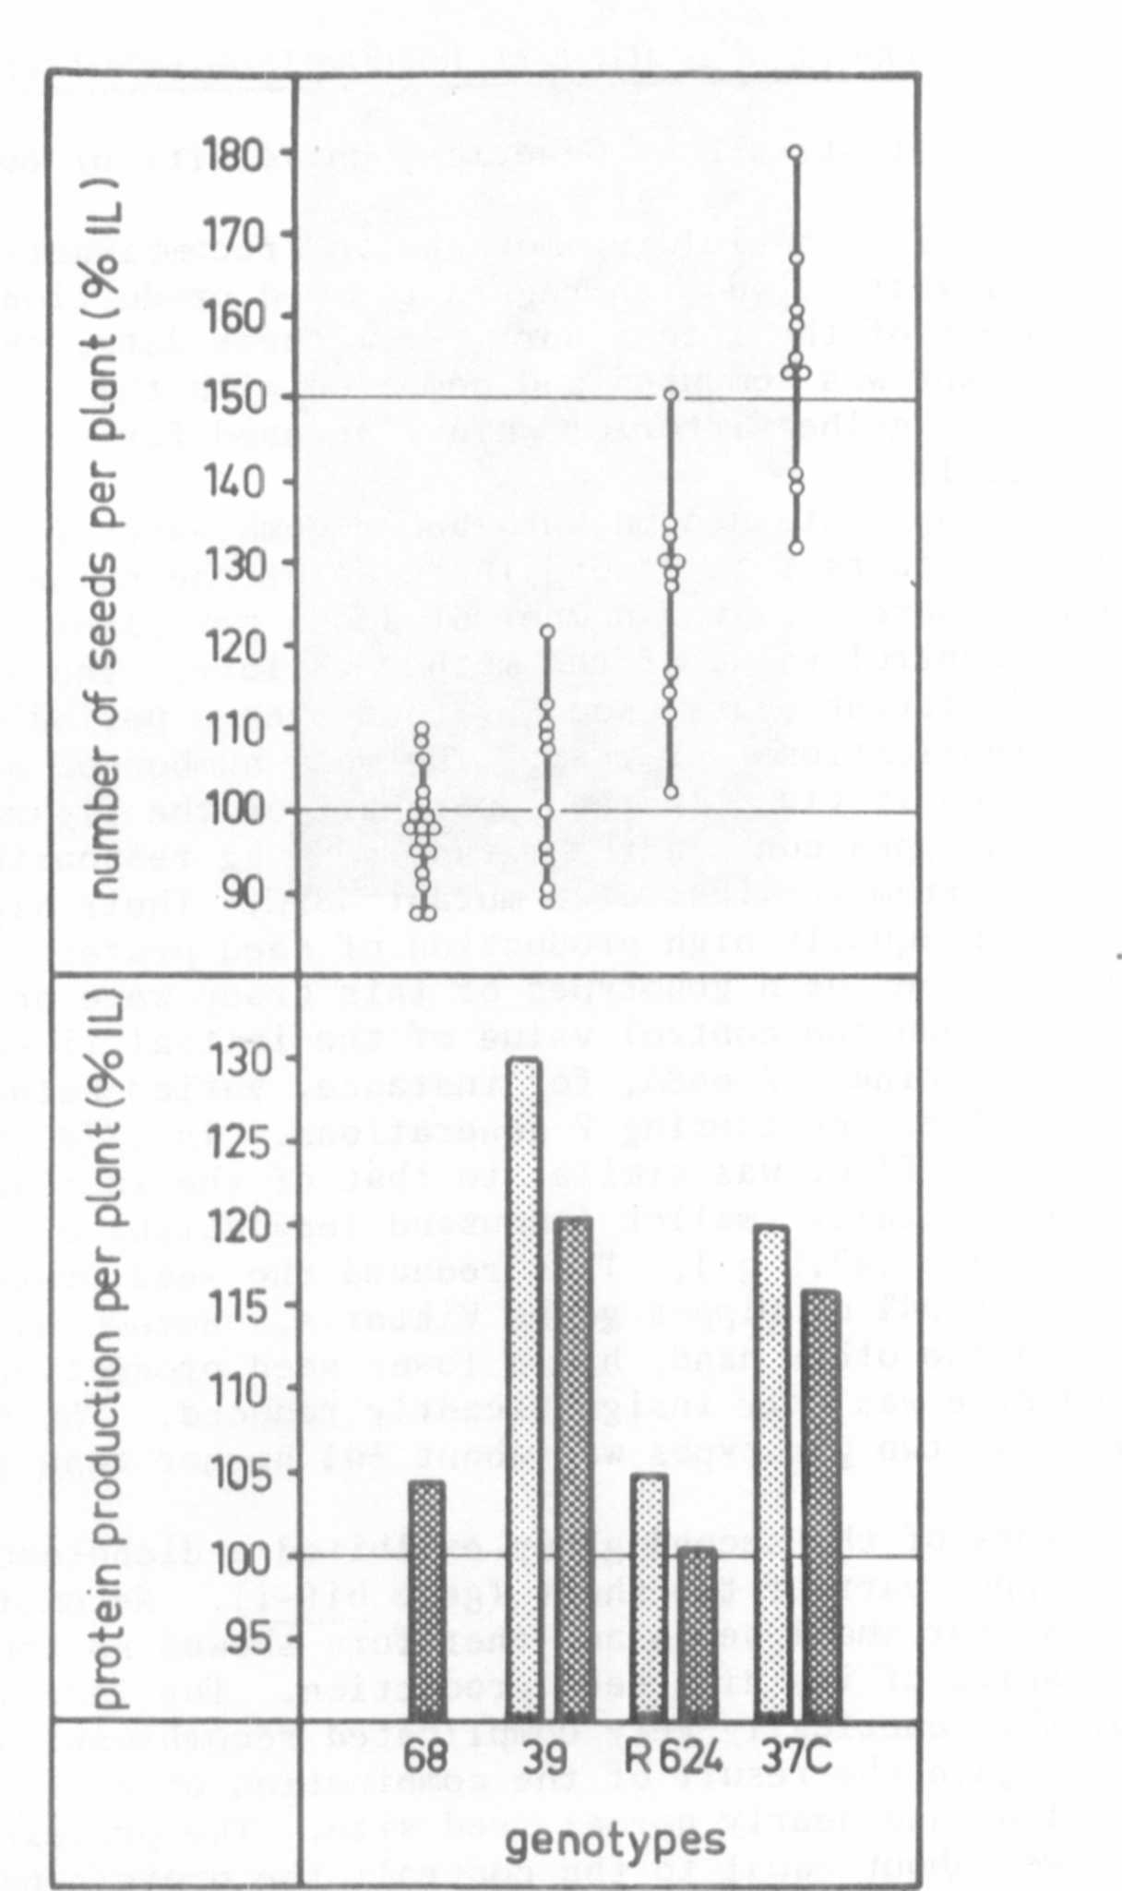
Fig. 1. Seed and protein production per plant of three Pisum mutants and
a recombinant. All the values are related to the control values
of the mother variety 'Uippes gelbe Viktoria'. Each dot represents
the mean value for one year (39, 68C) or for one replication in
3 years (37C, R 024), respectively.

