* *
Table 2. Ranking of phenotypes after two generations of minimal
and intense competition.
Rank | Minimum competitionPhenotype % |  | Rank | Intense competition(corrected)Phenotype %
1 | + + - | 33.7 | 1 | + + - | 24.2
2 | + + + | 22.2 | 2 | + + + | 23.0
3 | - + - | 13.9 | 5 | + - - | 16.2
4 | + - + | 11.9 | 4 | + - + | 15.3
5 | + - - | 11.7 | 3 | - + - | 10.2
6 | - + + | 4.8 | 6 | - + + | 9.2
7 | _ _ _ | 1.2 | 7 | _ _ _ | 1.9
8 | - - + | 0.4 | 8 | - - + | 0

Spearman rank correlation (r ) = .905

The results were tested by standard Chi-square techniques and were found
significant at the .001 level.

DESYNAPTIC ALLELIC PEA MUTANTS

Gostimski, S. A. and T. A. Ezhova Moscow State University, USSR

Two chlorophyll-mutant lines which were produced from treatment of
seeds with EI (line 9) and EMS (line 12) also were found to contain
meiotic mutations. These mutations seem to have arisen simultaneously with
the chlorophyll mutations in the initial cells, following mutagen treatment
of seeds.
Study of meiosis of meiotic mutants revealed that mutant genes in both
lines do not influence the process of conjugation of chromosomes in zygotene-
pachytene cells, but disturb chiasma formation, though to a different extent.
As a result of this disturbance, both mutant lines developed univalents in
the first metaphases, laggards at anaphases, high pollen sterility, and
slightly reduced seed production (Table 1).
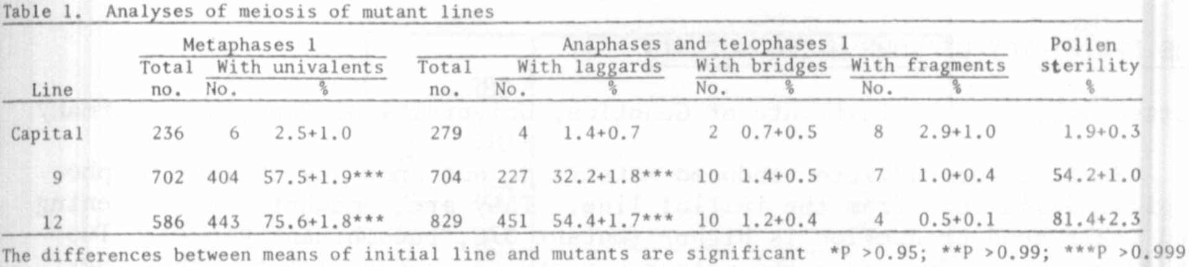

All F1 hybrids from crossing of desynaptic mutants (lines 9 x 12) had
a high percentage of sterile pollen (from 33.0 to 76.8%). Among 125 F₂ plants
from cross 9 x 'Capital' (initial variety), 98 plants were fertile and 27 plants
were semi-sterile (X²_{(3:1)}=0.77^{ns}). The distribution among 47 F₂ plants from
cross 12 x Capital was:*33 fertile, 14 semi-sterile (X²_{(3:1)}=0.57^{ns}). We
therefore conclude that the desynaptic mutations in lines 9 and 12 were reces-
sive mutations of the same gene.
In the progenies from our desynaptic mutants a few trisomies and one
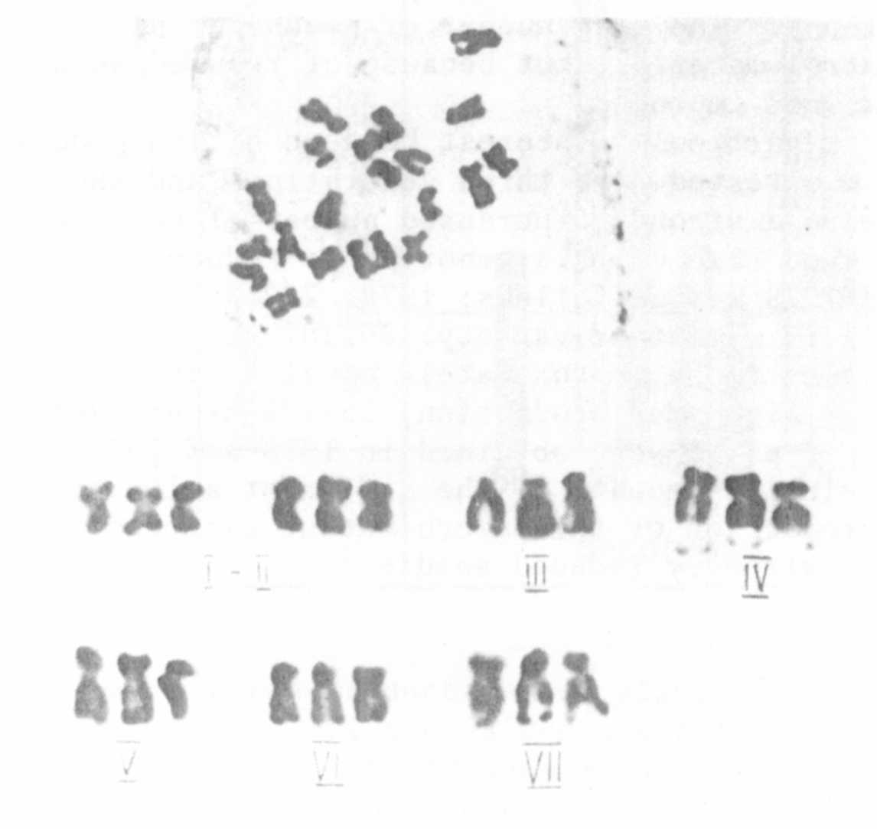
triploid were observed (Fig.l).
Fig. 1. Karyotype of triploid from line 9.

