FREQUENCY CHANGES IN MIXTURES OF Af-af, St-st, Tl-tl GROWN UNDER MINIMAL
AND INTENSE COMPETITION.

Glover, T. J. Hobart & Wm. Smith Colleges, Geneva, NY USA

A fundamental principle in population biology is the concept of fitness.
The fitness or realized reproduction of an individual depends on the organism's
phenotype interacting with the environment. A particular genotype may show
a wide range of fitness under different physical conditions and competitive
situations. Because organisms exhibit this flexibility of response with
respect to fitness it is unlikely that a single genotype of plant raised in
monoculture will produce the maximum number of seeds (offspring) under the
varying pressures encountered in field conditions.
In a plant such as Pisum where the commercial yield is closely correlated
with a major component of fitness, namely total number of seeds produced,
investigations of changes in fitness may have important practical consequences.
As a preliminary study of fitness and competition in Pisum, mixtures
of eight different genotypes affecting foliage type were tested under two
forms of spatial competition in the field at Geneva, NY. The eight genotypes,
furnished by G. A. Marx, were isogenic lines derived as F6's from a backcross
involving three major gene loci.
The genotypes utilized were all possible combinations of Af-af, St-st,
and Tl-tl. Afila homozygotes have leaflets replaced by extra tendrils, st
homozygotes have reduced stipules, and tl (acacia) homozygotes have tendrils
replaced by leaflets. The interaction between af and tl produces clusters of
small leaflets. No other obvious morphological changes occur due to inter-
action in any of the eight genotypes.
The eight genotypes were mixed together in equal ratios and grown on
trellises in the field in 1977. Phenotypes were scored in the seedling stage.
Dry seed was bulk-harvested and replanted on trellises in the field in 1979.
Again plants were scored as seedlings and dry seed was harvested. Samples
from 1979 seed were grown to seedling stage in the greenhouse and scored.
The ratios of the phenotypes of these seedlings represent the population ratios
after two generations of field selection under minimum spatial competition.
A similar planting scheme was followed with a mixture of the eight
genotypes grown under intense spatial competition in drilled plots. These
conditions were comparable with commercial cultural conditions. The drilled
plot initial mixture of seed inadvertently contained twice as much of the
AfAf stst T1T1 genotype as the other genotypes.^{1/} This error may have con-
founded the results due to density dependent selection. However, for ease
of comparison such selection was assumed to be negligible and the AfAf stst
TlTl were halved as correction procedure.
The results (Table 1) show dramatically the changes in composition of
the mixtures. The equal numbers of phenotypes in the field both on trellises
and in drilled plots in 1977 indicate equal and high germination rates for
all genotypes. After one generation the mixtures from trellises and drilled
plots were significantly different from the initial ratios and from each other.
While fitness measured as total number of dry seeds is not perfectly correlated
with marketable yield, mixtures of two or more genotypes may increase yield.

^{1/} sole responsibility for the mixture lies with G. A. Marx - Ed.

RESEARCH REPORTS 3
PNL Volume 12 1980

Table 1. Frequency of plants in each of 8 combinations of Af-af St-st Tl-tl
grown under minimal (a) and intense (b) competition.
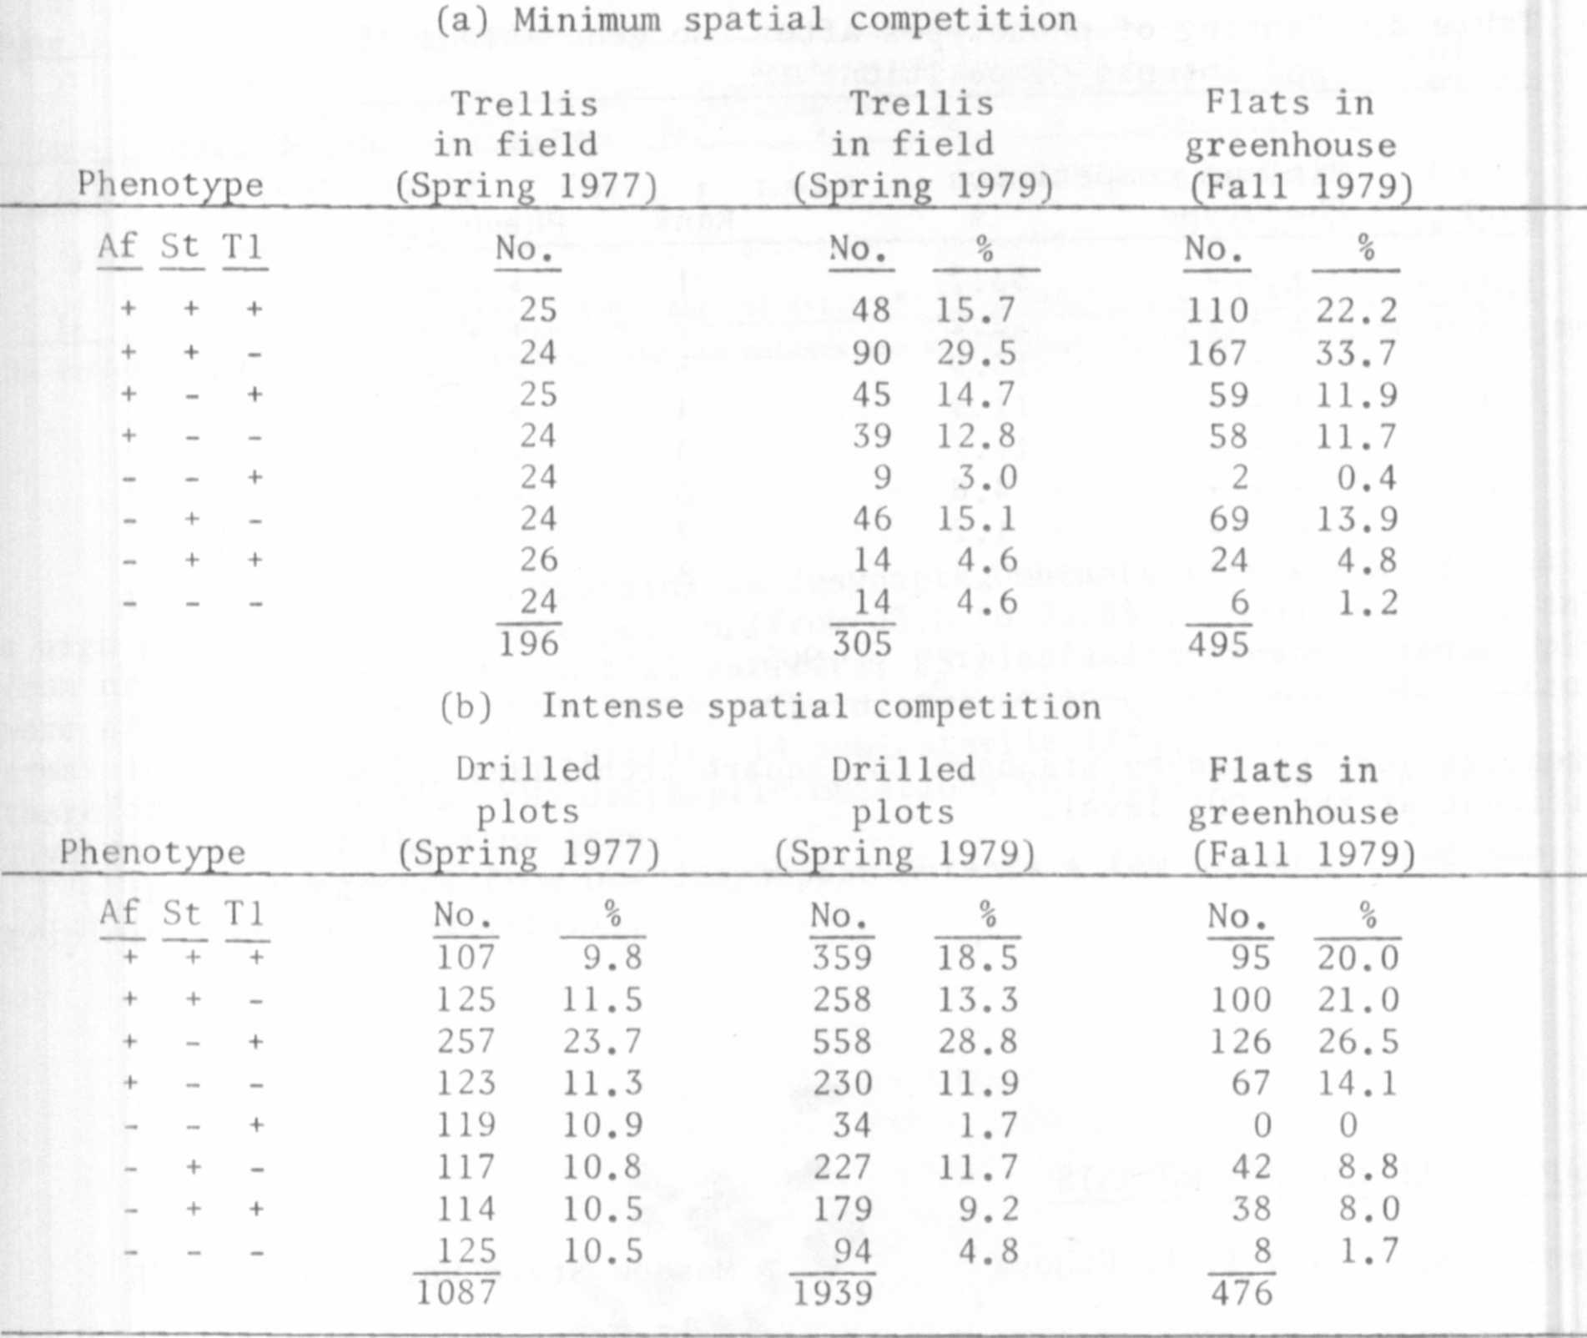

After two generations of selection, the ranked fitness of the genotypes
was similar in both trellised and drilled plots (Table 2). A Spearman
rank correlation (Snedecor § Cochran, Statistical Methods, 6th ed. 1967.
p. 194) was significant at the .01 level. AfAf StSt tltl and AfAf StSt T1T1
were clearly superior competitors in this regime; afaf stst tltl and
afaf stst TlTl were severely reduced in number, with the remaining four
genotypes exhibiting intermediate values.
These preliminary results suggest several experiments concerning the
effect of various genotype mixtures on marketable yield.

* *
Table 2. Ranking of phenotypes after two generations of minimal
and intense competition.
Rank | Minimum competitionPhenotype % |  | Rank | Intense competition(corrected)Phenotype %
1 | + + - | 33.7 | 1 | + + - | 24.2
2 | + + + | 22.2 | 2 | + + + | 23.0
3 | - + - | 13.9 | 5 | + - - | 16.2
4 | + - + | 11.9 | 4 | + - + | 15.3
5 | + - - | 11.7 | 3 | - + - | 10.2
6 | - + + | 4.8 | 6 | - + + | 9.2
7 | _ _ _ | 1.2 | 7 | _ _ _ | 1.9
8 | - - + | 0.4 | 8 | - - + | 0

Spearman rank correlation (r ) = .905

The results were tested by standard Chi-square techniques and were found
significant at the .001 level.

DESYNAPTIC ALLELIC PEA MUTANTS

Gostimski, S. A. and T. A. Ezhova Moscow State University, USSR

Two chlorophyll-mutant lines which were produced from treatment of
seeds with EI (line 9) and EMS (line 12) also were found to contain
meiotic mutations. These mutations seem to have arisen simultaneously with
the chlorophyll mutations in the initial cells, following mutagen treatment
of seeds.
Study of meiosis of meiotic mutants revealed that mutant genes in both
lines do not influence the process of conjugation of chromosomes in zygotene-
pachytene cells, but disturb chiasma formation, though to a different extent.
As a result of this disturbance, both mutant lines developed univalents in
the first metaphases, laggards at anaphases, high pollen sterility, and
slightly reduced seed production (Table 1).

