LOCATION OF NEW TRANSLOCATION IN PISUM

Ezhova, T. A. and S. A. Gostimski
Moscow State University, USSR

A study of 6-ray-induced chlorophyll mutant lines produced from the
'Capital' variety (normal structural type of chromosomes) revealed a recipro-
cal translocation in one of the lines (chlorina-mutant line No. 4). Karyo-
type analysis indicated participation in the interchange of chromosome 3
and one of the metacentric chromosomes (1 or 2) (Fig. 1). Studies of F1
hybrids produced by crossing line No. 4 x line 21 T(l-7) and line No. 4 x
line 83 T(3-5) showed the presence of hexavalents and four bivalents in the
cells of the first meiotic metaphase (Fig. 2). This confirmed the partici-
pation of chromosomes 1 and 3 in the interchange.
The translocation T(l-3) found in line No. 4 and a chlorina-mutation
from this same line, tentatively localized in chromosome 7, are apparently
non-connected mutational events induced simultaneously in initial cells of
the M1 seed following 6-irradiation.
Homozygous translocation T(l-3) was selected out in a pure line. The
plants of the T(l-3) line were not dissimilar phenotypically from the plants
of the initial variety.

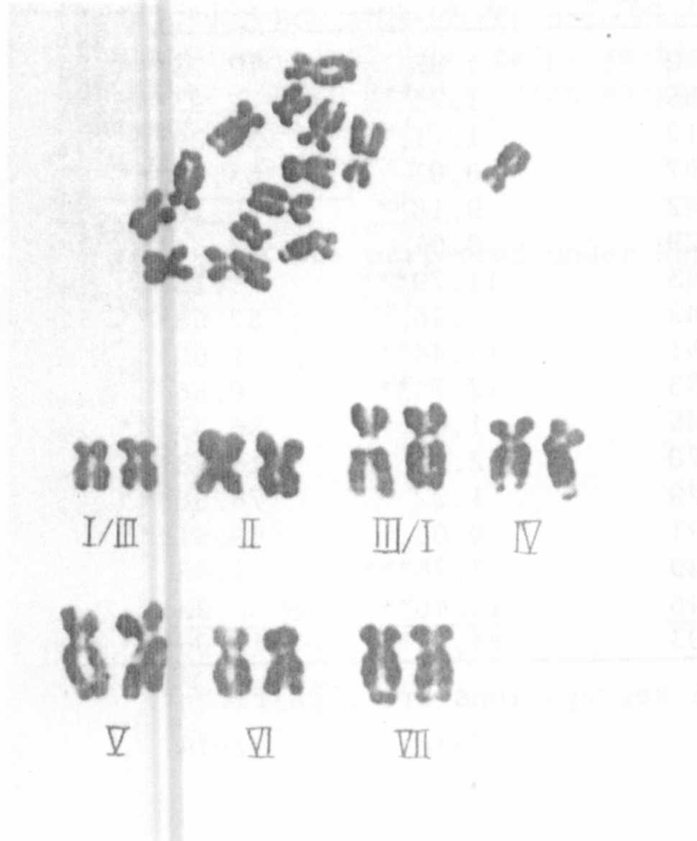
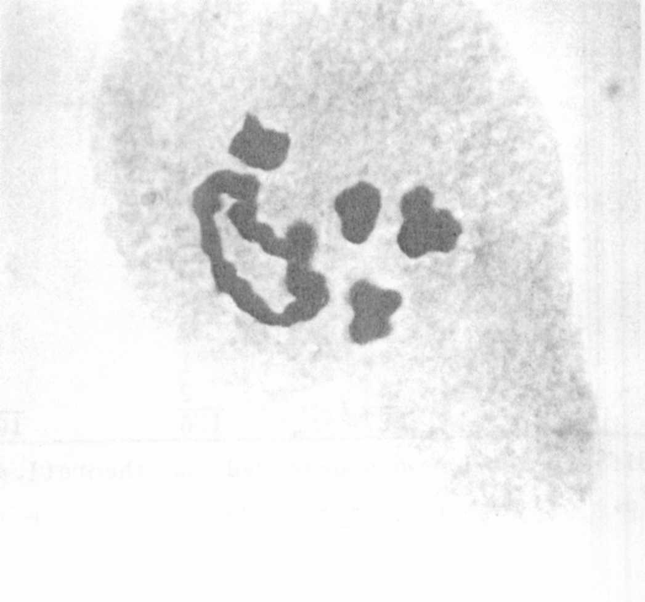
Fig. 1. Karyotype of plants from
line No. 4 with homozygous
translocation.
Fig. 2. First meiotic metaphase
in the F1 hybrids
(line 4 x line 21 T(l-7).

