PNL Volume 11 1979 RESEARCH REPORTS
8

YIELD POTENTIAL OF SEMI-DWARF AND DWARF GENOTYPES

Gottschalk, W. Institute of Genetics, University of Bonn, West Germany

About 30% of all mutants selected in our X-ray and neutron experiments
are reduced in plant height. They are dwarfs or semi-dwarfs and do not
represent a uniform group, neither morphologically nor anatomically nor
genetically. The reduced plant height can be due to:
Reduction in number of internodes.
Reduction in length of internodes (being due to a reduction of either
cell size or cell number).
The mutant genes of the short-stemmed genotypes can be dominant, recessive,
or intermediate; moreover, they can belong to multiple series.
In general, the seed production of the dwarf or semi-dwarf mutants is
lower than that of the mother variety. The yielding capacities of 37 short-
stemmed mutants of our collection are graphically given in the left hand part
of Fig. 1. Twenty-four of them have been tested in several generations.
Their mean values for the character "number of seeds per plant" are connected
by vertical lines. They are related to the corresponding means of the mother
variety (= 100%), grown in the same year at the same location. The graph
shows that only one mutant out of 24 was comparable with the initial line
with regard to seed production. All others were inferior. This holds true
also for the 13 mutants of this group which have been tested so far only in
one generation; their single values are likewise given in the graph.
Some of the short-stemmed mutants were crossed with other mutants of
our collection and a large number of different recombinant types is available
at the Institute. Fifty-five dwarf or semi-dwarf recombinant lines have
been studied with regard to grain yield. In 12 recombinants, values of several
generations are available while 43 lines have so far only been tested in a
single generation.(right hand part of the figure).
If we compare the distribution of the mean values of dwarf mutants and
recombinants, a shift toward increased seed production in the recombinants
is obvious. Quite a number of different recombinant types with reduced plant
height and normal or even increased seed production in comparison to the mother
variety is available. Some of these genotypes, derived from crosses with
fasciated mutants, have small grains. In this material, the positive effect
of the increased number of seeds per plant is offset by their reduced seed
size. This negative correlation, however, is not present in some other recom-
binant lines of this group. They show a favorable combination of reduced
internode length, normal seed size, and normal or even increased number of
seeds per plant, and are being tested further.

PNL Volume 11 197M
9 RESEARCH REPORTS

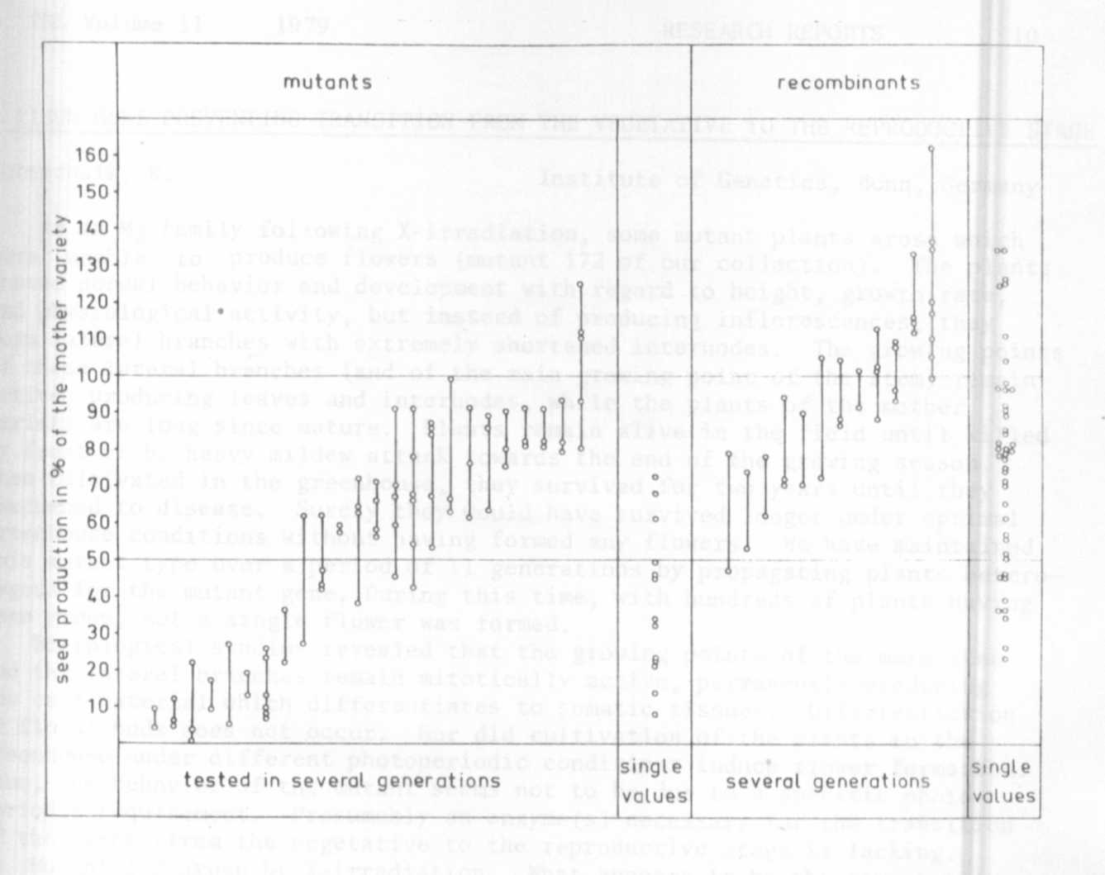

Fig. 1. The seed production of 37 short-stemmed mutants and 55 short-stemmed
recombinants of Pisum sativum as related to the yield of the mother
variety 'Dippes gelbe Viktoria'. Each dot represents the mean
value of the character "number of seeds per plant" for one generation.
The means of genotypes, tested in several generations, are connected
by vertical lines. From the remaining genotypes, means of only
one generation are available so far.

