RESEARCH REPORTS
PNL Volume 11
1979

SCREENING FOR ESTIMATING OPTIMAL DOSES OF COMBINED CHEMICAL AND PHYSICAL MUTAGENS

Swiecicki , W. K.
Plant Experiment Station, Wiatrowo, Poland

Screening for optimal doses of mutagens for new pea cultivars has been
carried out at our station for some years. In 1978 an experiment was set up
to compare the effects of chemical and physical mutagens and their combined
action. Three cultivars producing the highest seed yield were selected (viz.
'Finale', 'Paloma', 'Kaliski') and their dry seeds subjected to fast neutrons
and NEU at doses as follows:
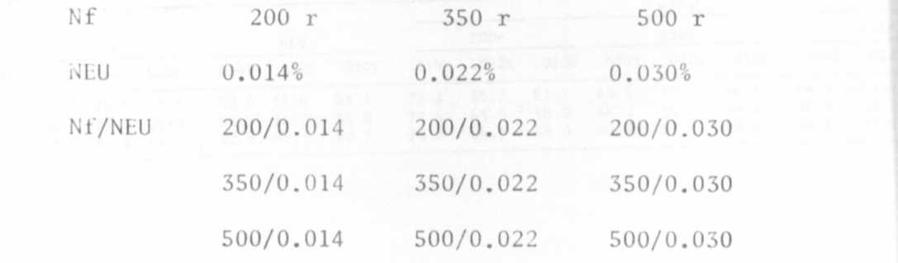
and controls.
The effectiveness of particular doses was estimated on the basis of
plant response in Mi and frequency of chlorophyl mutations in young Mo plants.
In Mi the following features were recorded: emergence rate, length of stem
with 2-5 and 4-5 leaflets, pollen grain viability (acetocarmine method),
seed yield/plant, number of pods/plant, number of seeds/plant/pod, weight
of 1000 seeds, and survival of plants. In M1 chlorophyl defects and deforma-
tions of meristem tip showing in abnormal stem development were observed.
It was decided to statistically analyze the results to find the possible
relationship between these injuries and the viability of pollen grains.
In Table 1 measurements of stem length with 4-5 leaflets are presented.
This developmental stage seemed to best exemplify the reducing effects of
mutagens. In all but one cultivar (Kaliski, 200 r) each irradiation dose
caused pronounced shortening of stem as compared to the controls. Also,
differences among cultivars were observed, e.g. the responses of cv. Kaliski
to Nf and NEU were similar, while the cv. Paloma, contrary to the cv. Finale,
seemed to be more susceptible to fast neutrons. Soaking of seeds in NEU
solution after irradiation caused considerably more pronounced shortening
of stems as compared to effects of separate mutagens.
Pollen grain viability (Table 2) was observed to be more decreased
with the increase of Nf than that of NEU doses. The differences will have
to be statistically proved; however, the results are likely to be insignificant
in many instances despite very high and differential doses.
Table 3 shows the number of plants which produced seeds. The survival
of plants treated with fast neutrons was not decreased with the increase in
mutagen doses; sometimes it was even higher than in the controls. The exception
was Paloma, where at 500 r the survival was distinctly decreased (80% of controls)
In contrast, soaking in NEU decreased the survival by approximately 50%. The
above is in agreement with the higher sensitivity observed for the cv. Paloma
to Nf and that of the cv. Finale to NEU.
The effects of NEU were also readily observed at combined mutagens. At
the highest dose (500r/0.030%) only 25% produced seeds as compared to the

PNL Volume 11 1979
RESEARCH REPORTS
34

controls. Considering the feature under discussion as determining the number
of families in M₂, the results obtained may be used for estimating the doses
and number of seeds to be involved in the treatment.
It seems that a thorough analysis of all results will provide grounds for
estimating the level of combined mutagen doses for new cultivars. It is planned
that the next stage of the experiment will involve comparison of Nf and NEU
and of combined mutagens effectiveness.
