PNL Volume 11 1979
RESEARCH REPORTS
1

GENET1C RESISTANCE TO Heterodera goettingiana Lieb. IN PISUM

Perrino, M. Di Vito, E. Porceddu, and F. Lamberti
Gerraplasra Laboratory, National Research Council, Hari, Italy

The different pea (Pisum) taxa constitute important crops all over the
world where peas are grown for human consumption as well as for livestock.
In many areas one of the most damaging pests of the pea crop is the nematode
Heterodera goettingiana (Ref: G. Thorne, Principles of Nematology, McGraw-Hill,
1961). Consequently, screening for resistance to this nematode was, and still
is, regarded an important part of the work to be performed on the pea collection
at this laboratory, and such screening work was recently commenced in colla-
boration with the Laboratory of Plant Nematology, Bari. This note presents
the initial success of this collaboration.
The results of tests involving 112 accessions of peas (Table 1) are
encouraging, as eight accessions representing three taxa were found to be
resistant to H. goettingiana. The screening work continues on other parts
of the pea collection. Additionally, work to elucidate the genetic nature
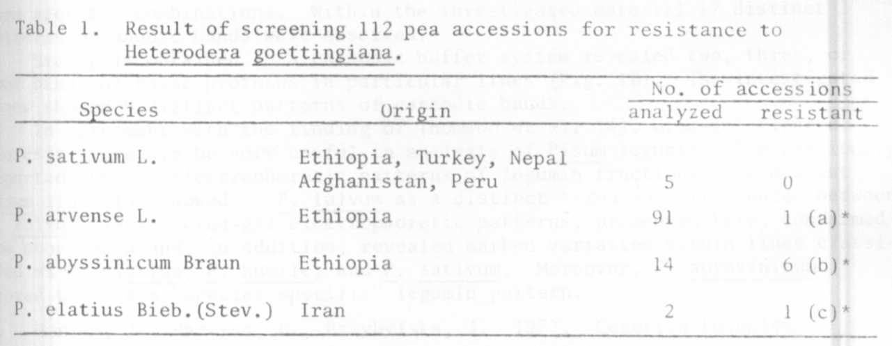
Code number of resistant accessions: (a) MG 101877; (b) MG 101789,
MG 1011790, MG 101791, MG 101794; (c) MG 10095b.
of the found resistance has been initiated.

