RESEARCH REPORTS
28
1979
PNL Volume 11

LINKAGE RELATIONS OF mo

Marx, G. A. and R. Provvidenti
New York State Agricultural Experiment Station, Geneva, USA

Pea mosaic, caused by hean yellow mosaic virus (BYMV=BV₂), is a disease
of economic importance in many pea growing areas of the world (Schroeder _{an}d
Provvidenti, New York State Agr. Exp. Sta. Bui. 806. 1964). Resistance to
the virus is conferred by a single recessive gene pair, mo/mo CYen and Fry,
Australian J. Agr. Res. 7:272-280. 1956).
Although BYMV resistance is routinely incorporated into our breeding
and genetic stocks, till now we have never undertaken a formal linkage study
involving mo. Preliminary tests pointed to a linkage of mo with wb and k
on chromosome 2 (Table 1).
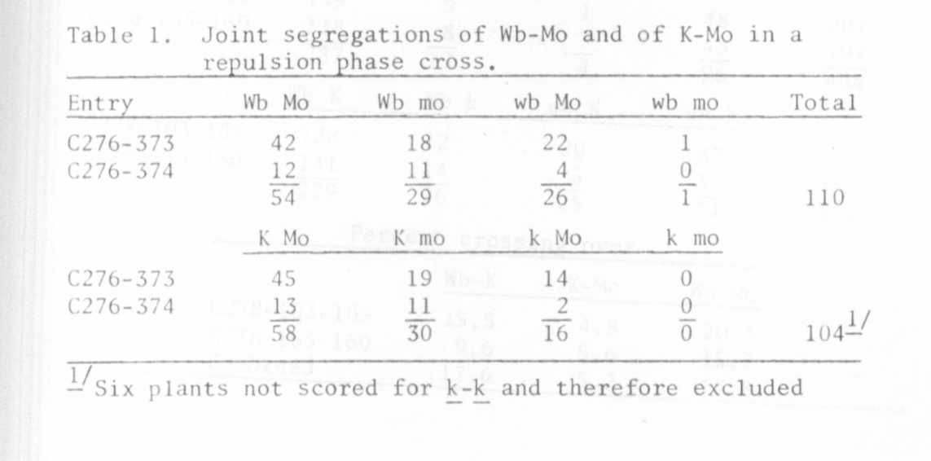

Following this, populations were grown and tested for crossover segregants
carrying wb, k and mo in coupling. Triply recessive plants were then crossed
with triply dominant plants and the F₂ progenies were grown and tested for
resistance in the greenhouse along with the respective resistant and suscep-
tible parents and with a traditional set of control varieties, viz.
'Bonneville' (R) and 'Ranger' (S).
Each plant in the test was artificially inoculated twice in a manner
outlined by Schroeder and Provvidenti (loc cit). A total of 404 F₂ plants
were tested for reaction to the virus but this was done in two separate groups
of approximately 200 plants each, planted about two weeks apart in September
1978. The greenhouse night temperature was maintained at approximately 15°C
+/- 5° and daytime temperatures were approximately 22°C (rarely over 27°C).
Natural daylight was supplemented by fluorescent and incandescent light to
a total of l6 hrs illumination daily.

PNL Volume 11 19 79
RESEARCH REPORTS

The raw data of the three-point test were sent to Dr. Blixt for computer
analysis where the two groups were analyzed separately and together (Table 2).
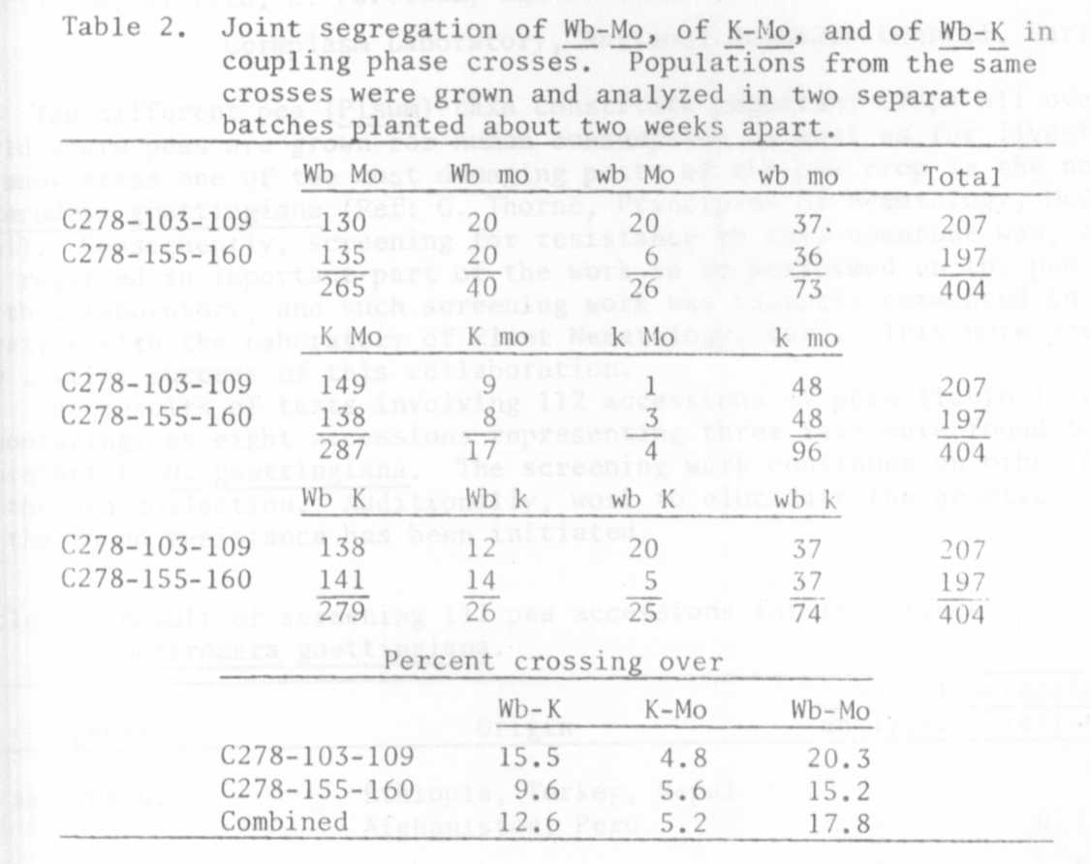

The results confirmed the preliminary findings and establish mo on chromosome 2
rather closely linked with k. All three single gene segregations, in both
groups, were statistically not significant; moreover, the relative order of the
three genes was the same. However, the calculated linkage intensity was different
in both instances so the data are presented separately and combined. Using the
combined data, the map distances in that segment of chromosome 2 are as follows:
