23 RESEARCH REPORTS PNL Volume 11 23

ON THE RELATIONSHIP OF ANTHOCYANIN PIGMENTATION AND STEM LENGTH IN PEA SEEDLINGS

Nozzolillo, C. University of Ottawa, Canada

In a previous report (PNL 9:42-43, 1977) it was noted that red-stemmed
seedlings grown from a heterogeneous seed lot identified as P.I. 356980 had
shorter inter-nodes on the average than green-stemmed seedlings from the same
lot. Otherwise the red- and green-stemmed plants were indistinguishable,
both having a red spot at the nodes and a wild-type flower. Crosses were
made by the author and by G. A. Marx between red-stemmed and green-stemmed
second generation plants derived from the original lot. All F1 seedlings
were red-stemmed. In the F2, red-stemmed seedlings were about three times
more numerous than green-stemmed seedlings (Table 1) suggesting that red-
stemmedness is dominant over green-stemmedness and that inheritance is a simple
Mendelian segregation of two alleles.
Internodal lengths of the F2 plants grown under fluorescent lights at
a constant temperature of 15°C were measured (Table 2). The offspring of
the selfed parent plants were also grown with the hybrids and measurements
of their internodes are included in Table 2. From Table 2 it can be seen
that internodal lengths of the F2 plants did not differ significantly between
red stems and green stems, although red-stemmed plants tended to be slightly
shorter, especially in the third and fourth internodes. The red-stemmed
parents, on the other hand, were decidedly shorter than the green-stemmed
parents in two of the three cases. In the third instance, the red line plants
were in fact green-stemmed, presumably as the result of an unintentional
selection of the offspring of a heterozygous red parent, and were taller than
green line plants. Thus there is no evidence of an association between inter-
node length and the presence or absence of basal anthocyanin.
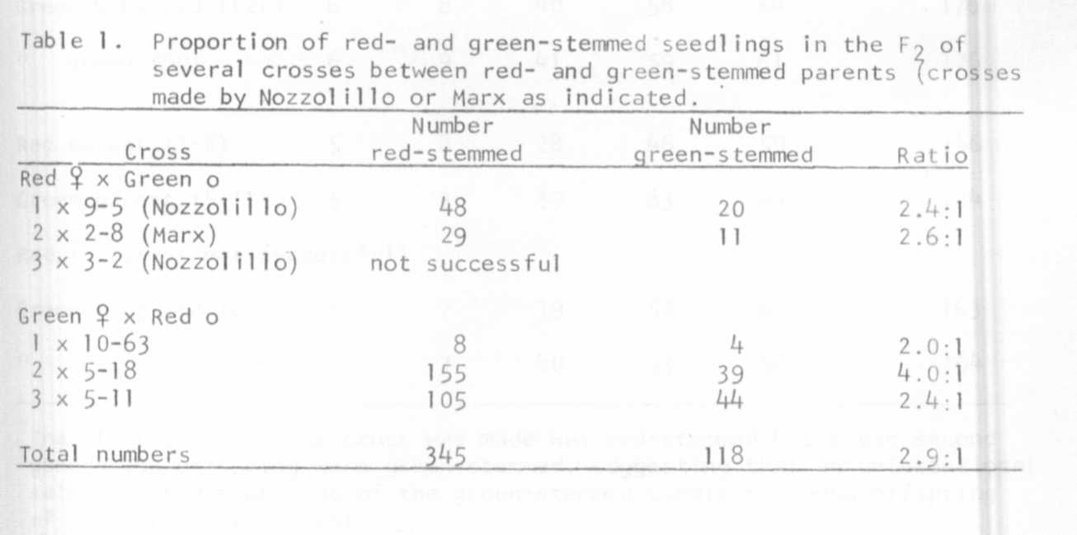

RESEARCH REPORTS
PNL Volume 11
1979
24

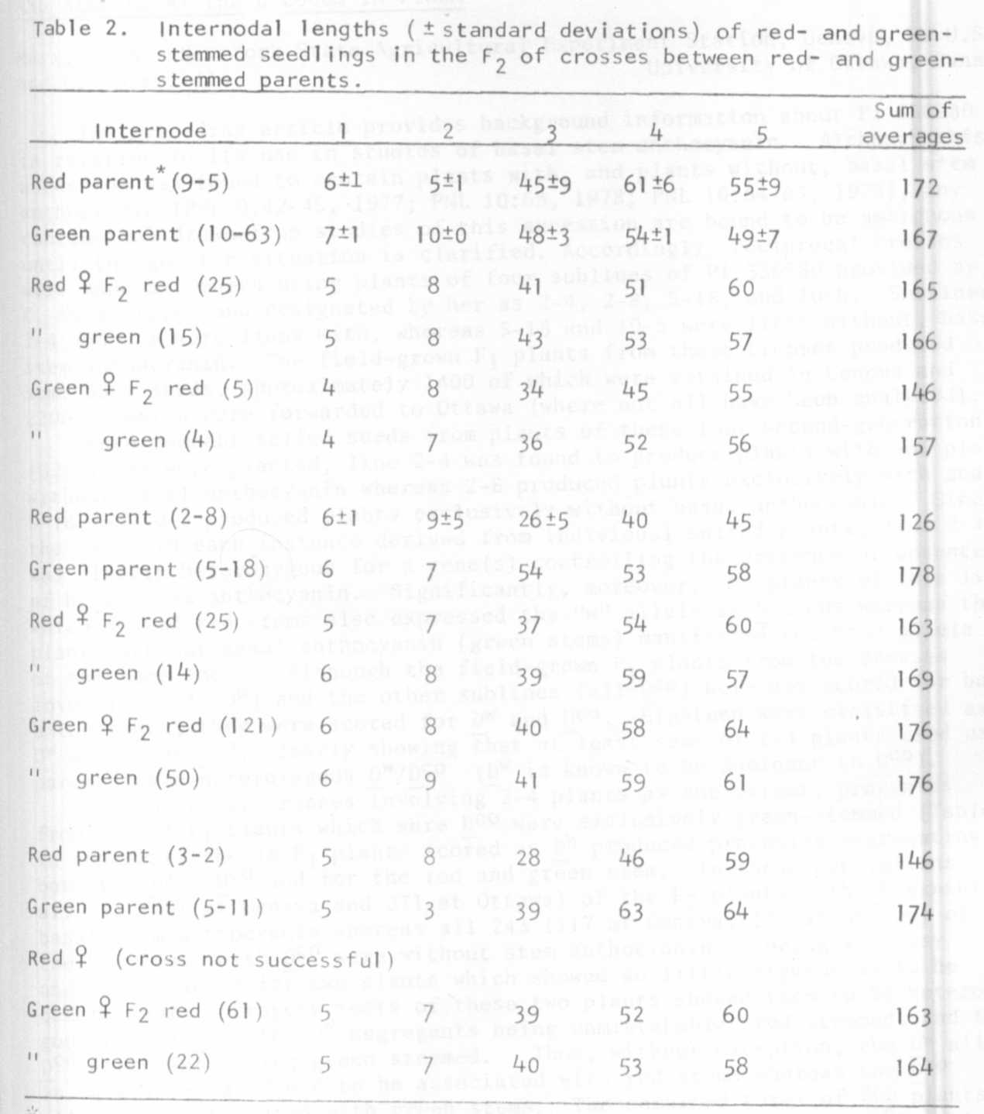
The plant on which the cross was made was red-stemmed but these second
generation offspring were green-stemmed, suggesting that an unintentional
selection had been made of the green-stemmed condition among offspring
of a heterozygous parent.

