HYBRIDIZATION TECHNIQUE VS. SUCCESS RATE

King, C, and A. F. Williams Williams Laboratories, Williams, Indiana, U.S.A

In the course of producing teaching materials, Williams Laboratories
contracts with several local gardeners to produce hybrid peas. Payment is
on a "per seed" basis, and hybridizers are encouraged to "streamline" their
technique. This past year, hybridizers were asked to keep specific records
to help determine the fairness of our wage policy. These records revealed
the following data, which seem worth sharing with pea geneticists.
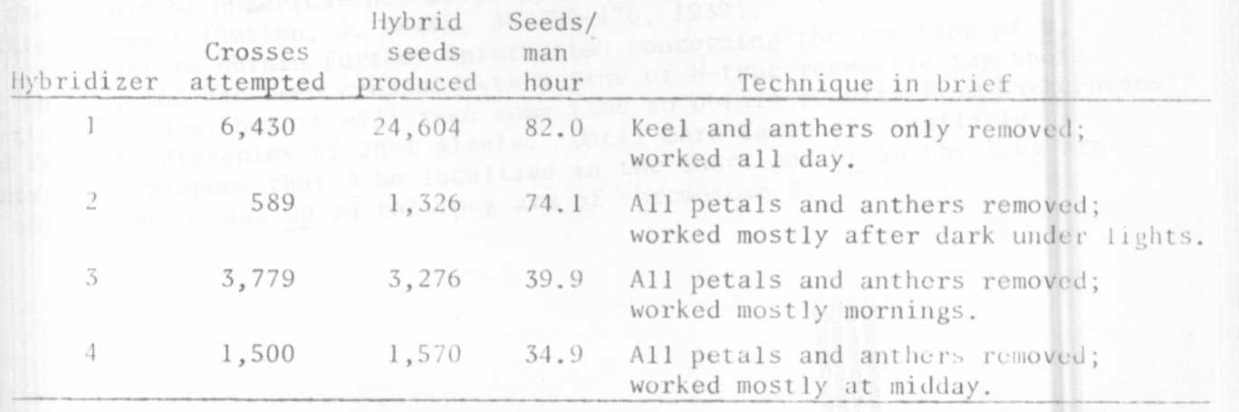
Hybridizer l's mature pods/cross average was 0.73 and her peas/mature
pod average was 5.9, compared to averages of ca. 0.35 and 3.0 for hybridizers
3 and 4. Though we use several parent combinations, all the above data were
derived using the variety 'Alderman' [a i U V r) as the female parent and
the variety 'Dwarf Grey Sugar' (A I le v R) as the pollen parent.
Removing all petals may save time per cross, but definitely not time
per hybrid seed produced. Our experience confirms that trauma and exposure
to direct sunlight are detrimental to high success rate.

LOCATION OF B AND St IN PISUM

Lamm, R. L. Swedish University of Agricultural Sciences, Alnarp, Sweden

In PNL 9:26-27, 1977, 1 pointed out that further cytogenetica1 studies
of interchange trisomies would be desirable in order to establish the location
of B and St in Pisum. The results of such investigations are given below.
In a backcross made by E. Nilsson between 1.85 (Extra Rapid, T[3-5]b,
B St) and L48 (De Winton, N-type, b st) as the recurrent parent, he demonstrate.
strong linkage between the T-point and these genes (Lamm, Hereditas 34:280-288.
1948). In addition to 118 2n plants, Nilsson found 10 2n+l plants, 8 of the
genotype B st and 2 being b st. I have repeated this backcross and, besides
50 2n plants, I obtained 5 trisomies - 3 B st and 2 b St. One of the trisomic
B st plants, on selfing, produced a progeny of 15 2n plants, 13 being of the
genotype b st and 2 B st. The progeny also contained one 2n+l plant of the
genotype B st. With reference to Fig. la, 1 found that the extra chromosome
in the four B st plants was the short 5³ chromosome, whereas the two b St
plants contained the long 3⁵ chromosome.
In Fig. lb, the probable pachytene configuration is illustrated. It
should, however, be mentioned that chiasmata in the interstitial segment are
rare. The genetic results indicate that belongs to the short and St to
the long arm of chromosome 3.
In Fig. lb, the probable location of Gp is also indicated according to
my results given in PNL 9:26-27, 1977. However, according to my earlier
results (PNL 8:36-37, 1976) from crosses with L84 (T[l-5]a), Gp should rather
be localized in the place indicated by brackets in Fig. lb. While considering
this location as an alternative, it should be noted that trisomies never occur
as the result of numerical non-disjunction if there is a chiasma in the inter-
stitial segment (Sutton, J. Genet. 38:459-476, 1939).
In order to obtain further information concerning the location of B,
St, and Gp, L83 has been crossed with a line of N-type recessive for those
particular genes, but it will take some time to obtain results from backcrosses
and from the progenies of 2n+l plants. Until more facts are available, I
tentatively propose that B be localized in the short and St in the long arm
of chromosome 3, and Gp in the long arm of chromosome 5.
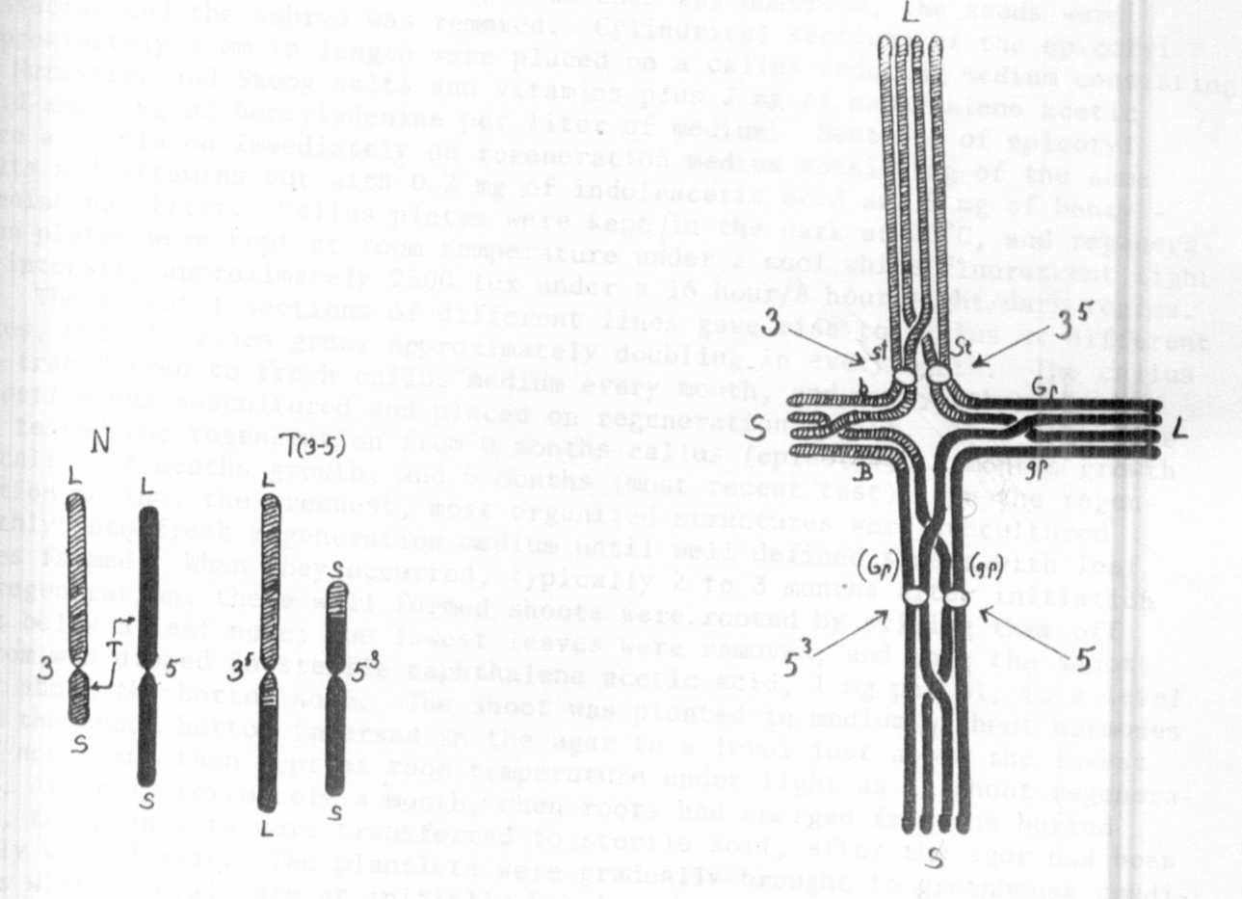

Fig. la. Illustration of the Fig. 1b. Probable pairing at pachytene in
reciprocal translocation giving the translocation heterozygote oi crosses
rise to the T(3-5) structure between L83 and lines ot the normal struc-
of L83. ural type with a tentative location of B,
St, and Gp.

