RECIPROCAL TRANSLOCATION IN PEA

Kaul, M. L. H. Institute of Cienetics, Bonn, West Germany

Interaction of recessive mutant genes has led to some new and bizarre
genotypes in the garden pea. During one such synthesis of digenic and trigenic
pea mutants, translocation heterozygosity was detected in the progeny of a plant
homozygous for acacia, afila, and cochleata (tl^{w}, af, coch). Such translocations
were not detected either in the single gene mutants or in the two gene recom-
binants viz. acacia/afila, acacia/cochleata, afila/ cochleata. Since such
translocations appeared only when these three mutant genes were present together
in a homozygous state, it was thought that the translocations are not only
gene-dependent but also genome-dependent (1). But further studies have not
revealed that the translocation is simply due to a gene mutation in the trigenic
pea mutant and its genetic status is being investigated.
Plants with the translocation heterozygote were partially sterile, had
much reduced pollen fertility, and reduced seed production. At MI, a ring of
4 chromosomes and 5 bivalents were present in the majority of the pollen mother
cells (Pig. 1). At advanced MI stages, in a few PMCs, associations of 4 chromo-
somes and a free univalent along with 5 bivalents were also observed. The
elimination of the 4th chromosome in these associations may be due to the avail-
ability of an extremely short chromosomal segment that is insufficient for
chiasma formation and, therefore, one of the translocated chromosomes is unable
to remain in this association. This inference is supported by the presence
of many IV configurations occurring as open rings, chains, or zizags. Whereas
the disjunction in the bivalents was normal at AI, the quadrivalent exhibited
an anomalous disjunction. This led to misdistributions and fragmentations and
laggard and bridge formations. However, a distribution of 6 + 8 was observed
in nearly 40% AI cells during male meiosis. Besides, monocentric and dicentric
bridges were also common at AI (Fig. 3, 4, 5). Second division stages were
abnormal and the microspores with micronuclei were abundant. While the genetic
tests indicated that these translocations were gene controlled, plants with
a ring of 6 chromosomes were detected (Fig. 2) from the progeny of the trans-
location heterozygote hybrids. This points to the possibility that some other
chromosome may be involved in the translocation as well. The translocation
homozygotes are weak, inviable, and with small flowers and abortive seeds.

(1) Kaul, M. L. 11. 1978. Proc. XIV Int. Cong. Genet. Moscow. (Abstr.).
Pt. 1, 29b p.

Fig. 1. 5 bivalents and a ring of IV
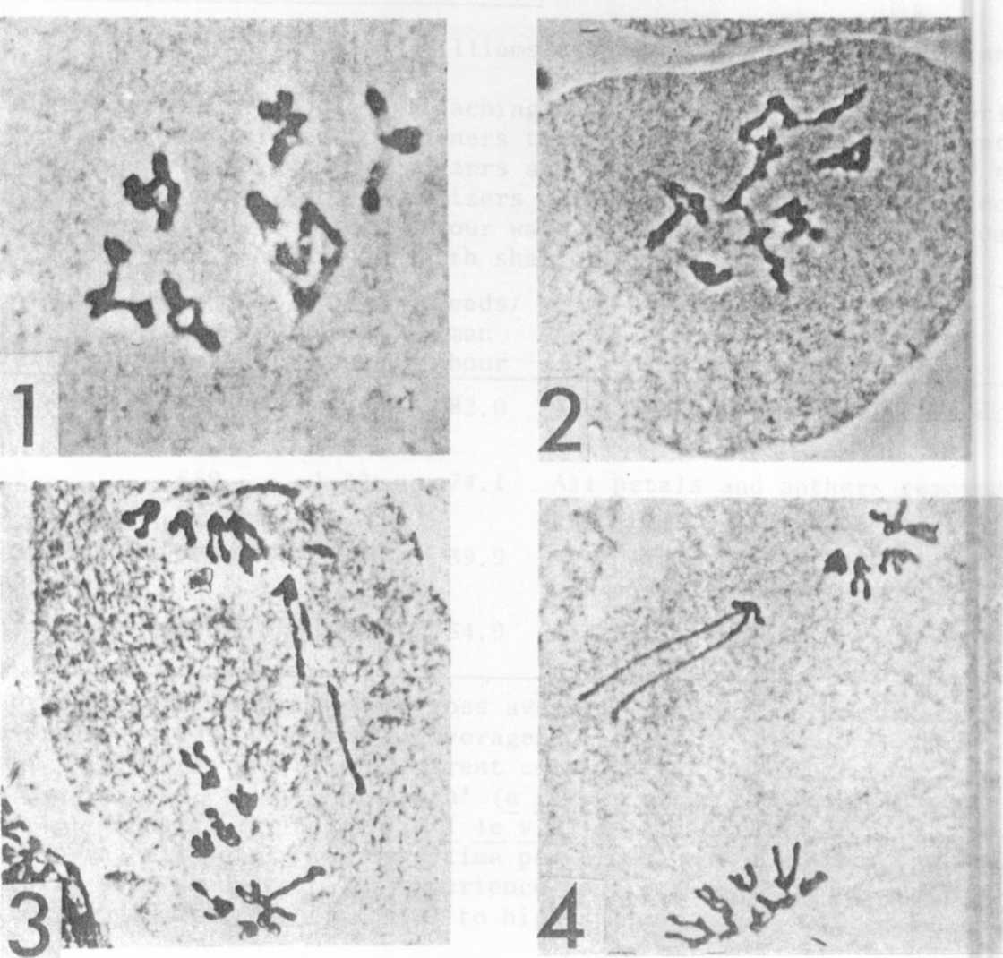
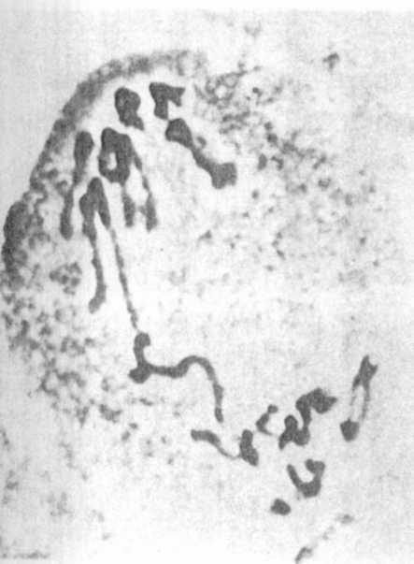
chromosomes at MI.

Fig. 2. 4 bivalents and an open VI
configuration at MI.

Fig. 3-4. Anaphase I - the very long arms
represent the crossover chromatids
of one of the chromosomes.

Fig. 5. Anaphase I bridge and misdistri-
bution of chromosomes.

