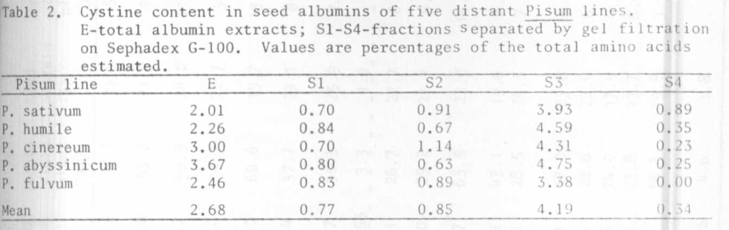
13 RESEARCH REPORTS PNL Volume 11 1979
(1) Przybylska, J., S. Blixt, J. Hurich, Z. Zimniak-Przybylska. 1977. Genetic
Polonica 18:27-38.
(2) Jakubek, M. and J. Przybylska. 1978. PNL 10:24.
(3) Jakubek, M. and J. Przybylska. 1979. Genetica Polonica (in press).
(4) Hurich, J., H. Parzysz, and J. Przybylska. 1977. Genetica Polonica lb:241
252.

AGRONOMIC PERFORMANCE AND SEED PROTEIN YIELD OF SOME PEA GENOTYPES

Kaul, M. L. H. University of Kurukshetra, India

Earlier (PNL 10:25-26, 1978) we reported measurements of height and of
several yield components in 25 varieties of peas grown at Kashmir (N.W. Himalaya
region of India). Table 1 includes some additional data obtained from the same
study. Among the tall types, T56 had the highest shelling percentage, number
of seeds per plant, grain yield, and seed protein yield but it had the lowest
seed protein content. 'Lincoln' performed second best, combining high grain
yield with better seed protein content. In the dwarf group, 'Early Badger'
and GC 468 were among the best in the test.

