PNL Volume 11 1979 RESEARCH REPORTS 1

PRESENCE OF THE HIGH-CYSTINE FRACTION IN THE PISUM SEED ALBUMINS

Jakubek, M. and J. Przybylska Polish Academy of Sciences, Poznan, Poland

Seed albumins of five Pisum ecotypes, showing characteristic electro-
phoretic patterns (1), were separated on a Sephadex G-100 column into four
chromatographic fractions, with the following approximate molecular weights:
80,000 (SI), 40,000 (S2), 18,000 (S3), and 7,000 (S4). Electrophoretic
patterns of these fractions were described previously (2). Data concerning
the relative contents and amino acid composition of the fractions are presented
in this report.
The following Pisum lines from the Weibullsholm Collection were investigated
P. sativum 'Kungsart', W 110; P_. humile, W 936; P. cinereum, W 1490;
P. abyssinicum, W 808; and P_. fulvum, W 1256. Extraction of albumins, fractiona- tion, and amino acid determination were carried out as described elsewhere (3) .
The average percentages of fractions S1-S4 in the total albumins recovered
from the column were: 16, 26, 48, and 11, respectively. Though elution profiles
of the Pisum lines investigated were similar, some differences in the relative
contents of particular fractions were observed (Table 1).
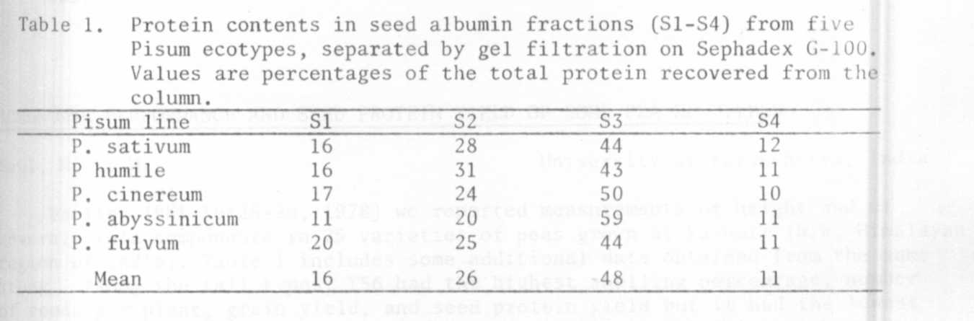
The corresponding albumin fractions of the five Pisum lines studied had
a rather uniform amino acid composition, but some marked differences in the
level of certain amino acids were observed between chromatographic fractions
of Pisum seed albumins. Fraction S1 was rich in leucine and fraction S2 in
tyrosine and phenylalanine. Fraction S3 contained a high amount of cystine
(Table 2) and a relatively small amount of leucine. The average content of
cystine in fraction S3 was about sixfold higher than that in the other fractions.

The data reported here indicate that a relatively high level of cystine
in total albumins of P. abyssinicum, observed in the previous (4) and present
investigations, is rather due to a larger proportion of the cystine-rich
fraction S3 (Table 1) than to a higher content of cystine in this fraction.

1/ - This work was performed under Government Project PR-4.

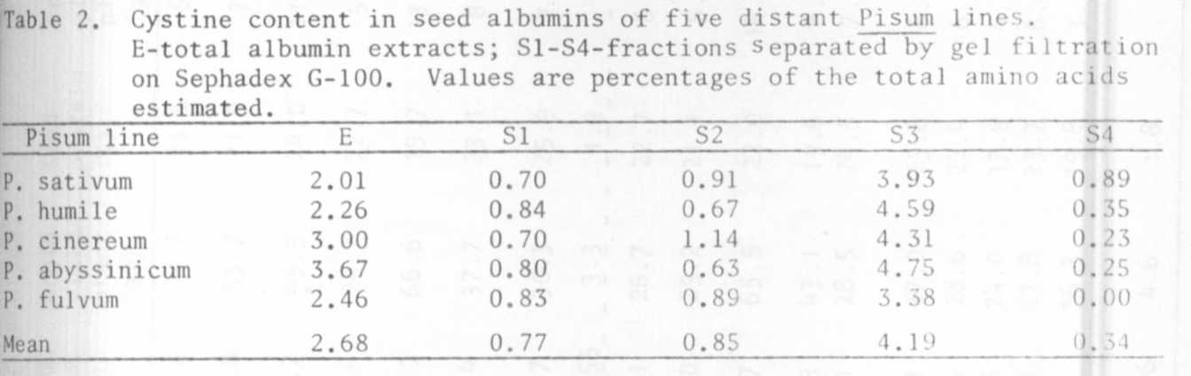
13 RESEARCH REPORTS PNL Volume 11 1979
(1) Przybylska, J., S. Blixt, J. Hurich, Z. Zimniak-Przybylska. 1977. Genetic
Polonica 18:27-38.
(2) Jakubek, M. and J. Przybylska. 1978. PNL 10:24.
(3) Jakubek, M. and J. Przybylska. 1979. Genetica Polonica (in press).
(4) Hurich, J., H. Parzysz, and J. Przybylska. 1977. Genetica Polonica lb:241
252.

AGRONOMIC PERFORMANCE AND SEED PROTEIN YIELD OF SOME PEA GENOTYPES

Kaul, M. L. H. University of Kurukshetra, India

Earlier (PNL 10:25-26, 1978) we reported measurements of height and of
several yield components in 25 varieties of peas grown at Kashmir (N.W. Himalaya
region of India). Table 1 includes some additional data obtained from the same
study. Among the tall types, T56 had the highest shelling percentage, number
of seeds per plant, grain yield, and seed protein yield but it had the lowest
seed protein content. 'Lincoln' performed second best, combining high grain
yield with better seed protein content. In the dwarf group, 'Early Badger'
and GC 468 were among the best in the test.

