A PISUM GENE PREVENTING TRANSITION FROM THE VEGETATIVE TO THE REPRODUCTIVE STAGE

Gottschalk, W. Institute of Genetics, Bonn, Germany

In an M2 family following X-irradiation, some mutant plants arose which
were unable to produce flowers (mutant 172 of our collection). The plants
showed normal behavior and development with regard to height, growth rate,
and physiological activity, but instead of producing inflorescences, they
form lateral branches with extremely shortened internodes. The growing points
of these lateral branches (and of the main growing point of the stem) remain
active, producing leaves and internodes, while the plants of the mother
variety are long since mature. Plants remain alive in the field until killed
by frost or by heavy mildew attack towards the end of the growing season.
When cultivated in the greenhouse, they survived for two years until they
succumbed to disease. Surely they would have survived longer under optimal
greenhouse conditions without having formed any flowers. We have maintained
this mutant type over a period of 11 generations by propagating plants hetero-
zygous for the mutant gene. During this time, with hundreds of plants having
been grown, not a single flower was formed.
Histological studies revealed that the growing points of the main stem
and the lateral branches remain mitotically active, permanently producing
new cell material which differentiates to somatic tissues. Differentiation
of floral buds does not occur. Nor did cultivation of the plants in the
greenhouse under different photoperiodic conditions induce flower formation.
Thus, the behavior of the mutant seems not to be due to a specific photo-
periodic requirement. Presumably an enzyme(s) necessary for the transition
of the plants from the vegetative to the reproductive stage is lacking.
Mutant 172 arose by X-irradiation. What appears to be the same mutant
was selected in neutron experiments. It is like 172 in all respects, but
heterozygous plants of the two sources have not yet been crossed to verify
their identity. The recessive gene in Mutant 172 is designated "veg".

SIMPLE PROTEIN ASSAY FOR PEA

Hartmann, K. Institute of Genetics, Bonn, West Germany

Breeding for increased protein in field crops has been facilitated by the
availability of efficient screening methods. Esen (Anal. Biochem. 89:264-273.
1978) has recently published a simple determination method for quantitative
assay of protein which gives a linear response from 0.05 to 3-4 mg/ml of pro-
tein. Beside purified proteins like cytochrome C, Bovine serum albumin (BSA),
and egg albumin, Esen proposed the applicability of this method for protein
extractions of plant tissues. The method requires spotting of five-microliter
samples of the protein solutions in question on Whatman chromatography paper
No. 1. The sheet is stained in a 0.1% coomassie brilliant blue R-250 solution
[composed of 65 parts of distilled water, 25 parts of isopropyl alcohol, and
10 parts of acetic acid (v/v/v)] for 15 min. Then the paper is destained by
passing it through 3 glass trays, each containing distilled water. Following
drying, the stained protein spots are cut out in the form of disks with a
corkborer (19 mm diam). An unspotted disk serves as a blank. The dye-protein
complex is eluted for 45 mm in test tubes containing 5 ml 0.1% sodium dodecyl
sulfate (SOS) solution. Then the solution is decanted into cuvettes and the
absorbance is read at 600 nm with a Beckman spectrophotometer against the eluate
of the blank set at 0.000 absorbance.
To determine the value of this assay in Pisum sativum seed protein, extrac-
tions, different amounts of seed flour of our initial line ('Dippes gelbe
Viktoria'J, were dissolved in a KCl-buffer (0.2 mol KC1, pH 6.85) to give an
estimated final concentration from 0.5 to 2.5 mg protein per ml. When the
extraction process lasts up to 48 hours, uniform and reproducible results were
obtained. Six replicates of each extraction were measured and compared with
a BSA regression line (Fig. 1) established by concentrations reaching from
0.5 to 2.5 mg protein per ml. These results are in good agreement with those
obtained by the Kjeldahl method. So far BSA seems to be a useful standard
tor estimating the seed protein values in Pisum until purified Pi sum seed
protein is available.
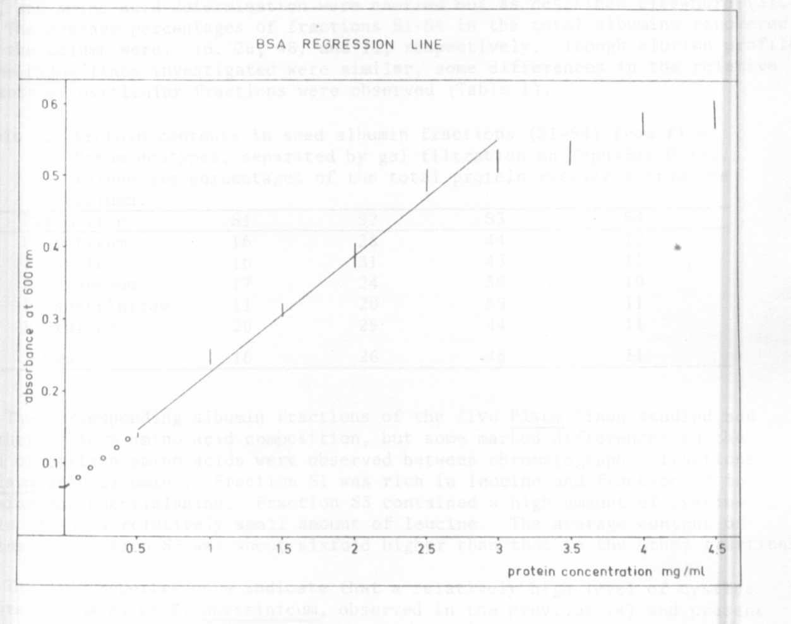
Fig. I. BSA-regression line established by concentrations reaching from
0.5 to 2.5 mg protein per ml.

